EASTERN MEDITERRANEAN UNIVERSITY
DEPARTMENT OF COMPUTER ENGINEERING
CMPE223 NUMERICAL LOGIC SYSTEMS

Experiment 7: Verilog language, Latch, D-FF, T-FF, JK-FF

Simple SR-Latch:

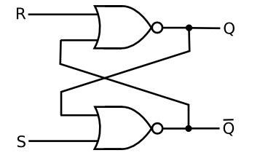

SR-Latch Verilog code:

module SR_LATCH(S, R, Q, Qbar);
input S, R;
output Q, Qbar;

reg Q, Qbar;

always @(S, R, Q, Qbar)
begin
Q <= !(R | Qbar);
Qbar <= !(S | Q);
end
endmodule

Simple D-FF:
The D-FF is a simple bit memory that is connected to the clock signal.
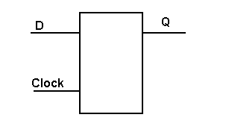
D-FF code:

module D_FF(D, clk, Q);
input D, clk;
output Q;
reg Q;

always @(posedge clk)
begin
Q <= D;
end
endmodule

Simple T-FF:
T-Flip Flop is toggle FF.

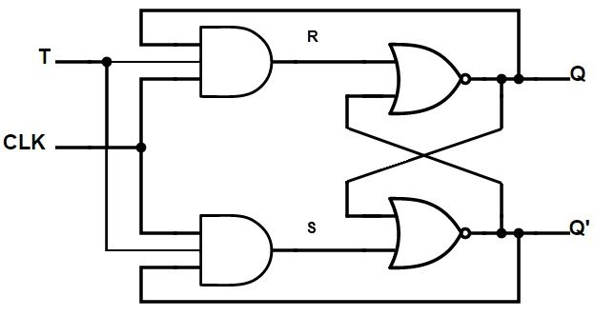

T-FF Code:
module T_FF(T, clk, Q, Qbar);
input T, clk;
output Q, Qbar;
reg Q, Qbar;
reg S, R;

always @(posedge clk)
begin
R <= T & clk & Q;
S <= T & clk & Qbar;
Q <= !(Qbar | R);
Qbar <= !(Q | S);
end
endmodule

JK-Flip Flop:
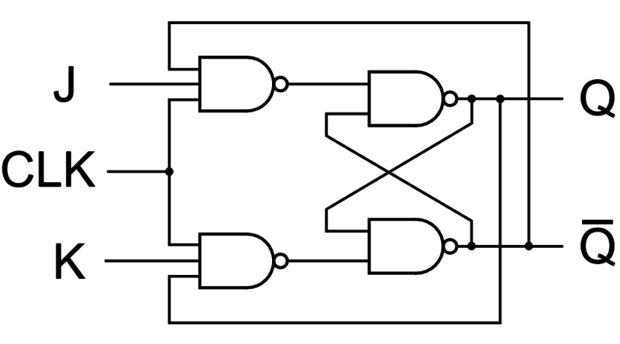

JK-FF Code:
module JK_FF(J, K, clk, Q, Qbar);
input J, K, clk;
output Q, Qbar;
reg Q, Qbar;
reg S, R;

always @(clk)
begin
S <= !(Qbar & clk & J);
R <= !(Q & clk & K);
Q <= !(S & Qbar);
Qbar <= !(R & Q);
end
endmodule

T-FF Counter:
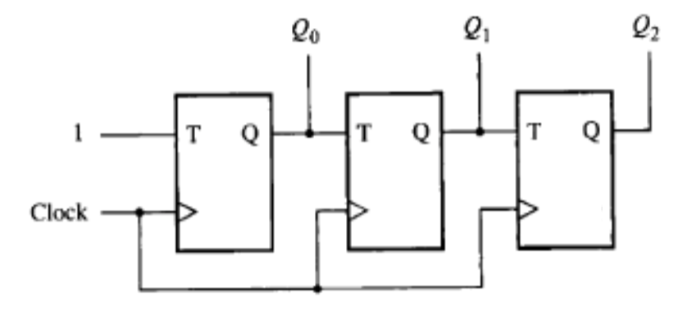
T-FF Counter Code:
module Counter(T, clk, Q, Qbar);
input T, clk;
output [3 : 0] Q, Qbar;

T_FF t0(T, clk, Q[0], Qbar[0]);
T_FF t1(Q[0], clk, Q[1], Qbar[1]);
T_FF t2(Q[1], clk, Q[2], Qbar[2]);
T_FF t3(Q[2], clk, Q[3], Qbar[3]);
endmodule

module T_FF(T, clk, Q, Qbar);
input T, clk;
output Q, Qbar;
reg Q, Qbar;
reg S, R;
always @(posedge clk)
begin
R <= T & clk & Q;
S <= T & clk & Qbar;
Q <= !(Qbar | R);
Qbar <= !(Q | S);
end
endmodule

Ömer DEMİR

