Unified Modeling Language (UML) | Sequence Diagrams
In this post we discuss Sequence Diagrams. Unified Modelling Language (UML) is a modeling language in the field of software engineering which aims to set standard ways to visualize the design of a system. UML guides the creation of multiple types of diagrams such as interaction , structure and behaviour diagrams.
A sequence diagram is the most commonly used interaction diagram.
Interaction diagram –
An interaction diagram is used to show the interactive behavior of a system. Since visualizing the interactions in a system can be a cumbersome task, we use different types of interaction diagrams to capture various features and aspects of interaction in a system.
Sequence Diagrams –
A sequence diagram simply depicts interaction between objects in a sequential order i.e. the order in which these interactions take place. We can also use the terms event diagrams or event scenarios to refer to a sequence diagram. Sequence diagrams describe how and in what order the objects in a system function. These diagrams are widely used by businessmen and software developers to document and understand requirements for new and existing systems.

Unified Modeling Language (UML) | Sequence Diagrams
In this post we discuss Sequence Diagrams. Unified Modelling Language (UML) is a modeling language in the field of software engineering which aims to set standard ways to visualize the design of a system. UML guides the creation of multiple types of diagrams such as interaction , structure and behaviour diagrams.
A sequence diagram is the most commonly used interaction diagram.
Interaction diagram –
An interaction diagram is used to show the interactive behavior of a system. Since visualizing the interactions in a system can be a cumbersome task, we use different types of interaction diagrams to capture various features and aspects of interaction in a system.
Sequence Diagrams –
A sequence diagram simply depicts interaction between objects in a sequential order i.e. the order in which these interactions take place. We can also use the terms event diagrams or event scenarios to refer to a sequence diagram. Sequence diagrams describe how and in what order the objects in a system function. These diagrams are widely used by businessmen and software developers to document and understand requirements for new and existing systems.

Figure – a sequence diagram
- Messages – Communication between objects is depicted using messages. The messages appear in a sequential order on the lifeline. We represent messages using arrows. Lifelines and messages form the core of a sequence diagram.
Messages can be broadly classified into the following categories :
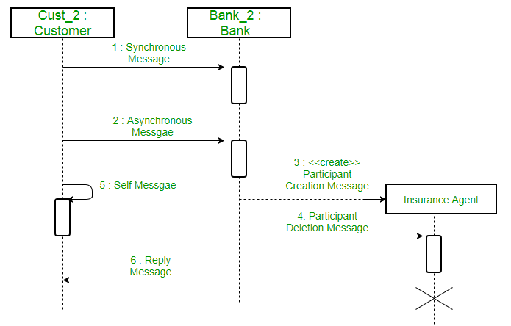
Figure – a sequence diagram with different types of messages
  - Synchronous messages – A synchronous message waits for a reply before the interaction can move forward. The sender waits until the receiver has completed the processing of the message. The caller continues only when it knows that the receiver has processed the previous message i.e. it receives a reply message. A large number of calls in object oriented programming are synchronous. We use a solid arrow head to represent a synchronous message.
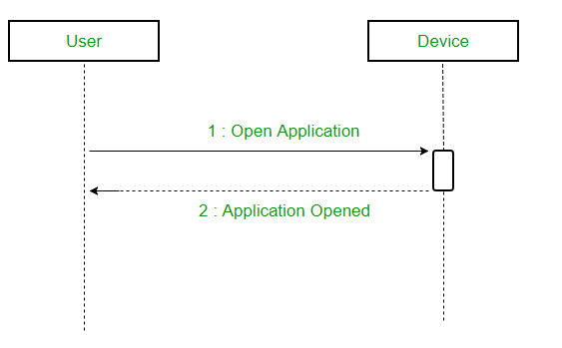
- Figure – a sequence diagram using a synchronous message
- Asynchronous Messages – An asynchronous message does not wait for a reply from the receiver. The interaction moves forward irrespective of the receiver processing the previous message or not. We use a lined arrow head to represent an asynchronous message.
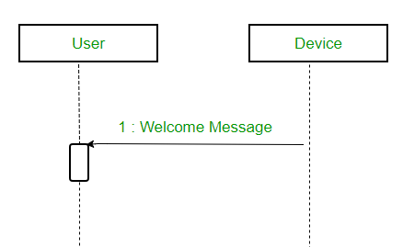
- Create message – We use a Create message to instantiate a new object in the sequence diagram. There are situations when a particular message call requires the creation of an object. It is represented with a dotted arrow and create word labelled on it to specify that it is the create Message symbol.
For example – The creation of a new order on a e-commerce website would require a new object of Order class to be created.
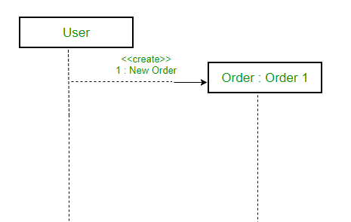
Figure – a situation where create message is used
- Delete Message – We use a Delete Message to delete an object. When an object is deallocated memory or is destroyed within the system we use the Delete Message symbol. It destroys the occurrence of the object in the system.It is represented by an arrow terminating with a x.
For example – In the scenario below when the order is received by the user, the object of order class can be destroyed.
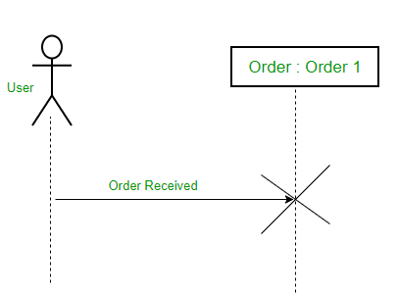
Figure – a scenario where delete message is used
- Self Message – Certain scenarios might arise where the object needs to send a message to itself. Such messages are called Self Messages and are represented with a U shaped arrow.
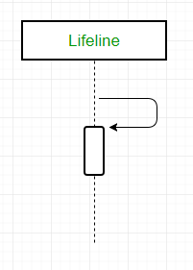
Figure – self message
For example – Consider a scenario where the device wants to access its webcam. Such a scenario is represented using a self message.
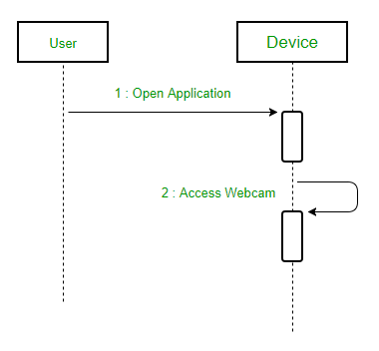
Figure – a scenario where a self message is used
- Reply Message – Reply messages are used to show the message being sent from the receiver to the sender. We represent a return/reply message using an open arrowhead with a dotted line. The interaction moves forward only when a reply message is sent by the receiver.
Figure – reply message
For example – Consider the scenario where the device requests a photo from the user. Here the message which shows the photo being sent is a reply message.
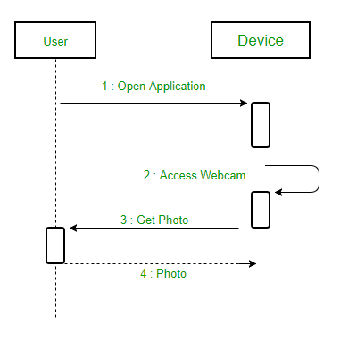
Figure – a scenario where a reply message is used
- Found Message – A Found message is used to represent a scenario where an unknown source sends the message. It is represented using an arrow directed towards a lifeline from an end point. For example: Consider the scenario of a hardware failure.
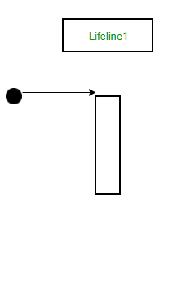
Figure – found message
It can be due to multiple reasons and we are not certain as to what caused the hardware failure.
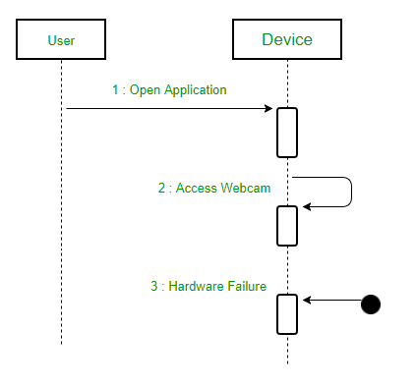
Figure – a scenario where found message is used
- Lost Message – A Lost message is used to represent a scenario where the recipient is not known to the system. It is represented using an arrow directed towards an end point from a lifeline. For example: Consider a scenario where a warning is generated.
Figure – lost message
The warning might be generated for the user or other software/object that the lifeline is interracting with. Since the destination is not known before hand, we use the Lost Message symbol.
- Actors – An actor in a UML diagram represents a type of role where it interacts with the system and its objects. It is important to note here that an actor is always outside the scope of the system we aim to model using the UML diagram.
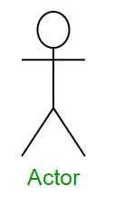
Figure – notation symbol for actor
We use actors to depict various roles including human users and other external subjects. We represent an actor in a UML diagram using a stick person notation. We can have multiple actors in a sequence diagram.
For example – Here the user in seat reservation system is shown as an actor where it exists outside the system and is not a part of the system.
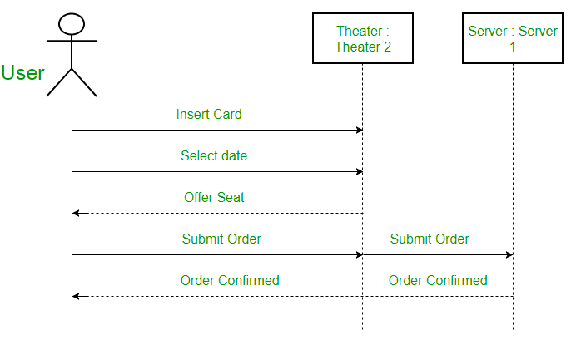
Figure – an actor interacting with a seat reservation system
- Lifelines – A lifeline is a named element which depicts an individual participant in a sequence diagram. So basically each instance in a sequence diagram is represented by a lifeline. Lifeline elements are located at the top in a sequence diagram. The standard in UML for naming a lifeline follows the following format – Instance Name : Class Name
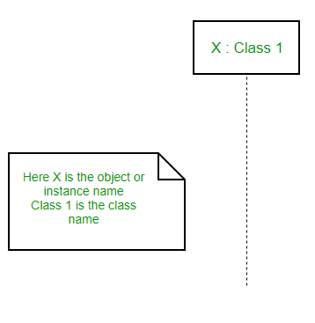
Figure – lifeline
We display a lifeline in a rectangle called head with its name and type. The head is located on top of a vertical dashed line (referred to as the stem) as shown above. If we want to model an unnamed instance, we follow the same pattern except now the portion of lifeline’s name is left blank.
Difference between a lifeline and an actor – A lifeline always portrays an object internal to the system whereas actors are used to depict objects external to the system. The following is an example of a sequence diagram:
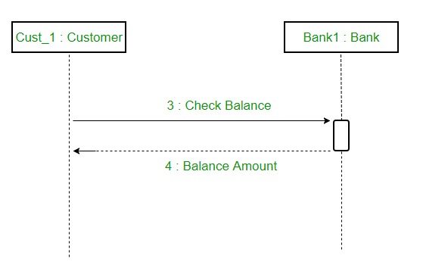
Figure – a sequence diagram

