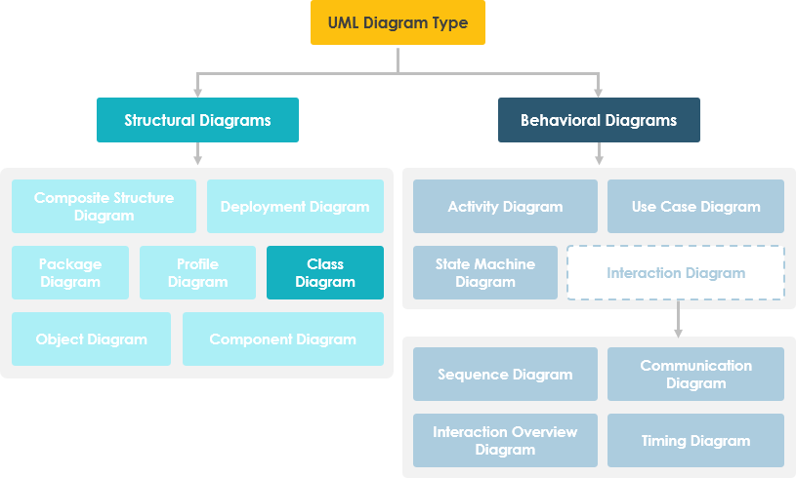

What is a Class
A description of a group of objects all with similar roles in the system, which consists of:
- Structural features (attributes) define what objects of the class "know"
  - Represent the state of an object of the class
  - Are descriptions of the structural or static features of a class
- Behavioral features (operations) define what objects of the class "can do"
  - Define the way in which objects may interact
  - Operations are descriptions of behavioral or dynamic features of a class

Class Notation
A class notation consists of three parts:
- Class Name
  - The name of the class appears in the first partition.
- Class Attributes
  - Attributes are shown in the second partition.
  - The attribute type is shown after the colon.
  - Attributes map onto member variables (data members) in code.
- Class Operations (Methods)
  - Operations are shown in the third partition. They are services the class provides.
  - The return type of a method is shown after the colon at the end of the method signature.
- The return type of method parameters is shown after the colon following the
  - Operations map onto class methods in code
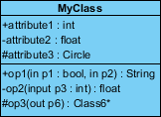
The graphical representation of the class - MyClass as shown above:
- MyClass has 3 attributes and 3 operations
- Parameter p3 of op2 is of type int
- op2 returns a float
- op3 returns a pointer (denoted by a *) to Class6

Class Relationships
A class may be involved in one or more relationships with other classes. A relationship can be one of the following types: (Refer to the figure on the right for the graphical representation of relationships).
Relationship Type | Graphical Representation
Inheritance (or Generalization):  - Represents an "is-a" relationship.  - An abstract class name is shown in italics.  - SubClass1 and SubClass2 are specializations of Super Class.  - A solid line with a hollow arrowhead that point from the child to the parent class | 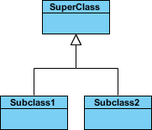
Simple Association:
- A structural link between two peer classes.
- There is an association between Class1 and Class2
- A solid line connecting two classes
Aggregation:  A special type of association. It represents a "part of" relationship.  - Class2 is part of Class1.  - Many instances (denoted by the *) of Class2 can be associated with Class1.  - Objects of Class1 and Class2 have separate lifetimes.  - A solid line with an unfilled diamond at the association end connected to the class of composite | 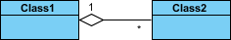
Composition:
A special type of aggregation where parts are destroyed when the whole is destroyed.
- Objects of Class2 live and die with Class1.
- Class2 cannot stand by itself.
- A solid line with a filled diamond at the association connected to the class of composite
Dependency:
- Exists between two classes if the changes to the definition of one may cause changes to the other (but not the other way around).
- Class1 depends on Class2
- A dashed line with an open arrow

Relationship Names
- Names of relationships are written in the middle of the association line.
- Good relation names make sense when you read them out loud:
  - "Every spreadsheet contains some number of cells",
  - "an expression evaluates to a value"
- They often have a small arrowhead to show the direction in which direction to read the relationship, e.g., expressions evaluate to values, but values do not evaluate to expressions.
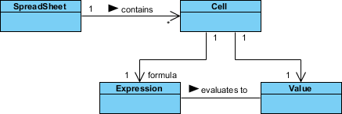

Relationship - Roles
- A role is a directional purpose of an association.
- Roles are written at the ends of an association line and describe the purpose played by that class in the relationship.
  - E.g., A cell is related to an expression. The nature of the relationship is that the expression is the formula of the cell.

Navigability
The arrows indicate whether, given one instance participating in a relationship, it is possible to determine the instances of the other class that are related to it.
The diagram above suggests that,
- Given a spreadsheet, we can locate all of the cells that it contains, but that
  - we cannot determine from a cell in what spreadsheet it is contained.
- Given a cell, we can obtain the related expression and value, but
  - given a value (or expression) we cannot find the cell of which those are attributes.

Visibility of Class attributes and Operations
In object-oriented design, there is a notation of visibility for attributes and operations. UML identifies four types of visibility: public, protected, private, and package.
The +, -, # and ~ symbols before an attribute and operation name in a class denote the visibility of the attribute and operation.
- + denotes public attributes or operations
- - denotes private attributes or operations
- # denotes protected attributes or operations
- ~ denotes package attributes or operations

Class Visibility Example
In the example above:
• attribute1 and op1 of MyClassName are public
• attribute3 and op3 are protected.
• attribute2 and op2 are private.
Access for each of these visibility types is shown below for members of different classes.

Access Right | public (+) | private (-) | protected (#) | Package (~)
Members of the same class | yes | yes | yes | yes
Members of derived classes | yes | no | yes | yes
Members of any other class | yes | no | no | in same package

Multiplicity
How many objects of each class take part in the relationships and multiplicity can be expressed as:
- Exactly one - 1
- Zero or one - 0..1
- Many - 0..* or *
- One or more - 1..*
- Exact Number - e.g. 3..4 or 6
- Or a complex relationship - e.g. 0..1, 3..4, 6.* would mean any number of objects other than 2 or 5

Multiplicity Example
- Requirement: A Student can take many Courses and many Students can be enrolled in one Course.
- In the example below, the class diagram (on the left), describes the statement of the requirement above for the static model while the object diagram (on the right) shows the snapshot (an instance of the class diagram) of the course enrollment for the courses Software Engineering and Database Management respectively)
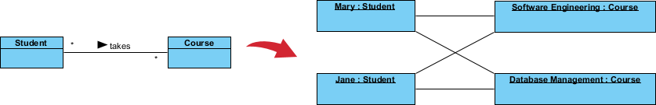

Aggregation Example - Computer and parts
- An aggregation is a special case of association denoting a "consists-of" hierarchy
- The aggregate is the parent class, the components are the children classes
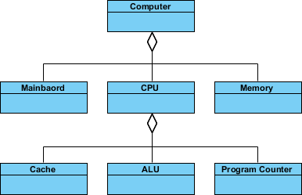

Inheritance Example - Cell Taxonomy
- Inheritance is another special case of an association denoting a "kind-of" hierarchy
- Inheritance simplifies the analysis model by introducing a taxonomy
- The child classes inherit the attributes and operations of the parent class.
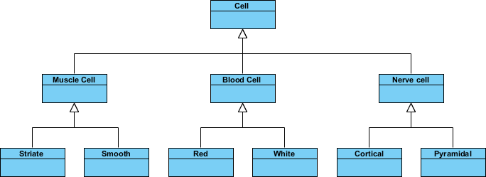

Class Diagram - Diagram Tool Example
A class diagram may also have notes attached to classes or relationships. Notes are shown in grey.
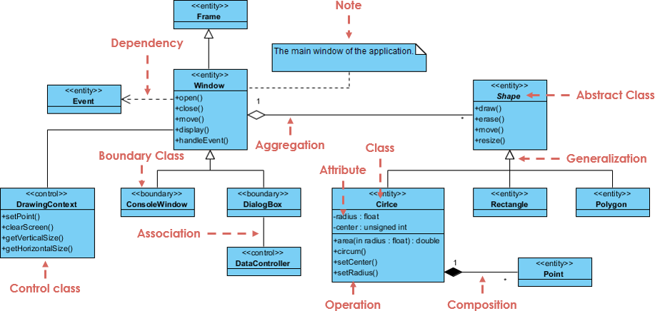
In the example above:
We can interpret the meaning of the above class diagram by reading through the points as following.
- Shape is an abstract class. It is shown in Italics.
- Shape is a superclass. Circle, Rectangle and Polygon are derived from Shape. In other words, a Circle is-a Shape. This is a generalization / inheritance relationship.
- There is an association between DialogBox and DataController.
- Shape is part-of Window. This is an aggregation relationship. Shape can exist without Window.
- Point is part-of Circle. This is a composition relationship. Point cannot exist without a Circle.
- Window is dependent on Event. However, Event is not dependent on Window.
- The attributes of Circle are radius and center. This is an entity class.
- The method names of Circle are area(), circum(), setCenter() and setRadius().
- The parameter radius in Circle is an in parameter of type float.
- The method area() of class Circle returns a value of type double.
- The attributes and method names of Rectangle are hidden. Some other classes in the diagram also have their attributes and method names hidden.

Dealing with Complex System - Multiple or Single Class Diagram?
Inevitably, if you are modeling a large system or a large business area, there will be numerous entities you must consider. Should we use multiple or a single class diagram for modeling the problem? The answer is:
- Instead of modeling every entity and its relationships on a single class diagram, it is better to use multiple class diagrams.
- Dividing a system into multiple class diagrams makes the system easier to understand, especially if each diagram is a graphical representation of a specific part of the system.

