 | EASTERN MEDITERRANEAN UNIVERSITY  SCHOOL OF COMPUTING AND TECHNOLOGY  DEPARTMENT OF INFORMATION TECHNOLOGY  COURSE POLICY SHEET | 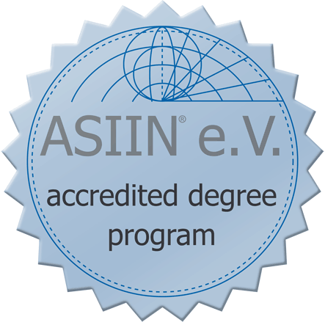

Course Code | ITEC 456 | Course Title | Applied Animation Techniques
Semester | 2017-2018 Spring | Language | English
Category | UE (University Elective) | Level | Third-Fourth Year
Workload | 180 Hours | Teaching Format | 3 Hours Lecture, 2 Hours Laboratory
EMU Credit | (2,3,0) 3 | ECTS Credit | 6
Prerequisite(s) | - | Course Web | http://staff.emu.edu.tr/hasanoylum

Instructors(s) | Senior Instructor Hasan Oylum
e-mail(s) | hasan.oylum@emu.edu.tr | Office No: | CT118

Course Description
Creating Mouse Tools. Pop-Up Windows in Graphics. Creating pop-up windows. Interactive Drawing Tools. A CAD Program. (Two, Three)-Dimensional Graphics. Solid Modeling. Use of Ready Graphics Tools to develop animations. Current and future trends in animations.

General Learning Outcomes
On successful completion of this course students should be able to:
- Use movie essentials such as “Authoring environment, Timeline, Frames, Layers and Scenes”.
- Standardized on the use of toolbox to design a model for animating the designed objects.
- Analyse how to create movie symbols and the use of built-in library symbols.
- Do and managing the content on the stage, such as transforming objects, stacking orders etc..
- Practiced on the use of colors to manipulating objects and essentials of importing and using bitmaps.
- Analyse the use of animation techniques, such as: Motion tweening, shape tweening, masking
- Expert on, the use of ActionScript on animations.
- Capable of how to integrate sounds on animations.
- Standardized on animations and their Internet applications.
- Practiced and using their knowledge on a project, such as game development or a multimedia profile for a company etc..

Teaching Methodology / Classroom Procedures
- Course will be given to the student interactively in the lab hour
- This course has highly practical applications
- All the lectures, labs, quizzes, etc. will be in front of the computer
- Students should attend to the labs just on time and regularly, 60 % absenteeism will automatically failed the student
- Students are responsible to develop a term project and present it at the end of the semester
- During the exam surfing through the internet or cheating with your friend (talking, sharing files, documents, etc. are strictly forbidden)
- Instructor Home Page, http://sct.emu.edu.tr/oylum must frequently be visited for the course announcements, the exam/quiz results, etc.

Course Materials / Main References
Text Book:
Jim Shuman, Adobe® Flash® CS5 Revealed, DELMAR CENGAGE Learning, 2011.
Resource Books:
- Jim Shuman, Macromedia Flash 8 Revealed, Thomson Course Technology, 2006.
- Sham Bhangal, ActionScript for Flash MX 2004, an Apress Company., 2004.
- E-book: Flash 8 Projects for Learning Animation and Interactivity.
- James D. Foley, Andries van Dam, Steven K. Feiner, John F. Huges, Computer Graphics: Principles and Practice, Addison-Wesley Publishing Company Inc., 1990.
- Sham Bhangal, Amanda Farr, Patrick Rey, Foundation Flash 5, Friends of ED, 2000.
Lecture Notes:
All lab applications will be published through the internet as an *.fla files (Use winrar to get flash samples).

Weekly Schedule / Summary of Topics
Week 1 | Introduction: Graphics environment, movie essentials and animation techniques
Week 2 | Introduction to graphics environment and movie essentials: Keyframe, Motion Tween, Timeline, Frames, Layers, Scenes
Week 3 | The use of symbols: Graphic, button, movie clip symbols and libraries
Week 4 | Managing content on the stage: Grouping and transforming objects
Week 5 | Animation Techniques on: Fonts, Colors and Text processing
Week 6-7 | Basic Animations: Motion tweening and motion guide techniques, Shape tweening techniques, Masking with text and bitmaps
Week 7-8 | Midterm Examinations Week
Week 9 | Actions and interactions: Creating animated buttons and ActionScripts
Week 10 | Applications on Action Scripts: Intelligent actions
Week 11 | The use of sounds and videos on the stages of animation
Week 12 | Flash and the Internet, Web page Preparation & Publishing a movie
Week 13-14 | Intermediate ActionScript and futures cape  Term Project Presentation and Submission
Week 15-17 | Final Examinations Week

Requirements
- Each student can have only one make-up exam. One who misses an exam should provide a medical report within 3 days after the missed exam. The make-up exam will be done at the end of the term and will cover all the topics. No make-up exam will be given for the quizzes.
- Students who do not pass the course and fail to attend the lectures regularly may be given NG grade.
- Students are responsible from every subject that will be covered in the lab.
- Students have to be ready for the practical quizzes; no make up will be given to the practical quizzes. But one of the worst quizzes will be eliminated.
- Students should attend to the labs and quizzes just on time regularly and submit their quiz results and projects.
- Within the first two weeks each students are expected to choose a term project topics from the published list and register their topic through the assistant
- Students are responsible to develop a term project and present it at the end of the semester
- During the exam surfing through the internet or cheating with your friend (talking, sharing files, documents, etc.) are strictly forbidden.
- Instructor Home Page, http://sct.emu.edu.tr/oylum must frequently be visited for the course announcements, the exam/quiz results, etc.
- Tutorials will be organized on animation techniques by using Adobe Flash CS5.

Method of Assessment
Evaluation and Grading | Project | Quizzes (Practical) | Midterm Exam | Final Exam
Percentage | 20 % | 20 % | 20 % | 40 %

