EASTERN MEDITERRANEAN UNIVERSITY
Department of Industrial Engineering
IENG212/MANE212 Modelling and Optimization
HOMEWORK 3 Spring 2021-22

- A company has three production facilities S₁,S₂ and S₃ with production capacity of 17,19 and 18 units (in 100s) per week of a product, respectively. These units are to be shipped to four warehouses D₁, D₂, D₃, and D₄ with requirement of 15, 6, 17 and 14 units (in 100s) per week, respectively. The transportation costs (in $) per unit between factories to warehouses are given in the table below:
Replace the Y=The summation of the all digits in your student number X=the summation of three last digits of your student number in the following transportation problem and find an initial feasible solution by Vogel approximation method.

 | D₁ | D₂ | D₃ | D₄
S₁ | 19 | 30 | 60 | Y | 44
S₂ | 72 | 20 | 40 | 15 | 38
S₃ | X | 18 | 60 | 20 | 28
 | 18 | 31 | 17 | 24

- Formulate this transportation problem as an LP model to minimize the total transportation cost.
- Draw the graph of the problem.
- Fine a feasible solution using Northwest and minimum-cost methods.
- Compare the starting solutions obtained by the northwest-corner, least-cost and Vogel method for the following model.
 | D₁ | D₂ | D₃ | Supply
S₁ | 6 | 3 | 1 | 7
S₂ | 2 | 3 | 5 | 3
S₃ | 2 | 8 | 9 | 9
Demand | 5 | 4 | 11

- A carwash employs workers on daily price-rate basis for their weekly work. There are five worker and their charges and speed are different (Table 1). According to an earlier understanding only one job is given to one worker and the worker is paid for a full hour even if he works for a fraction of an hour. There are five rent a car firms which each worker should wash the cars of one these firms. The number of received car from each of the mentioned firms is in Table 2.
Table1 Table2
Worker | Rate per day $ | No of cars washed/day |  | Firms | No of received cars
A | 50 | 12 |  | 1 | 50
B | 60 | 14 |  | 2 | 85
C | 30 | 8 |  | 3 | 70
D | 40 | 10 |  | 4 | 124
E | 40 | 11 |  | 5 | 84

- A large oil company operating a number of drilling platforms in the North Sea is forming a high speed rescue unit cope with emergency situations which may occur. The rescue unit comprises 6 personal who, for reasons of flexibility, undergo the same comprehensive training program. The six personnel are assessed as to their suitability for various specialist tasks and the marks they received in the training program are given in the following table:
Trainee Number
Specialist Task | I | II | III | IV | V | VI
Unit Leader | 21 | 5 | 21 | 15 | 13 | 28
Helicopter Pilot | 30 | 11 | 16 | 8 | 16 | 4
First Aid | 28 | 2 | 11 | 16 | 25 | 25
Drilling Technology | 19 | 16 | 14 | 15 | 18 | 8
Firefighting | 26 | 21 | 22 | 28 | 29 | 24
Communications | 3 | 21 | 21 | 11 | 26 | 26

- Show that the number of the feasible solution for an assignment problem is equal to n!, where n is the number of jobs and persons.

- Write the associated linear programming problem for the following network flow problem. | 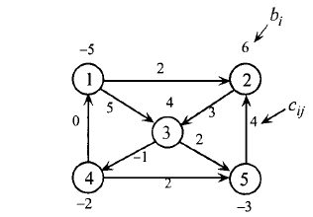
- Draw a network regarding the following linear programming problem.
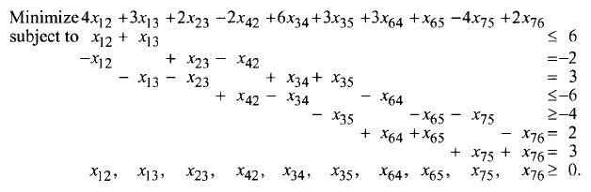
= 6
= -2
= 2
= -6
= -4
= 2
= 2
≥0

- Suppose that the following figure represents a railroad network. The numbers beside each arc represent the time it takes to traverse the arc. Two locomotives are stationed at point 2 and three locomotives are at point 3. One locomotive is needed at point 5 and 4 locomotives are needed at point 6. Formulate the problem to get the power required to points 6 and 5 with minimum cost.
6
2
2
2
5
3
1
1
3
1
2
4
6
4
4

- Find the minimum spanning tree in the following graph. Write the related Dynamic linear programming problem when C={0,3,5} the (23 points)

