ITEC 113 Algorithms and Programming Techniques Lab 2 (Leture 2 Exercises)

Task 1 Read a number from keyboard and print twice that number on screen
Desired output:
Please enter a number :
10
The result is : 20
Note: The values shown in blue font are entered from the keyboard
AAnalysis
Input: num
Process: result2*num Output : result
AAlgorithm
Flowchart | Pseudocode
Display “Please Enter a number” Input num result ←2*num
Display result
• | We need to declare two variables : num and result
• | We assume the user  will enter only integer numbers and twice an integer is another integer. Therefore data type of these variables is INT

Task 1 Continued
CC Program
#include ....
{

}

Ooutput:
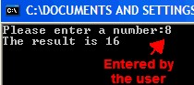
Task 2: Read a number (cgpa) from keyboard. If the number is greater than or equal to 2.00, display ‘Pass’.
D
D
D
e
e
e
s
s
s
i
i
i
r
r
r
e
e
e
d
d
d
O
O
O
u
u
u
t
t
t
p
p
p
u
u
u
t
t
t
:
:
:
Alternatively
Please enter
your cg
pa
:
1.25
Please enter
your cgpa
:
2.82
Pass
Note: The values shown in blue font are entered from the keyboard
AAnalysis
Input: cgpa
Process: Check if cgpa> 2.00 print “pass” Output : “Pass”
Algorithm
Flowchart | Pseudocode
start  “Pass”  End  cgpa  Cgpa>2.00  No  “Please enter  your cgpa”  Yes | Display “Please enter your cgpa”  Input cgpa  If cgpa >= 2.00  Display “Pass”  End if;

Task 2 Continued
C

C Program
#include...
{
}

Output:

User enters a number that is less than 2.00
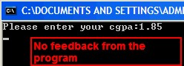

Alternative Input : User enters a number that is greater than, or equal to 2.00
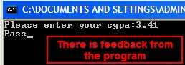
Task 3: Read a number (cgpa) from keyboard. If the number is greater than or equal to 2.00, display ‘Pass’, otherwise display ‘Fail’.
D
D
D
e
e
e
s
s
s
i
i
i
r
r
r
e
e
e
d
d
d
O
O
O
u
u
u
t
t
t
p
p
p
u
u
u
t
t
t
:
:
:
Alternative 3
Alternative 2
Alternative 1
Please enter
your cgpa
:
1.25
Fail
Please enter
your cgpa
:
2
.25
Pass
Please enter
your cgpa
:
3
.25
Pass
Note: The values shown in blue font are entered from the keyboard

Analysis
Input: cgpa
Process: Check if cgpa>= 2.00 print “pass”, otherwise print “fail” Output : “Pass” or “Fail”
AAlgorithm
Flowchart | Pseudocode
start  “Pass”  End  cgpa  Cgpa>2.00  “Fail  No  “Please enter  your cgpa”  Yes | Display “Please enter your cgpa”  Input cgpa  If cgpa >= 2.00  Display “Pass”  Else  Display “Fail”  End if;
CC Program
#include.....
{
}

O

output:

User enters a number that is less than 2.00
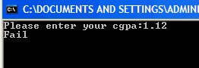

Alternative Input: User enters a number that is greater than or equal to 2.00
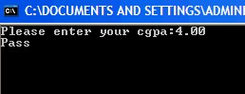
Task 4: Read a number (cgpa) from keyboard. If the number is greater than or equal to 3.00 display ‘Honor student’, if the number is less than 3.00 but greater than 2.00, display ‘Pass’, otherwise display ‘Fail’.
D
D
D
e
e
e
s
s
s
i
i
i
r
r
r
e
e
e
d
d
d
O
O
O
u
u
u
t
t
t
p
p
p
u
u
u
t
t
t
:
:
:
Alternative 3
Alternative 2
Alternative 1
Please enter
your cgpa
:
1.25
Fail
Please enter
your cgpa
:
2
.25
Pass
Please enter
your cgpa
:
3
.25
Honor Student
Note: The values shown in blue font are entered from the keyboard
Analysis
Input: cgpa
Process: Check if cgpa>= 2.00 print “pass”, otherwise print “fail” Output : “Pass” or “Fail”

Algorithm
Flowchart | Pseudocode
start  “Fail”  End  cgpa  Cgpa>3.00  No  “Honor  Student”  Yes  Cgpa>2.00  “Pass”  Yes  “Please enter  your cgpa:”  No | Display “Please enter your cgpa”  Input cgpa  If cgpa >= 3.00 then  Display “Honor Student”  Else if cgpa >= 2.00 then  Display “Pass”  Else  Display “Fail”  End if;
C Program
#include
{

}
Ooutput:

User enters a number that is greater than or equal to3.00
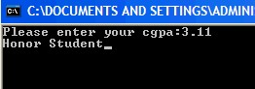

Alternative Input: User enters a number that is less than 3.00 but greater than or equal to 2.00
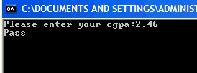

Alternative Input: User enters a number that is less than 2.00
