Attacks on Passwords
Dictionary attack
For the English language, there are less than 50000 common words, 1000 common human first names, 1000 typical pet names, and 10000 common last names. There are only 36525 birthdays and anniversaries for almost all living humans on the planet. So, an attacker can compile a dictionary of all these common passwords of fewer than 100000 entries.
Secure passwords
Number of possible 8-character passwords on a typical American keyboard is 94^8=6*10^15, trying of such number of passwords is infeasible
Complex passwords is difficult to remember
It is recommended to have at least 8 symbols, including letters, digits, special signs, and different case symbols (upper and lower)
Social Engineering
The three B’s of espionage – burglary, bribery, and blackmail – apply equally well to computer security. Together with trickery we get one of the most powerful attacks against computer security – social engineering.
Pretexting
Eve calls a helpdesk and tells that she has forgotten her password, when she is actually calling about the account of someone else, say, Alice. The helpdesk agent may ask Eve a few personal questions about Alice, which, if Eve has done her homework, she can answer with ease.. Then the agent resets the password for Alice’s account and gives Eve the new password. This attack does not any hardware or software but very effective.
Baiting
It involves using some kind of “gift” as a bait to get someone to install malicious software. For example, an attacker could leave a few USB drives in the parking lot of a company with an otherwise secure computer system, even marking some with the names of popular software programs or games. The hope is that some unsuspecting employee will pick up a USB drive on his lunch break, bring it into the company, insert it into an otherwise secure computer, and unwittingly install the malicious software.
Quid Pro Quo
Latin “something for something”. For example, an attacker, Bob, might call victim, Alice, on the phone saying that he is a helpdesk agent who was referred to Alice by a coworker. Bob then asks Alice if she has been having any trouble with her computer or with her company’s computer in general. Or he could ask Alice if she needs any help in coming up with a strong password now that it is time to change her old one. In any case, Bob offers Alice some legitimate help. He may even diagnose and solve a problem she has been having with her computer. This is the “something” that Bob has now offered Alice, seemingly without asking for anything in return. At that point, Bob then asks Alice for her password, possibly offering to perform future fixes or offering to do an evaluation of how strong her password is. Because of the social pressure that is within each of us to want to return favor, Alice may feel completely at ease at this point in sharing her password with Bob in return for his “free” help. If she does so, she will have just become a victim of the quod pro quo attack.
Vulnerabilities from programming errors
The classic buffer overflow attack injects code into a running application by exploiting the common programming error of not checking whether an input string read by the application is larger than the variable into which it is stored (the buffer). Thus, a large input provided by the attacker can overwrite the data and code in the application performing malicious actions specified by the attacker.

Malicious software
  - Insider attacks
    - Backdoors
Backdoors inserted for debugging purposes: some special key combinations allowing a developer getting access to the system variables. Backdoors may be intentionally left by developers for the next malicious accesses. Easter eggs are some not declared functionalities which might be deliberately made by developers.
    - Logic bombs
Is a program that performs a malicious action as a result of a certain logical condition (e.g., developer is not paid money for his work).
    - Defenses from insider attacks
- Avoid single point of failure. Let no one person be the only one to create backups or manage critical systems
- Use code-walk-through. Source code shall be available and analyzed versus specification
- Use archiving and reporting tools. When a program code is archived, it can be analyzed by managers (after automatic digesting), and it becomes harder for a team member to avoid the existence of malware source code to go undiscovered after an attack
- Limit authority and permissions. Use a least privilege principle
- Physically secure critical systems
- Monitor employee behavior. Be especially on the lookout for system administrators and programmers that have become disgruntled
- Control software installations. Limit new software installations to programs that have been wetted and come from reliable sources
  - Computer viruses
    - Virus definition
It is a code that can replicate itself by modifying other files or programs to insert code that is capable of further replication. Viruses phases of execution:
- Dormant phase: it is existing but lays low avoiding detection
- Propagation phase: replication is made
- Triggering phase: some logical condition causes virus performing payload, or transition from phase to phase
- Action phase: payload execution
    - Virus types
- Program virus (file virus)
- Macrovirus
- Boot sector virus
    - Defenses against viruses
Virus signatures
Virus detection and quarantine
    - Encrypted viruses
They may be discovered by checking for decryption code
    - Polymorphic/metamorphic viruses
They modify themselves using different encryption keys (polymorphic) or reordering code instructions (metamorphic)
  - Malware attacks
    - Trojan horse attack
Looking innocent programs attractive for a user but having undeclared functionality
    - Computer warms
Is a program that spreads copies of itself without the need to inject itself into other programs, and usually without human interaction. They typically spread by exploiting vulnerabilities (e.g., buffer overflow) in applications run by Internet-connected computer systems that have a security hole. Once a system is infected, a warm must make steps to ensure that it persists on the victim machine and survives rebooting. On Windows machines, this is commonly achieved by modifying the Windows Registry, a database used by the operating system that includes entries that tell the operating system to run certain programs and services or load device drivers on system startup. One of the most common registry entries for this purpose is called
HKEY_LOCAL_MACHINE\SOFTWARE\Microsoft\Windows\CurrentVersion\Run
Associating with this entry the path to the executable file of the warm will result in Windows executing the worm on startup. Thus, malware detection software always checks this entry (and other registry entries specifying programs to run at startup) for suspicious executable names Fig. 1.
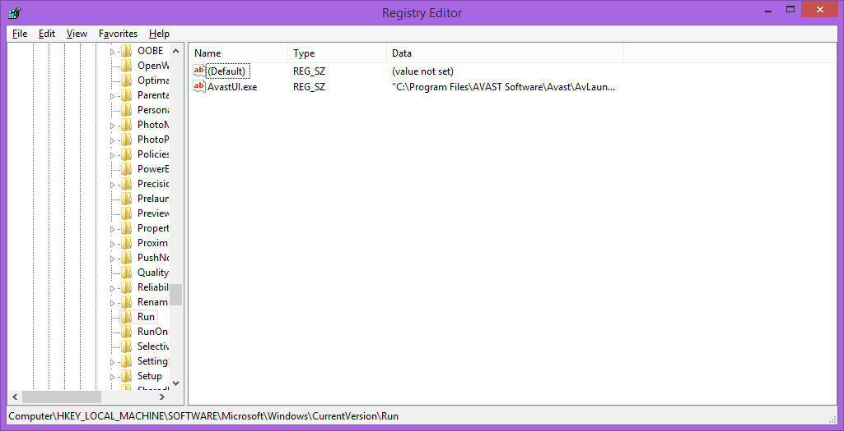
Fig. 1. Screenshot of regedit output of HKEY_LOCAL_MACHINE\SOFTWARE\Microsoft\Windows\CurrentVersion\Run
Detecting of worms is similar to detecting viruses. In addition, network-level scanning and filtering that analyze the content of network packets before they are delivered to a machine, allows to detect and lock worms in real time.
    - Rootkits
It Is an especially stealthy type of malware. Rootkits typically alter system utilities or the operating system itself to prevent detection. For example, a rootkit that infect the Windows Process Monitor utility, which lists currently running processes, could hide by removing themselves from the process list. Likewise, a rootkit might hide files on disk by infecting utilities that allow the user to browse files, such as Windows Explorer. Rootkits are often used to hide the malicious actions of types of malware, such as Trojan horses and viruses.
Concealment
Rootkits employ several techniques to achieve stealth. Software can either run in user-mode, which includes ordinary program execution, or kernel-mode, which is used for low-level, privileged operating system routines. Accordingly, rootkits may operate in either of these two modes.
Some user-mode rootkits work by altering system utilities or libraries on disk. While this approach may be the simplest, it is easily detected. Because checking the integrity of files can be performed offline by using a cryptographic hash function, as detailed below. Other user-mode rootkits insert code into another user-mode process’s address space in order to alter its behavior, using technologies such as DLL injection, http://resources.infosecinstitute.com/using-createremotethread-for-dll-injection-on-windows/ . Anti-rootkit software running at the kernel level may detect such rootkits.
Kernel-mode rootkits are considered more difficult to detect, because they work at the lowest levels of the operating system. Kernel rootkits in Windows are typically loaded as device drivers, because the device driver system is modular – it allows users to load arbitrary code into the kernel.
Once rootkit code is loaded into the kernel, several techniques may be employed to achieve stealth. One of the most common methods is known as function hooking. Because the rootkit is running with kernel privileges, it can directly modify kernel memory to replace operating system functions with customized versions that steal information or hide the existence of the rootkit. For example, a rootkit might replace a kernel function that enumerates files in a directory with a nearly identical version that is designed to skip over particular files that are part of the rootkit. This way, every program that uses this function will be unable to detect the rootkit. Kernel function hooking is powerful in that rootkit developers only have to alter one function, as opposed to patching every system utility that lists directory contents.
Another kernel-mode rootkit technique involves modifying the internal data structures the kernel uses for bookkeeping purposes. For example, the Windows kernel keeps a list of information on the device drivers that are currently loaded into memory. A rootkit might modify this data structure directly to remove itself from the list and potentially avoid detection. A rootkit that performs this action may be difficult to remove.
Once a system is infected, a rootkit must take steps to ensure that it persists on the victim machine and survives rebooting, including the modification of appropriate entries in the Windows Registry. Since anti-rootkit software searches the registry for suspicious entries, to avoid detection, some rootkits modify the kernel functions that list registry entries. This is an example of the arms race that takes place between rootkit and ant-rootkit software which are constantly engaged in a complex game of hide-and-seek.
Detecting rootkits
User-mode rootkits can be detected by checking for modifications to files on disk. On Windows, important code libraries are digitally signed, so that any tempering would invalidate the digital signature and be detected. Another commonly employed technique is to periodically compute a cryptographic hash function for critical system components while the system is offline. This hash can be recomputed while the system is online, and if the hashes do not match, then a rootkit may be altering these files. In addition, kernel-mode anti-rootkit software can detect code injection in system processes.
Kernel-mode rootkits can be more difficult to detect. Most anti-rootkit applications detect kernel rootkits by searching for evidence of techniques such as function hooking. Such rootkit detectors may keep signatures of certain kernel functions that are likely to be targeted by rootkits, and inspect kernel memory to determine if any modifications have been made to this functions. However, because kernel rootkits operate at the highest level of system privileges, they may preemptively detect anti-rootkit software and prevent it from achieving its goals. Therefore, sometimes an in-depth offline analysis of an infected system, including inspection of the registry and boot records, is required to defeat rootkits.
Given the difficulty of guaranteeing the removal of rootkits, users are often advised to reformat their hard drive on suspicion of infection, rather than risking continued compromise by failing to remove all traces of rootkit activity.
Zero-day attacks
They use vulnerabilities that have not been known to the software developers. To detect such attacks, potentially dangerous actions of programs (deletion and modification of files, Internet activity) cause alerts to users, so that they decide whether these are legitimate or not. It is as a program runs in a virtual machine, or sand-box.
    - Botnets
Networks of compromised computers are known as botnets, their owners as bot herders. Botnets can contain several million compromised machines.
One of the key properties of a botnet is a central command-and-control mechanism. Once bot software is installed on a compromised computer via a worm, Trojan horse, or some other malware package, the infected machine, known as zombie, contacts a central control server to request commands. To avoid detection, command servers use dynamic IPs and unexpected channels to send commands (e.g., Twitter, Instant Messaging).
Botnets may be used for credit card numbers stealing, sending of spam, DDoS attacks, etc.
  - Privacy invasive software
    - Adware
Typically, an adware program is installed on a user’s computer because he visits an infected web-page, opens an infected e-mail attachment, installs a shareware or freeware program that has the adware embedded in it.
    - Spyware
Collects passwords, monitors keystrokes, captures screen, tracks cookies

