Term Project Task “Secure Teams-Like System”
CMSE-353 “Security of Software Systems”
Fall-2023, posted 19.10.2023
- The Term Project concerns developing Secure Teams-Like System (STLS) having actors: Student, Teacher, and System Administrator. System Administrator introduces new users and grants/revokes their privileges. Teachers can create groups (teams) of students, assign students and teachers to them. Teachers can create channels in the teams. Channels are used for the broadcast communication. Information is stored DES-encrypted. Secret keys are created/periodically updated by System Administrator. Users can see teams they are assigned to or created by them. Users can communicate via chat. Appearance of STLS is expected resembling Teams:
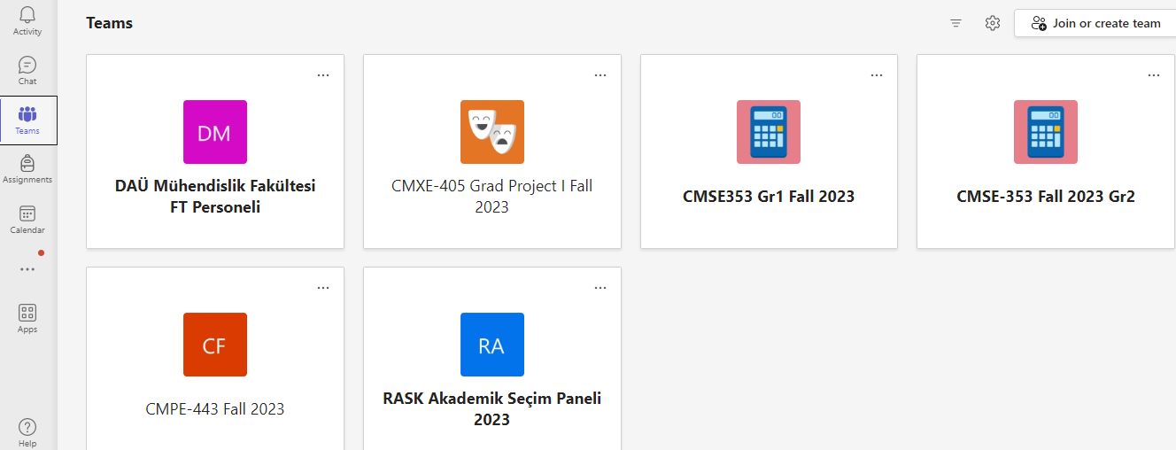 | 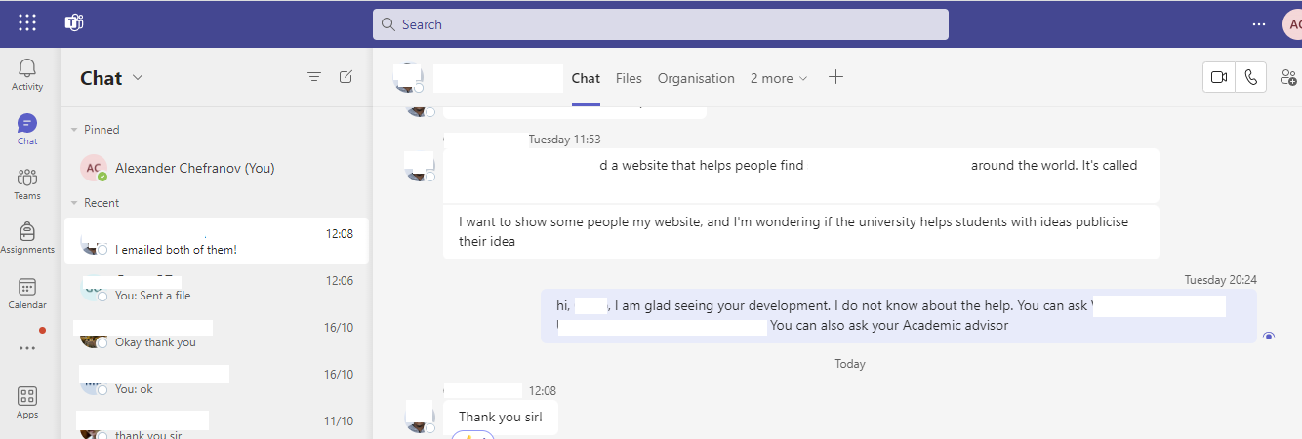
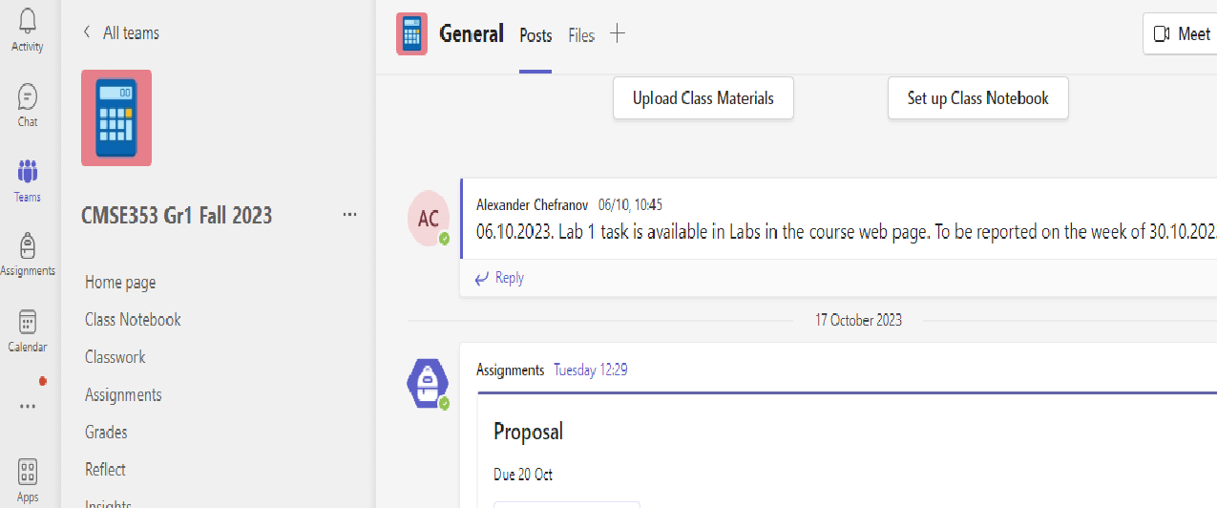 | 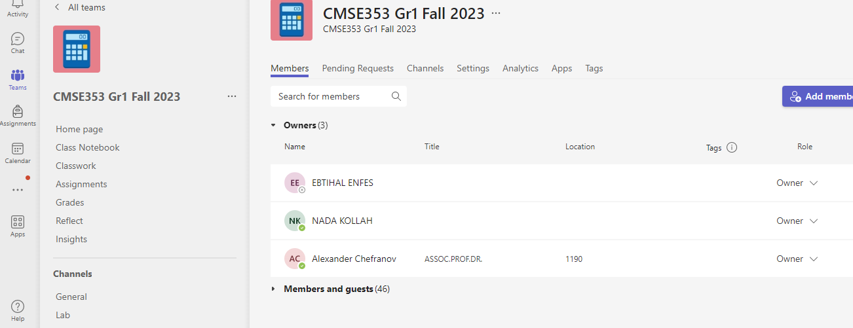

- Term project will be made by the teams established for Labs.
- Implement solution of your problem as a software application using any appropriate tools. You may reuse your Lab codes.
- Conduct tests with your application to validate its correctness
- Prepare (in Word) a report on your assignment having:

- Cover page
- outline,
- problem definition,
- description of work breakdown and task distribution between team members,
- description of algorithm for solving your problem,
- description of database structure designed
- description of tools you used for implementation of your problem and the details of their installation and preparation for usage
- description of the developed program (parts of the program referencing to Appendices: item 13), their explanation, ways of their interaction, synchronization, etc.)
- user guide (how to use your program – what and where should be installed, launched, how it should be interpreted)
- description of conducted tests and their results with screenshots of the runs
- conclusion
- references on used sources (books, articles, web-sites, etc.)
- Appendices with the most important code explained in the main part: item 8).
- The report shall be printed, and, additionally, a Zip-file having all the Term Project-related materials (doc-file with your report, sources and executables of your application, results of your tests, and instructions how to use your program) shall be uploaded in the Teams Assignment to be defined later. It shall be possible to install and run your program from the zip-file provided.
- Printed reports shall be handed to Lab Coordinator Nada Kollah and uploaded to Teams latest by 25.12.2023, Monday, 16.00. Later submission will be penalized (2 points/working day).
- Defense of your working applications will be arranged in the period 26.12-29.12.2023. Presentation time will be specified on the report submission. The report will be assessed out of 8 points, and 12 points – for presentation of the working application and its explanation

