# CMSE 443 Lab 4

# Dynamic Images (weeks of May 4-18, 2020; due date May 18, 2012)

In this Lab you are to write a program providing output of dynamic graphical image of a cart with inverted pendulum similar to the one shown in the Fig. below (do not show l,y,u,, sizes, directions, axes shown in Fig.)

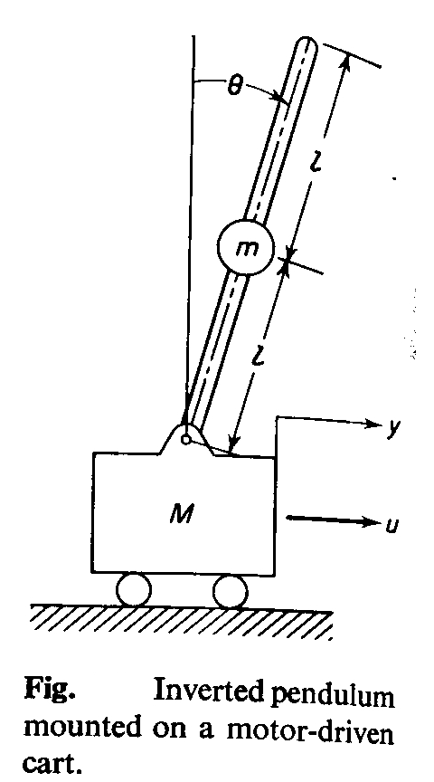

**Lab Task:**

Write a program which shall provide

1. Graphical output of the cart with inverted pendulum on the screen
2. Interface allowing a user to move the cart with the pendulum as a whole rightward and leftward (keys Right-Arrow, Left-Arrow, respectively), and rotate pendulum without moving of the cart (Up-Arrow, LeftShift-Down-Arrow – to descend counter-clockwise, RightShift-Down-Arrow – to descend clockwise).
3. Each key-stroke leading to 1-step modification of the current state (for example, 1 click on Left-Arrow button moves the cart by 5 pixels leftward – if the step is 5 pixels; 1 click on Up-Arrow button rises pendulum by the angle of 50 – if the step is 50)

**Defense of the Lab:**

You shall be able to show developed working product to the evaluator and explain

* what was done,
* what for it was done,
* how it was done.

Write a report on the Lab explaining your work done.

**Report shall be prepared by a team. A zipped file with all Lab-related materials (report, sources, executables, etc.) shall be given to the evaluator.**

**Both the answers and the report will be graded.**

**Due date for the report submission – 18.05.2020, Monday, 16.30, Microsoft Team ~~CMPE137~~.**