ITEC397 Chapter 07 LABWORK
- An example for a Compiler Error
- Open a macro-enabled Excel sheet, go to developer Tab, open the Visual Basic editor, if it is not created, create a module (module1)
- Create a sub routine named example_07_01
- Write the code (infinite loop) and run it to see the “Compiler Error” you have done.
Sub example_07_01
X=2
Do Until x=9
X = X +1
MsgBox “X=” & X
End Sub
- Here, we used Do Until statement but missed to end it with Loop statement.
- Modify the code as it is given below and re-run it
Sub example_07_01
X=2
Do Until x=9
X = X +1
Loop
MsgBox “X=” & X
End Sub
- An example for a Runtime Error
- Create a sub routine named example_07_02
- Write the code (infinite loop) and run it to see the “Runtime error” you have done.
Sub example_07_02
X=2
MsgBox X / (X - 2)
End Sub
- Modify the code as it is given below and re-run it
Sub example_07_02
X=2
MsgBox X / (X + 2)
End Sub

- An example for a Logical Error and debugging of it
- Create a sub routine named example_07_03
- Write the code (infinite loop) and run it to see the system will never finish it is a Logic error.

Sub example_07_03
X=2
Do Until x=1
X = X +1
Loop
End Sub
- Break the program with pressing Ctrl-Break buttons. When the Code execution has been interrupted window appear, click the Debug button (Instant watch Mode).
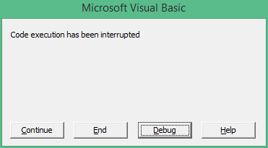
- With pressing F8, statement by statement you can run your code, and if you bring the cursor on any variable, you can learn the current value of it.
- Drag the yellow arrow on to the statement as x=2, check the current value of the x, then execute that statement (F8) and re-check the current value of the X.
- You can stop the execution completely by clicking Reset button, or restart your code with Run (F5) button.

- An example for using Stop Statement for debugging
- Copy-Past the content of the example_07_03 as a new subroutine example_07_04
- Modify it as it will be as the given code below.
Sub example_07_04()
x = 2
Do Until x = 1
x = x + 1
Stop
Loop
End Sub
- Run your code. With clicking F8 execute the statements step by step.

- Using the Watch Window in debugging
  - With Calling Debug Add watch bring the following configuration window, and enter the variable name x into the Expression field and click OK.

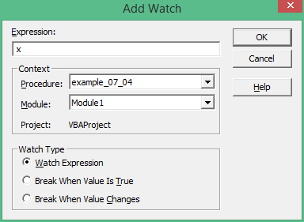
  - On the bottom most part of the screen Watch panel have to be appear.
  - Run the code of example_07_04 and follow the variable X.

- Example for Single Stepping
  - Open the exercise example_07_03
  - Click the statement “Loop”, and then press CTRL+F8, that will run all statements above until the statement “Loop” (where the cursor was on)

- Example of using Call Stack Dialog in debugging
- Create a sub routines example_07_05, f_assign(), and f_add() with the code given below
Sub t_assign()
x = 2
End Sub

Sub t_add()
x = x + 1
End Sub
Sub example_07_05()
t_assign
Do Until x = 1
t_add
Loop
End Sub
  - Put a break on the statement Loop, run the code in stepwise until it will come on the subroutine t_add, then press Ctrl-L to open the Call-Stack window to see, t_add is the current subroutine which is called by example_07_05 (It is still uncompleted task).

