

**E**astern **M**editerranean **U**niversity

**D**epartment of **M**echanical **E**ngineering

**L**aboratory **H**andout

### COURSE: Thermodynamics II (MENG246)

**Semester: Spring 2017-2018**

**Name of Experiment: Air Conditioning**

**Instructor: Assist. Prof. Dr. Devrim Aydın**

**Lab Assistant: Mohamed Alibar**

Submitted by:

Student No:

Group No:

Date of experiment:

Date of submission:

----------------------------------------------------------------------------------------------------------

**EVALUATION**

|  |  |  |
| --- | --- | --- |
| **Activity During Experiment & Procedure 30 %** | |  |
| **Data &Results 35 %** | |  |
| **Discussion, Conclusion & Answer to the Questions 30 %** | |  |
| **Neat and tidy report writing 5 %** | |  |
| **Overall Mark** |  | |

**Name of evaluator:**

**OBJECTIVE:**

Find the change in the relative humidity of air with simple heating.

**GENERAL DESCRIPTION:**

The Hilton Air Conditioning Laboratory Unit has been designed to demonstrate the basic principle of Air Conditioning, i.e. how heat and moisture can be added to or abstracted from a moving stream of air and hence allow the control of environment and comfort levels.

A variable speed fan blows air through a 254mm square ducting. Both heating and cooling sections are incorporated. Heat being added by electric resistance elements whilst a vapour compression refrigerant circuit abstracts heat and, within certain limits, moisture as well. Moisture can be added by the injection of steam.

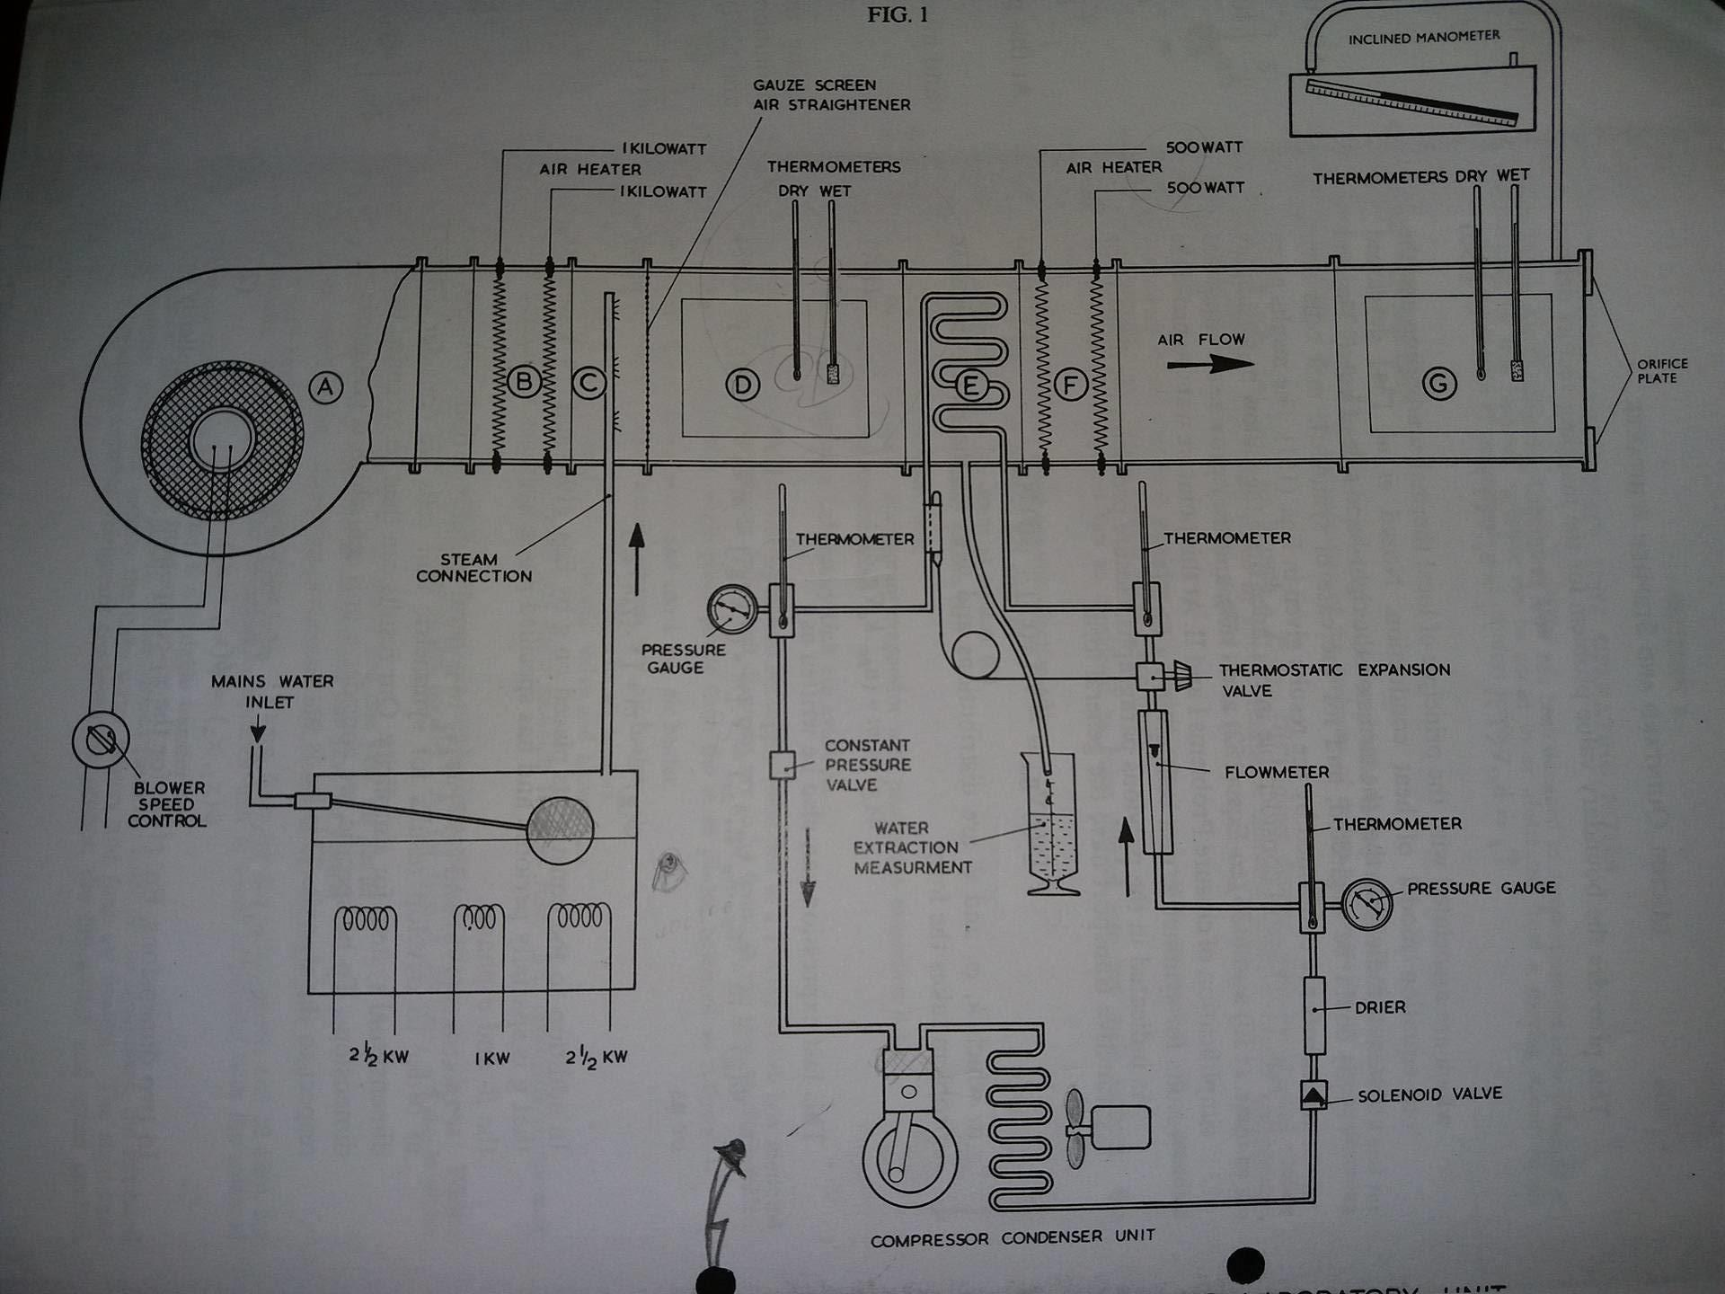

**DISCUSSION AND CONCLUSION**

The aim is to determine the change in relative humidity from psychrometric chart and compare it with the value which is evaluated from equation 1. Please denote the value of on the attached psychrometric chart.

 (1)

In order to increase the accuracy of the experiment, please employ given data.

T1=15oC

T2=40oC

=60%

