About EMU
INSERT PHOTO HERE !!! (state-university.jpg)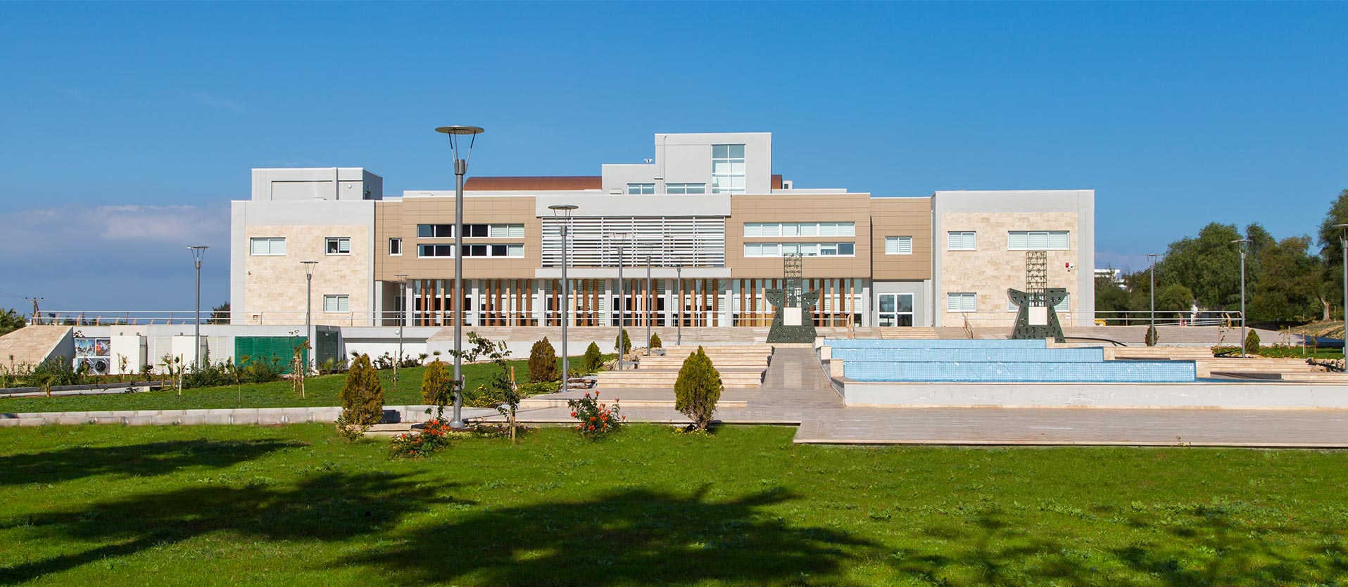
International Career
Having been providing higher education in TRNC since 1979 with all programs accredited by the Turkish Higher Education Council (YÖK), Eastern Mediterranean University is the only state university in TRNC.
With its highly developed infrastructure, prominent academic staff members, 16,000 students from 110 and 1,100 academics from 35 different countries, quality programs in English, the opportunity of learning a second foreign language, student exchange programs, rich sports, social and cultural activity opportunities, international accreditations, an international teaching context, and a diploma recognised throughout the world, EMU prepares its students for their international careers by educating them in becoming creative and competitive individuals with entrepreneurial skills.

EMU has been offering quality education through 107 undergraduate and school programs and 103 postgraduate and doctoral degree programs provided by 12 faculties, 4 schools and Foreign Languages and English Preparatory School.
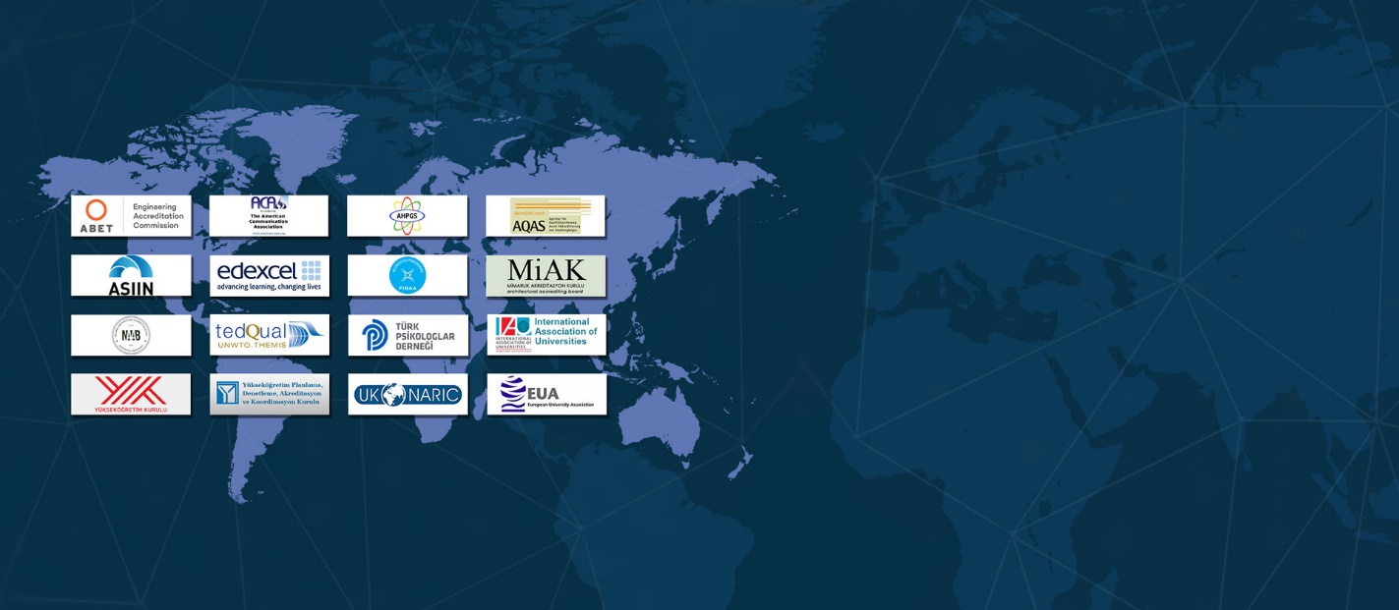
INSERT PHOTO HERE !!! (accreditations.jpg)
Education at International Standards
Closely following the national standards and rules and paying special attention to quality in education, our University sees international accreditation and supervision as a foundation for development.
EMU is a full member of the International Association of Universities, the European University Association, Community of Mediterranean Universities and the Federation of the Universities of the Islamic World. Giving special importance to international recognition, EMU has received the accreditation of various prominent international accrediting bodies. EMU is only one of five universities in the region to have been awarded the prestigious ABET (Accreditation Board of Engineering and Technology) in the field of engineering.
Similarly, EMU Architecture Faculty holds the MİAK accreditation. Business and Economics Faculty, Tourism Faculty and School of Computing and Technology have been granted the accreditation of FIBAA. Education Faculty English Language Teaching (ELT) Department was accredited by AQAS. Additionally, EMU School of Tourism and Hospitality Management gained the accreditation of TEDQUAL and the Computer Technologies and Information Systems offered by School of Computing and Technology (SCT) successfully passed ASIIN accreditation process. EMU Foreign Languages and English Preparatory School has successfully obtained EDEXCEL accreditation. Last but not least, our University’s Business and Economics Faculty is a full member of EFMD and AACSB along with only three universities in Turkey.
INSERT PHOTO HERE !!! (the.jpg)
Listed Among the Best Universities in the World
The publisher of widely-referenced university rankings in the world, U.K. -based Times Higher Education (THE) has announced the ranking of the best universities in the world on Thursday, 2 September, 2021. In the said ranking, universities were evaluated based on Education, Research, Information Sharing and International Outlook. In the said ranking, the Eastern Mediterranean University (EMU) took its well-deserved place within the 501-600 band with a remarkable increase from the 801-1000 band, despite the general decline experienced all over the world and the 136 newly added universities.
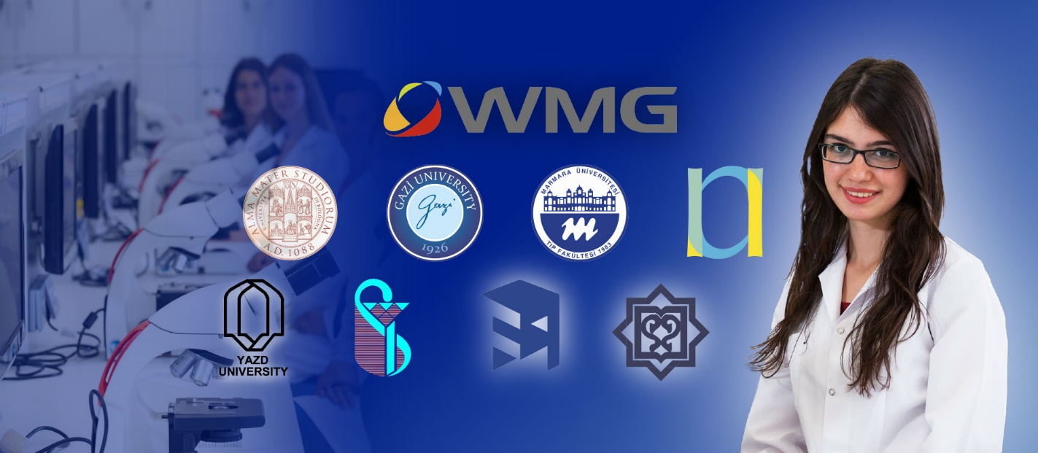
INSERT PHOTO HERE !!! (joint-programs.jpg)
Double Major Opportunities
While giving the students a chance to gain expertise in a specific field, EMU also provides opportunities for developing oneself in other areas. Students registered to EMU programs may benefit from double major and minor program applications if they meet the required conditions.

Student Exchange Program Opportunities
The Student Exchange Program is a fantastic opportunity available for the students at the Eastern Mediterranean University to spend a semester or two at one of many universities that EMU collaborates with across 13 countries. These carefully prepared collaborations with prominent institutions across the globe gives every student at EMU the chance to take their courses in countries like America, Canada, Italy, Austria, South Korea and China, and transfer their credits to EMU completed. The undeniable benefits of such a program are made even easier to reach by a well experienced team at the International office, helping every student individually with their journey. With more universities and countries being added to the student exchange portfolio, EMU is providing more opportunities for more students.

