PROJECT PROPOSAL FORM

PROJECT NUMBER :
PROJECT NAME :
PROJECT START DATE:
PROJECT END DATE:

A.1. Preliminary Project Information

A.1.1
Project No
Project Name
Start Date
End Date
Time

A.1.2
Project Manager
Name Surname |  | ID No
Title/Role
Address
Phone
Email

A.2 Group Information

A.2.1
Student 1
Name Surname |  | ID No
Title/Role
Address
Phone
Email

Student 2
Name Surname |  | ID No
Title/Role
Address
Phone
Email

A.2.2
List of Completed / Ongoing Projects of Team

B.1 Introduction to Project

B.1.1
Summary of Project

B.1.2
Key Words

B.1.3
Aim of Project

B.1.4
Innovative Aspects/Contributions of Project

B.1.5
Methods to be Applied

B.1.6
Economic and National Outcomes

B.2 Reason of Starting the Project, Methods and R&D Stages

B.2.1
1- Explain the reason of starting this project. (Max 500 charachter)
2- Explain the purpose of this project.

3- Explain
- output of project
- national / international standards if exist
- the specific objectives of the project
- success criterias
- relistic constraints
4- Explain
- the methods to be applied during R&D activities
- applications
- technics and tools to be used
- standards to be followed under the workflow
Which SOFTWARE PROCESS MODEL in below will you apply? Why? How? Explain.
* The waterfall model?
*V-model of software process?
*Evolutionary development?
*Component-based software engineering? Etc.

Explain, Project Workflow:

- Feasibility and Pre-research:

- System Design:

- Software development:

- Prototype implementation and testing work:

- Maintenance:

5- Explain
- the contribution of national/international technological development if exist
- starting a new research and development projects within or outside the team
- launch new applications or research studies in different technology areas

With whom we can cooperate?
Expectations:
Published work:
Can your output be an input for other similar national/international projects?

B.3 Innovative and Unique Aspects

B.3.1
1- Describe
- differences
- advantages
- superiority
compared to other similar projects.

B.4.1
2- Who can contribute to this project in your team?
Example:
- Project Manager
- System Designer
- .....

C.1 Gantt Chart and Work Packages

C.1.1 Gantt Chart
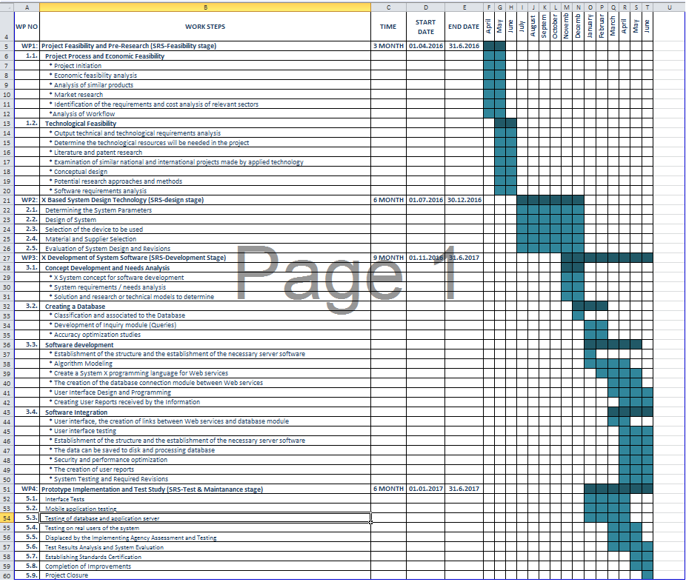

C.1.2 List of Work Packages
Work Package No | 1
Work Package Name | Project Feasibility and Pre-Research (SRS-Feasibility stage)
Start-End Date and Time
Related Organizations
1- List the activities of work packages.
1.1 Project Process and Economic Feasibility:

1.2 Technological Feasibility:

2- Describe the methods and parameters that will be used for work package.
3- List the experiments, tests and analysis in the work package.
4- List the output of work package and its success criterias.
Outputs:

Success Criterias:

5- Explain the relation of output with other work packages

Work Package No | 2
Work Package Name | X Based System Design Technology (SRS-design stage)
Start-End Date and Time
Related Organizations
1- List the activities of work packages.
2- Describe the methods and parameters that will be used for work package.
3- List the experiments, tests and analysis in the work package.
4- List the output of work package and its success criterias.
Outputs:

Success Criterias:

5- Explain the relation of output with other work packages

Work Package No | 3
Work Package Name | X Development of System Software (SRS-Development Stage)
Start-End Date and Time
Related Organizations
1- List the activities of work packages.
2- Describe the methods and parameters that will be used for work package.
3- List the experiments, tests and analysis in the work package.
4- List the output of work package and its success criterias.
Outputs:

Success Criteria:

5- Explain the relation of output with other work packages

Work Package No | 4
Work Package Name | Prototype Implementation and Test Study and Maintanance (SRS-Test & Maintanance stage)
Start-End Date and Time
Related Organizations
1- List the activities of work packages.
2- Describe the methods and parameters that will be used for work package.
3- List the experiments, tests and analysis in the work package.
4- List the output of work package and its success criterias.
Outputs:

Success Criteria:

5- Explain the relation of output with other work packages

C.1.3 List of Milestones (should be matched in the gantt chart)
 | Description of Output | Expected Time Interval
Example: | Feasibility Studies | 01.07.2014 – 30.09.2014
1
2
3
4
5
6
7

C.1.4 List of Risks (see following example, find other risks of your Project!)
Risk | Probability | Effects | Your Strategy
The time required to develop the software is underestimated. | High | Serious | ?
Software tools cannot work together in an integrated way. | High | Tolerable | ?
Customers fail to understand the impact of requirements changes. | Moderate | Tolerable | ?
The rate of defect repair is underestimated. | Moderate | Tolerable | Replace potentially defective components with more reliable bought-in components.
The size of the software is underestimated. | High | Serious | Investigate buying sw components;  Investigate use of a program generator.
Code generated by code generation tools is inefficient. | Moderate | Insignificant
Key staff are ill at critical times in the project. | Moderate | Serious | Reorganize team so that there is more overlap of work and people therefore understand each other’s jobs.
The database used in the system cannot process as many transactions per second as expected. | Moderate | Serious | Investigate the possibility of buying a higher-performance database.

C.2 Project Management and Organization

C.2.1 Project Team
Personnel Name | Title | ID | Education Status | Graduation Date | Date of Starting Work | Idea Owner

C.2.2 Organization Scheme (an example is given below!)
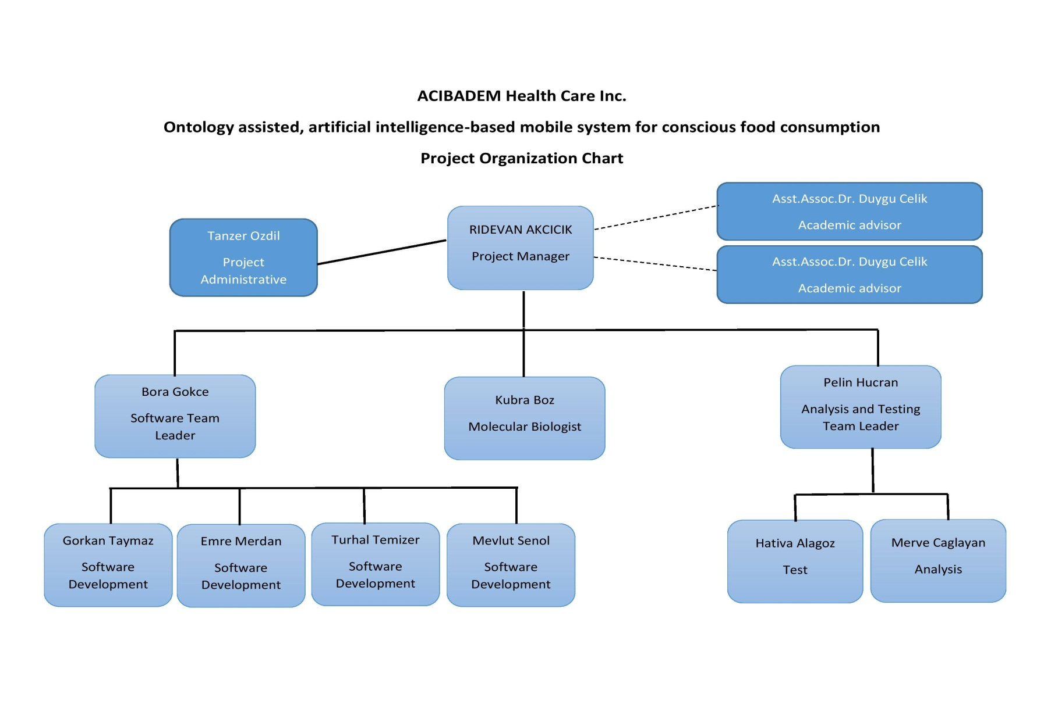

D.1 Economic Forecasts
1- Evaluate the commercialization potential of project outcomes. List possible risks here?

2- List your expectations to your company which are come by your project
Time-to-market (month):
The expected increase in sales revenue (%):
The expected increase in market share (%):
Time to start to gain:

D.2 National Outcomes
1- Specify the output that may be subject to patent, utility model and industrial design registration in the project.
2- Explain the potential of project and its outputs that may have an effect on social life, education, health and etc.
3- Explain the positive and negative effects of project outputs for environment and human being.

(M013) Instrument / Equipment / Software / RELEASE PURCHASES
Project Name
Line no | Instrument / Equipment / Software / Publication Name |  | No. of Item | Capacity | Technical specification | Purpose of Project Activities | Post-Project Place of Use / Purpose |  | Unit Price (USD) | Unit Price (TL) | Total Amount (TL)
 |  |  |  |  |  |  | R & D | Production
1
2
3
4
5
6
7
8
9
10
 |  |  |  |  |  |  |  |  |  | TOTAL | TL

(M030) Quarterly Estimated Cost Form (TL)
Project Name :
Cost Item | 2017 |  | TOTAL  (TL) | TOTAL COST RATE OF CONTENTS (%)
 | I | II
Personnel
Travel
Instrument / Equipment / Software / Publications
Domestic Works Made By R & D and Testing Institutions
International Works Made By R & D and Testing Institutions
Domestic Services Procurement
Overseas Service Procurement
Material
TOTAL COST |  |  |  | 100
CUMULATIVE COST |  |  |  | 100
IN THE PROJECT TOTAL MAN-MONTH

APPENDIX

