ITEC 202 – Operating Systems
Ubuntu LiveCD

Ubuntu LiveCD
A live CD can be used for a quick demo or test of Ubuntu. By the help of a LiveCD you can try Ubuntu without any changes to your machine. Windows or whatever operating system you use normally is unaffected after trying this and then rebooting. The standard Ubuntu CD can also be used as a Live CD as well as an installer. Live mode is the default option when booting from CD. Live CDs are designed for people that want to use Ubuntu on a computer for a few hours. It is also very useful to practice the ITEC202 laboratory exercises at home.

Preparing your LiveCD
Download Ubuntu from http://www.ubuntu.com/download/desktop. For a live CD, avoid the "alternate CD" & the Server Edition because it has no desktop. Then burn a new cd with the downloaded .iso file.

Using your LiveCD
Put the Ubuntu CD into the CD/DVD-drive and reboot the computer. You should see a menu with “Try Ubuntu” or “Try Ubuntu without any change to your computer”. If you don't get this menu, read the booting From the CD guide for more information. Choose “Try Ubuntu” (Fig. 1). You should get a desktop which we call a "LiveCD session". If you don't see a desktop, or need safe graphics mode, read the boot options for more information (Fig. 2)

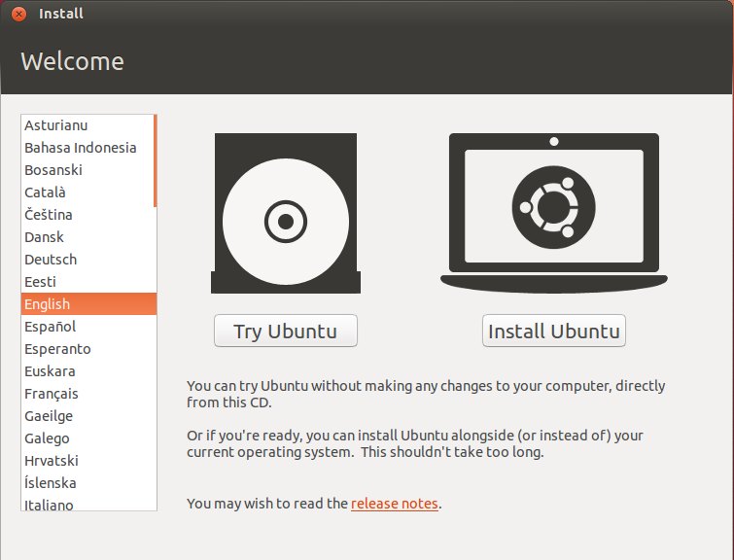 | 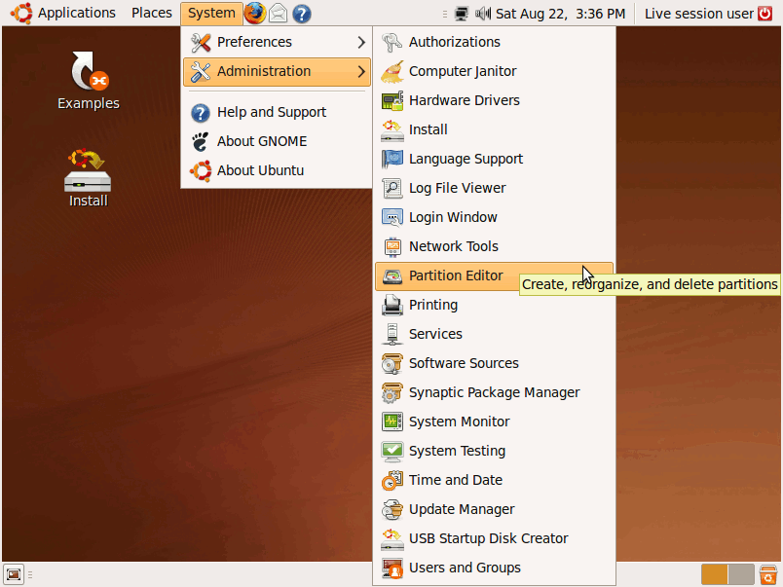
Fig. 1. Try Ubuntu menu | Fig. 2. Ubuntu Desktop

The Firefox icon on the top panel should let you surf the internet. Other normal programs are available in the menus. After you have finished, shut the computer down and remove the CD. At this point anything you saved to the desktop or Documents folders and such will vanish - only things you saved into folders on the hard-drive will remain. This means that there won't be any trace of your personal data (e-mails, passwords etc.) left on the machine.

