**EASTERN MEDITERRANEAN UNIVERSITY**



**Department of Industrial Engineering**

**IENG584 Advanced Quality Engineering**

**HOMEWORK 4 Spring 2018-19**

1. One-pound coffee cans are filled by a machine, sealed, and then weighed automatically. After adjusting for the weight of the can, any package that weighs less than 16 Oz is cut out of the conveyor. The weights of 25 successive cans are shown in Table 6E.19. Set up a moving range control chart and a control chart for individuals. Estimate the mean and standard deviation of the amount of coffee packed in each can. Is it reasonable to assume that can weight is normally distributed? If the process remains in control at this level, what percentage of cans will be under filled?

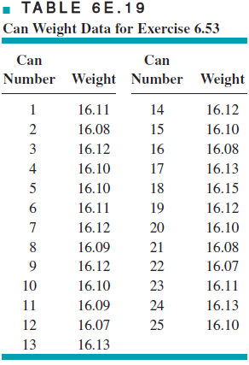

1. The data in Table 7E.1 give the number of nonconforming bearing and seal assemblies in samples of size 100. Construct a fraction nonconforming control chart for these data. If any points plot out of control, assume that assignable causes can be found and determine the revised control limits.



1. The number of nonconforming switches in samples of size 150 are shown in Table 7E.2. Construct a fraction nonconforming control chart for these data. Does the process appear to be in control? If not, assume that assignable causes can be found for all points outside the control limits and calculate the revised control limits.



1. The data in Table 7E.3 represent the results of inspecting all units of a personal computer produced for the past ten days. Does the process appear to be in control?



1. A process produces rubber belts in lots of size 2500. Inspection records on the last 20 lots reveal the data in Table 7E.5.

(a) Compute trial control limits for a fraction nonconforming control chart.

(b) If you wanted to set up a control chart for controlling future production, how would you use these data to obtain the center line and control limits for the chart?



1. Based on the data in Table 7E.6 if an *np* chart is to be established, what would you recommend as the center line and control limits? Assume that *n*  500.



1. A control chart for the fraction nonconforming is to be established using a center line of *p*  0.10. What sample size is required if we wish to detect a shift in the process fraction nonconforming to 0.20 with probability 0.50? (Assuming 3 sigma limits)
2. A process is controlled with a fraction nonconforming control chart with three-sigma limits, *n*  100, UCL  0.161, center line  0.080, and LCL  0.

(a) Find the equivalent control chart for the number nonconforming.

(b) Use the Poisson approximation to the binomial to find the probability of a type I error.

(c) Use the correct approximation to find the probability of a type II error if the process fraction nonconforming shifts to 0.2.

(d) What is the probability of detecting the shift in part (c) by at most the fourth sample after the shift?

1. A fraction nonconforming control chart has center line 0.01, UCL  0.0399, LCL  0, and *n*  100. If three-sigma limits are used, find the smallest sample size that would yield a positive lower control limit.
2. Assume that in a Demerit System there are five clasess A, B, C, D, and E. Also the demerite weights of classes are Class A-100, Class B-80, Class C-50, Class D-10 and Class E-1. If *ciA, ciB, ciC, ciD,*and *ciE,* are present the number of defects in mentioned classes, respectively,
   1. Define the number of demerits in the inspection unit.
   2. Define the number of demerits per unit.
   3. Compute the control limits for related *u* chart.
3. Why is the *np* chart not appropriate with variable sample size?