Sums of powers
- 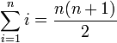
- 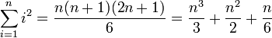
- 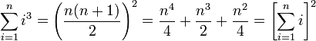
- 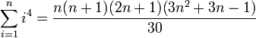
- 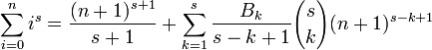
where B_{k} is the kth Bernoulli number.
- 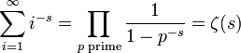
where ζ(s) is the Riemann zeta function.

Power series
Infinite sum (for | x | < 1) | Finite sum
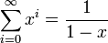 | 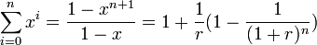where r > 0 and 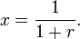
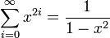
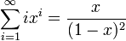 | 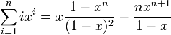
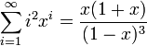
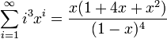
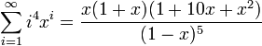
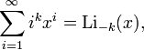where Li_{s}(x) is the polylogarithm of x.

Simple denominators
- 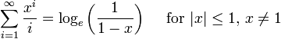
- 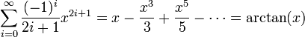
- 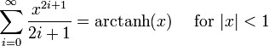
- 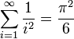

Factorial denominators
Many power series which arise from Taylor's theorem have a coefficient containing a factorial.
- 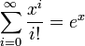
- 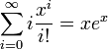(c.f. mean of Poisson distribution)
- 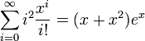(c.f. second moment of Poisson distribution)
- 
 