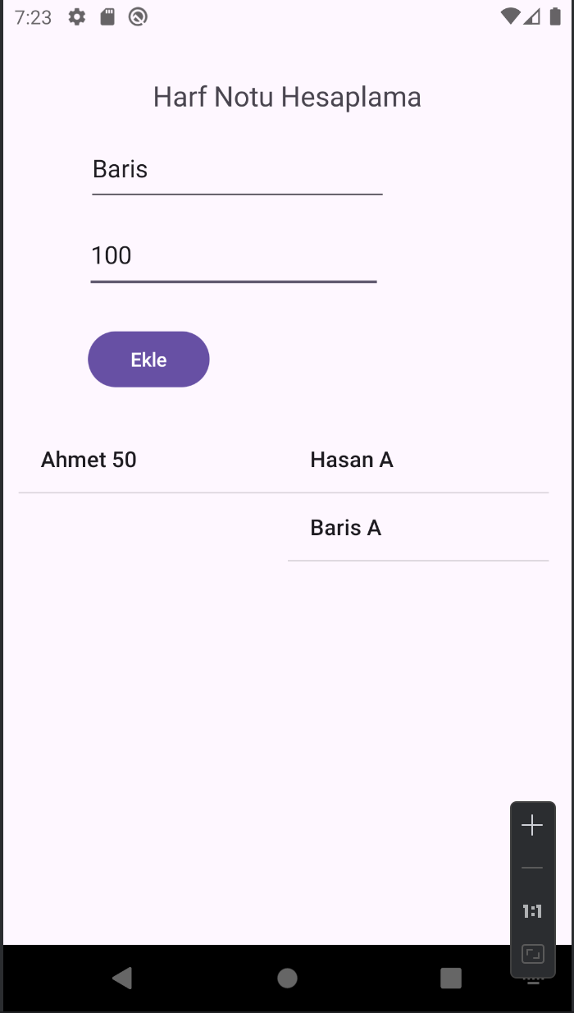

package com.example.blgm419_harfnotuhesaplama;

import android.annotation.SuppressLint;
import android.os.Bundle;
import android.view.View;
import android.widget.AdapterView;
import android.widget.ArrayAdapter;
import android.widget.Button;
import android.widget.EditText;
import android.widget.ListView;

import androidx.activity.EdgeToEdge;
import androidx.appcompat.app.AppCompatActivity;
import androidx.core.graphics.Insets;
import androidx.core.view.ViewCompat;
import androidx.core.view.WindowInsetsCompat;

import java.util.ArrayList;

public class MainActivity extends AppCompatActivity {

Button bt_ekle;
EditText et_isim,et_toplamnot;

ListView lv_ogrenciler,lv_harfnotu;

ArrayList<String> ogrenciler;
ArrayList<String> harfnotlari;

ArrayList<Ogreni> ogrencinesneleri;

ArrayAdapter<String> adaptor1;
ArrayAdapter<String> adaptor2;

@SuppressLint("MissingInflatedId")
@Override
protected void onCreate(Bundle savedInstanceState) {
super.onCreate(savedInstanceState);
EdgeToEdge.enable(this);
setContentView(R.layout.activity_main);
ViewCompat.setOnApplyWindowInsetsListener(findViewById(R.id.main), (v, insets) -> {
Insets systemBars = insets.getInsets(WindowInsetsCompat.Type.systemBars());
v.setPadding(systemBars.left, systemBars.top, systemBars.right, systemBars.bottom);
return insets;
});

bt_ekle=findViewById(R.id.button);
et_isim=findViewById(R.id.editTextText);
et_toplamnot=findViewById(R.id.editTextNumber);

lv_ogrenciler=findViewById(R.id.lvnotlar);
lv_harfnotu=findViewById(R.id.lvharfnotu);

ogrenciler=new ArrayList<>();
harfnotlari=new ArrayList<>();

ogrencinesneleri=new ArrayList<Ogreni>();

adaptor1=new ArrayAdapter<>(this, android.R.layout.simple_list_item_1,ogrenciler);
adaptor2=new ArrayAdapter<>(this, android.R.layout.simple_list_item_1,harfnotlari);

lv_ogrenciler.setAdapter(adaptor1);
lv_harfnotu.setAdapter(adaptor2);

bt_ekle.setOnClickListener(new View.OnClickListener() {
@Override
public void onClick(View view) {

ogrenciler.add(et_isim.getText().toString()+" "+et_toplamnot.getText().toString());

Ogreni yeniogrenci=new Ogreni(et_isim.getText().toString(),Integer.parseInt(et_toplamnot.getText().toString()));

ogrencinesneleri.add(yeniogrenci);

adaptor1.notifyDataSetChanged();

}
});

lv_ogrenciler.setOnItemClickListener(new AdapterView.OnItemClickListener() {
@Override
public void onItemClick(AdapterView<?> adapterView, View view, int i, long l) {

String harfnotu="";

if (ogrencinesneleri.get(i).getToplamNot()>=80){
harfnotu="A";
}else {if (ogrencinesneleri.get(i).getToplamNot()>=70){
harfnotu="B";
}else{harfnotu="F";}

}

harfnotlari.add(ogrencinesneleri.get(i).getIsim()+" "+harfnotu);

adaptor2.notifyDataSetChanged();

ogrencinesneleri.remove(i);
ogrenciler.remove(i);

adaptor1.notifyDataSetChanged();

}
});

}
}

package com.example.blgm419_harfnotuhesaplama;

public class Ogreni {

String Isim;
int ToplamNot;

public Ogreni(String isim, int toplamNot) {
Isim = isim;
ToplamNot = toplamNot;
}

public String getIsim() {
return Isim;
}

public void setIsim(String isim) {
Isim = isim;
}

public int getToplamNot() {
return ToplamNot;
}

public void setToplamNot(int toplamNot) {
ToplamNot = toplamNot;
}
}

