**CMPE_CMSE371 Analysis of Algorithms**

**Problem Set 2**

Q1. Show That:

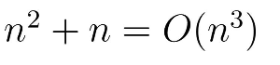

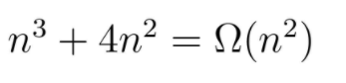

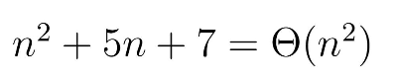



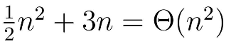

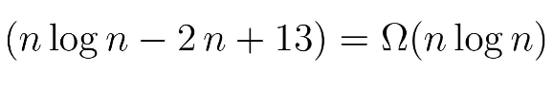

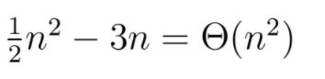









Q2. In the following recurrences, give the asymptotic upper and lower bounds of T(n). Assume that T(n) is constant for n ≤ 10. Keep your limits as tight as possible and justify your answers. You can try different solution methods for each option.

