Spinner Project:

public class MainActivity extends AppCompatActivity {
String[] bankNames={"TED","ISBANK","HSBC","PNB","OBC"};
Spinner myspin;
ArrayAdapter aa;
@Override
protected void onCreate(Bundle savedInstanceState) {
super.onCreate(savedInstanceState);
setContentView(R.layout.activity_main);
myspin=(Spinner) findViewById(R.id.spinner);
aa=new ArrayAdapter(this,android.R.layout.simple_spinner_item,bankNames);
aa.setDropDownViewResource(android.R.layout.simple_spinner_dropdown_item);
myspin.setAdapter(aa);
myspin.setOnItemSelectedListener(new AdapterView.OnItemSelectedListener() {
@Override
public void onItemSelected(AdapterView<?> parent, View view, int position, long id) {
Toast.makeText(MainActivity.this,"Hi "+bankNames[position],Toast.LENGTH_LONG).show();
}
@Override
public void onNothingSelected(AdapterView<?> parent) {
}
});
}
}

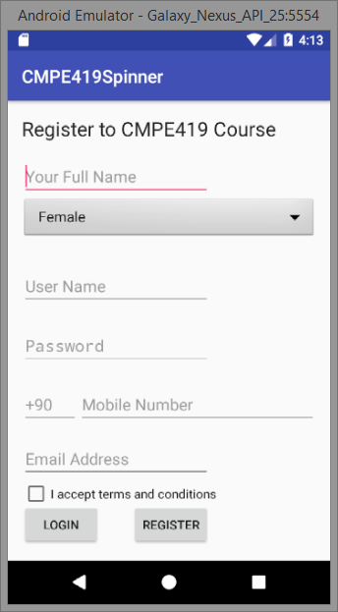

public class MainActivity extends AppCompatActivity {
EditText edt1;
Button bt1,bt2;
Spinner myspinner;
ArrayAdapter adapter;
String[] items={"Female","Male"};
@Override
protected void onCreate(Bundle savedInstanceState) {
super.onCreate(savedInstanceState);
setContentView(R.layout.activity_main);
Init();
}
private void Init() {
myspinner=(Spinner)findViewById(R.id.spinner);
adapter=new ArrayAdapter(this,android.R.layout.simple_spinner_item,items);
adapter.setDropDownViewResource(android.R.layout.simple_spinner_dropdown_item);
myspinner.setAdapter(adapter);
bt1=(Button)findViewById(R.id.button);
bt1.setOnClickListener(new View.OnClickListener() {
@Override
public void onClick(View v) {
edt1.setText(myspinner.getSelectedItem().toString());
}
});
edt1=(EditText)findViewById(R.id.editText);
//edt1.setText(myspinner.getSelectedItem().toString());
}
}

