CMSE419 LAB 10
Due May 15, 2020.

Q1. Create an application that gets Name, Surname, and Phone number from the user and save it to the file. Use “Add to File” button to write user data to the file. “Read and List” button will list all the information entered to the file within new activity.
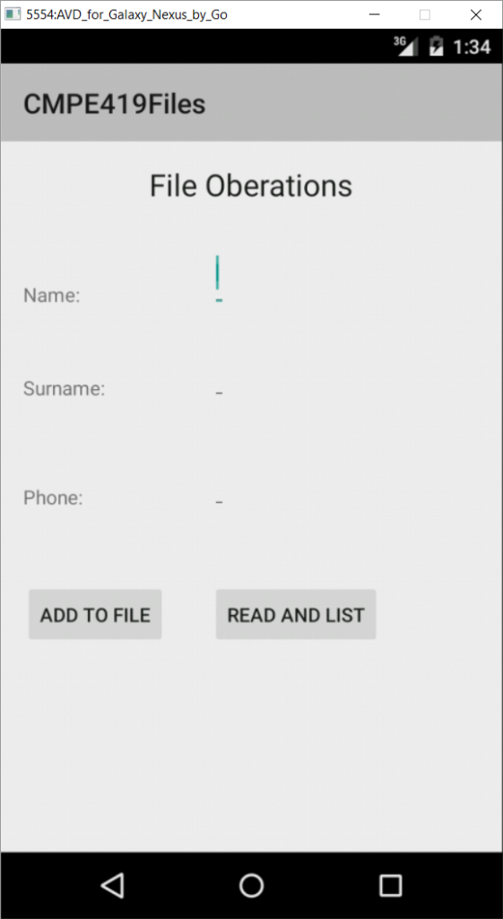

You have to let user to select an item from the list and delete it. “Update File” Button in new activity will rewrite all the data available in the list to the file.

Q2. Solve Q1. By using SQLite database.

