CMSE419 LAB IV

Due April 3, 2020.

Q. Update LAB2 as follows:
- Create an Array list of STUDENTS.
- Use the following GUI for your operations:
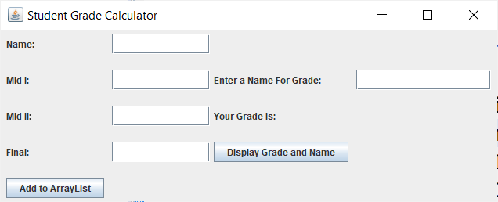

- Enter student informations one by one and add them to array list by using ADD button.
- Enter a name and disply Name and Grade of that student if it is in the ArrayList. (Use 20%, 30% and 50% for Mid I, Mid II and Final respectively)

