CMSE419 LAB V

Due April 10, 2020.

Q. Simple Calculator:
- You have to create the following GUI.
- Get input and perform selected operation (+, -, *, /).
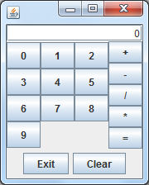

- Exit button lets you to exit from the program.
- Clear button will clear the text in the textField.

