CMSE419 LAB VI

Due April 10, 2020.

Q. Simple DICE GAME:
- You have to create the following GUI.
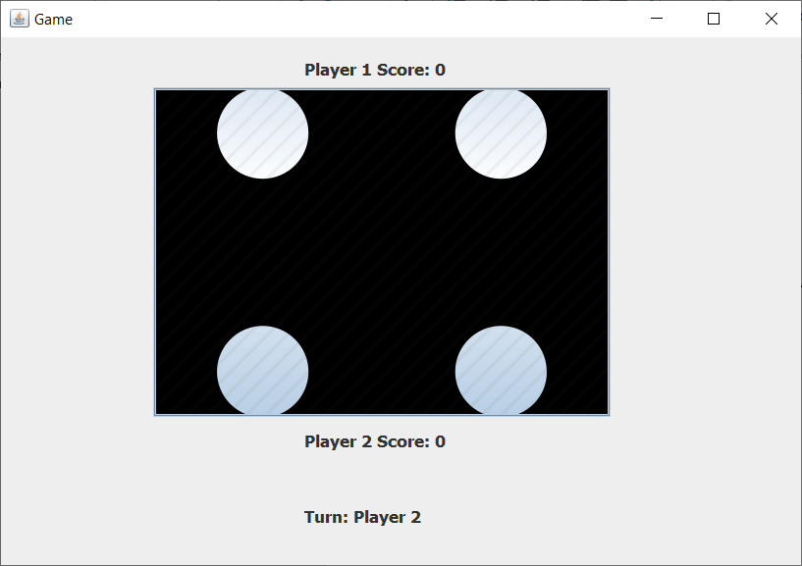
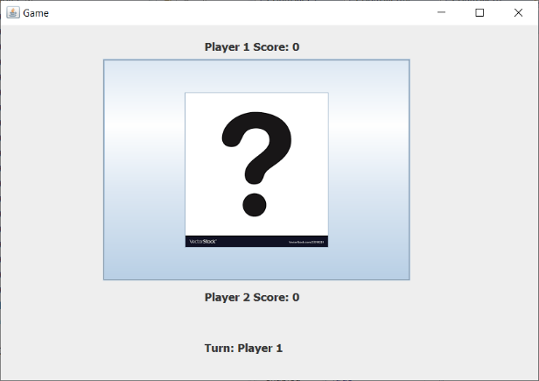

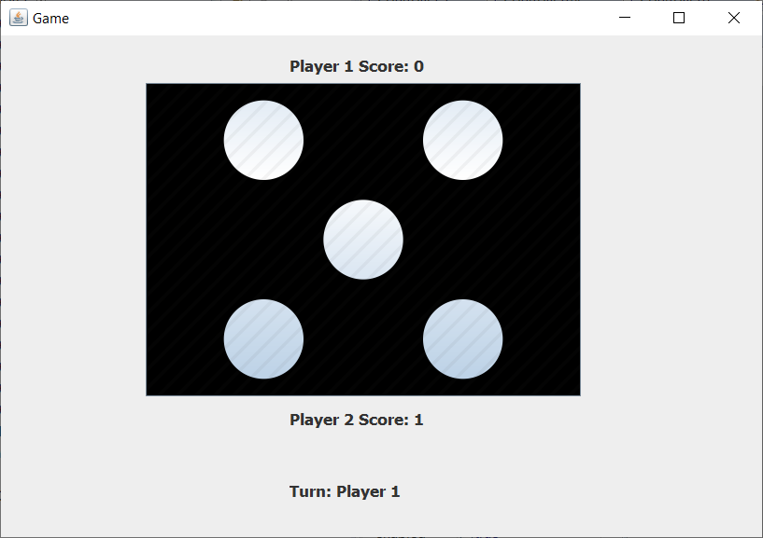

- Your code should ask two users to play the game by pressing the button.
- You have to identify the winner and increase the score of winner player.
- You have to regularly update “Player I Score”, “Player II Score” and “Turn:” labels.
- int random = (int)(Math.random() * 6 + 1); creates a random integer between 1 and 6.

