CMPE419 LAB VI

Due April 17, 2020.

Q. Dice Game A:

* You have to create the following Activity.

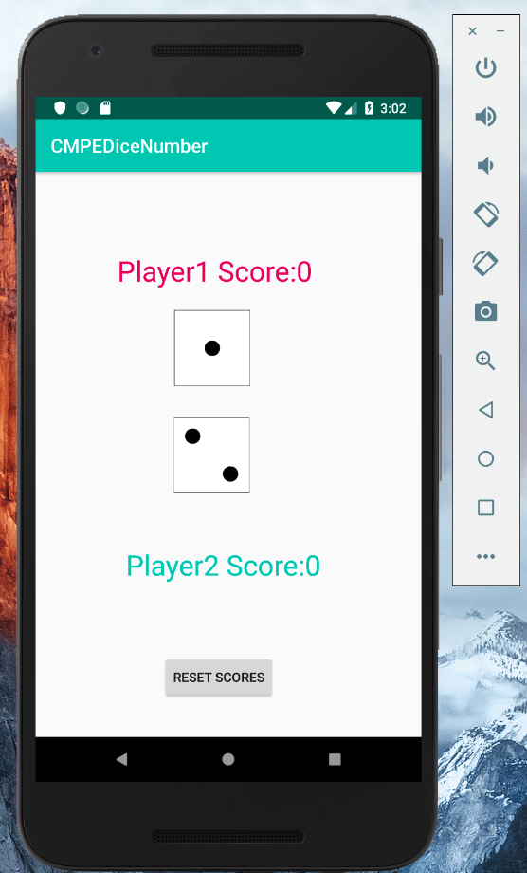

This is the simple dice game that you have to implement by using Android Studio.

Players will select a number randomly by clicking on dice face images. If players’ 1 face is grater than the second one, score of the player 1 should increase by one.

The “Reset Scores” button will reset the scores to 0.

Your code should have no logical error. Players should play one after the other.

Hint: You have to use ImageButton.

Q. Dice Game B:

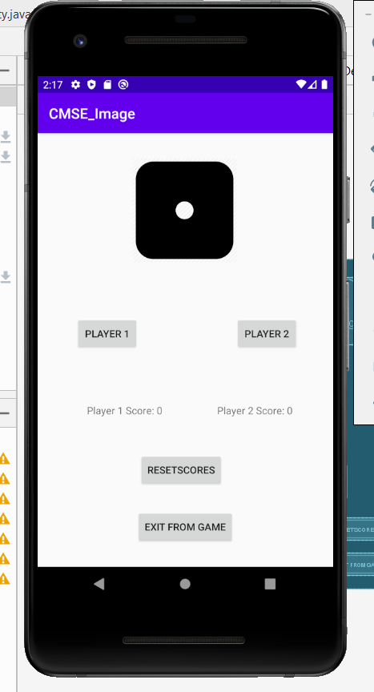In this activity players should use Buttons to play. Like Game A players should play one after the other.