CMPE419 LAB VIII

Due April 24, 2020.

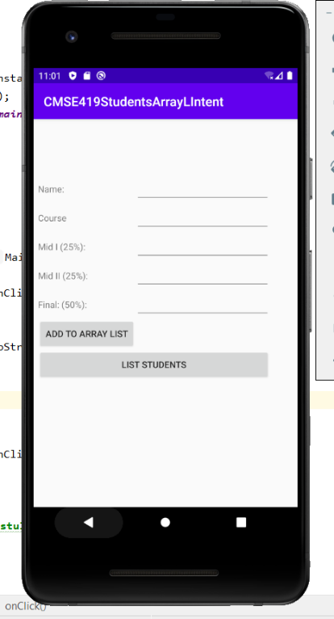
Question: In this homework you have to create the following activity that gets “Name”, “Course Code”, “ Mıd I”, “Mıd II”, and “Final” Calculate Total Grade of the appropriate course and add it to the “String” array ist.

In second activity use ListView and display “Name, Course Code and Total” of the informations that you have entered in activity main.

