CMPE419 LAB VIII

Due May 1, 2020.

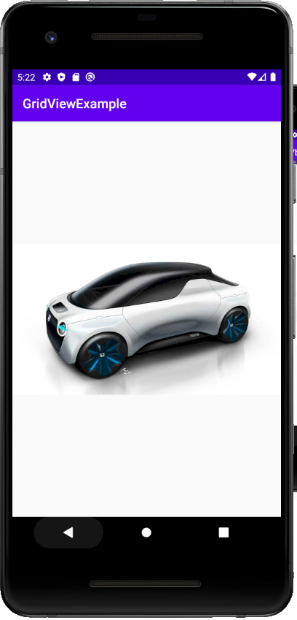
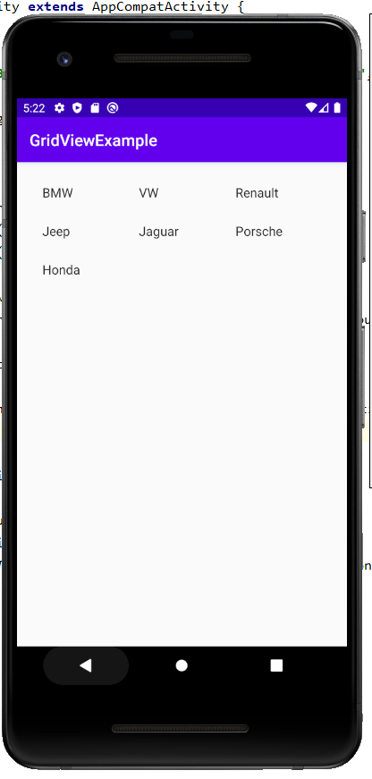
Q. The following outputs are expected to be created by using GridView. At least 8 objects, items or animals (according to your personal choice) are required to be selected. Selected items will be listed in GridView and the picture will be displayed in the second activity based on your choice.

Q2. X-O Game Project. In this project you are expected to do the (3X3) X-O Game for two players.
Your Game should have no logical error.(i.e. use bt.setEnabled(false) method for your buttons to disabling the selected buttons). With New Game Button you have to restart the game.
