CMPE536 Metaheuristics
Fall 2020-2021
Assignment II

In this assignment you are assigned randomly to one of the following algorithms aveilable in Table I.

Algorithms
- Genetic Algorithm Problem: Selected 2 QAP Problems
- PSO Problem: Selected 2 Test Problems (F1-F10) (with 10 and 30 Variables)
- ANT Colony Optimization Problem: Selected 2 QAP Problems
- Differential Evolution Problem: Selected 2 Test Problems (F1-F10) (with 10 and 30 Variables)
Table I

# | C.Code | Grup | Std.Id | Algorithm | Due Date
1 | CMPE536 | 01 | 18500574 | GA | 8.12.2020
2 | CMPE536 | 01 | 18500772 | GA | 8.12.2020
3 | CMPE536 | 01 | 19500561 | ACO | 8.12.2020
4 | CMPE536 | 01 | 19500650 | ACO | 8.12.2020
5 | CMPE536 | 01 | 20500070 | PSO | 15.12.2020
6 | CMPE536 | 01 | 20500231 | PSO | 15.12.2020
7 | CMPE536 | 01 | 20510428 | PSO | 15.12.2020
8 | CMPE536 | 01 | 20510466 | DE | 15.12.2020
9 | CMPE536 | 01 | 20600059 | DE | 15.12.2020
10 | CMPE536 | 01 | 20610116 | DE | 15.12.2020
11 | CMPE536 | 01 | 20610118 | ACO | 8.12.2020

You have to run your algorithm 10 times. In each run maximum iteration should be selected as 1000. Collect global best solutions for each run and criate a table that shows averages of your solutions.

Algorithm | Run 1 | R. 2 | R. 3 | R. 4 | R. 5 | R. 6 | R. 7 | R. 8 | R. 9 | R.10 | Average
Problem1
Problem2

Conclude how you can improve your solutions. Update your algorithm with a method that you have sugested in your conclusion and create same table with your updated solutions.

Problem Description
Goal:
In the Quadratic Assignment Problem (QAP), n units (usually departments, machines, or electronic components) must be assigned to n locations given the distance between the locations and the flow between the units. The goal is to find the assignment that minimizes the sum of the products of distance traveled and flow between the units.
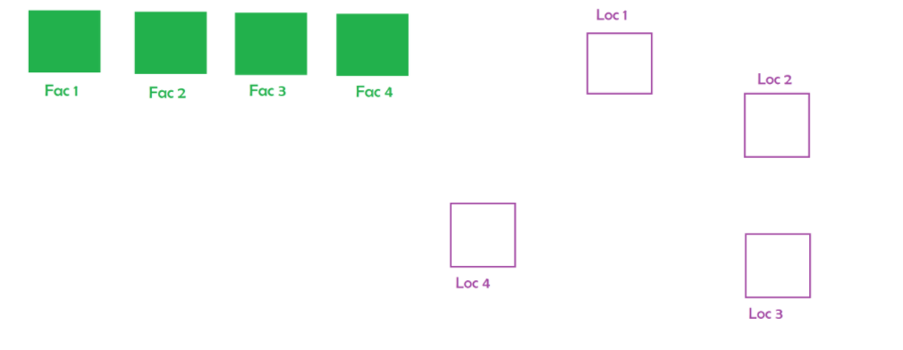
In the QAP n units(facilities, departments, machines, or electronic components) must be assigned to n locations give the matrixes of flow.
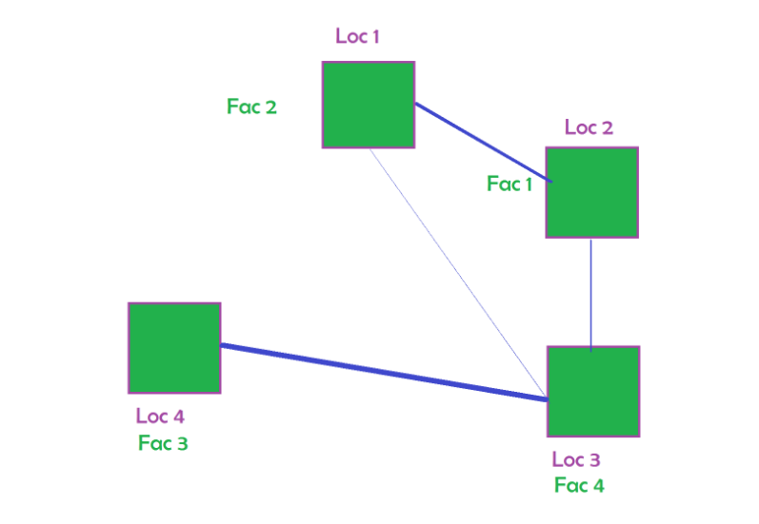
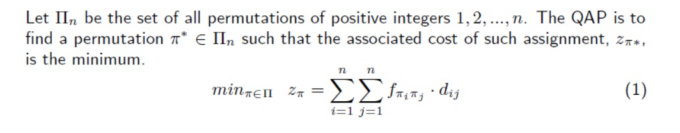

Data:
The format of the data is as follows:
- Number of points
- Matrix A (d): distance between each location
- Matrix B (f) : flow between each facility
Problems:
Tai12a.dat
Tai12b.dat
Tai15a.dat
Tai17a.dat
Tai100a.dat
Optimal Solutions:
https://coral.ise.lehigh.edu/data-sets/qaplib/qaplib-problem-instances-and-solutions/#Ta

