**CMPE536 Metaheuristics**

**Spring 2024-2025**

**Assignment**

**Due Date: 29 May 2025, 16:00**

**In this assignment you are assigned randomly to one of the following algorithms aveilable in Table I.**

|  |
| --- |
| **Algorithms** |
| 1. **Tabu Search: Solve at least 2 problems for QAP** |
| 1. **Simulated Annealing: Solve at least 2 problems for QAP** |
| 1. **Genetic Algorithm: Solve at least 2 problems for QAP** |
| 1. **Ant Colony Optimization: Solve at least 2 problem for QAP** |
| 1. **Particle Swarm Optimization: Solve at least 2 problemss from Real Valued Test Problems** |
| 1. **Diferential Evolution: Solve at least 2 problems from Real Valued Test Problems** |
| 1. **Genetic Algorithm: Solve at least 2 problems from Real Valued Test Problems** |

**Table I**

**You have to run your algorithm 10 times. In each run maximum iteration should be selected as 1000. Collect global best solutions for each run and criate a table that shows averages of your solutions.**

|  |  |  |  |  |  |  |  |  |  |  |  |
| --- | --- | --- | --- | --- | --- | --- | --- | --- | --- | --- | --- |
| **Algorithm** | **Run 1** | **R. 2** | **R. 3** | **R. 4** | **R. 5** | **R. 6** | **R. 7** | **R. 8** | **R. 9** | **R.10** | **Average** |
| **Problem1** |  |  |  |  |  |  |  |  |  |  |  |
| **Problem2** |  |  |  |  |  |  |  |  |  |  |  |

**Conclude how you can improve your solutions. Update your algorithm with a method that you have sugested in your conclusion and create same table with your updated solutions.**

**QAP Problem Description**

**Goal:**

In the Quadratic Assignment Problem (QAP), n units (usually departments, machines, or electronic components) must be assigned to n locations given the distance between the locations and the flow between the units. The goal is to find the assignment that minimizes the sum of the products of distance traveled and flow between the units.

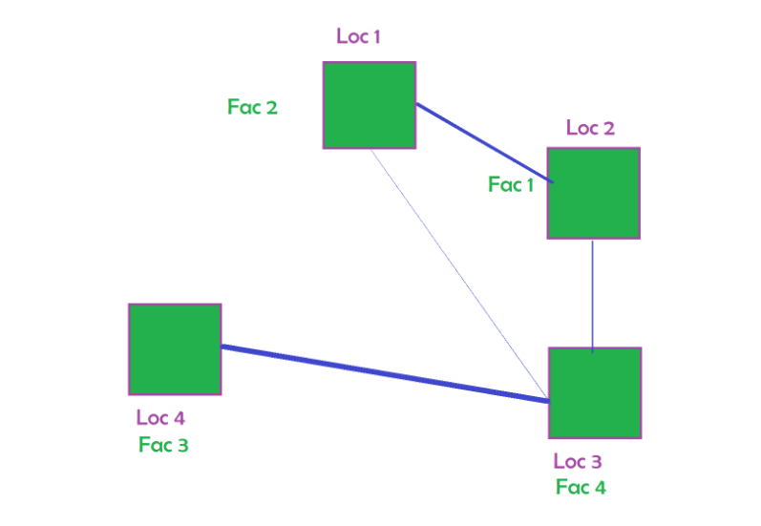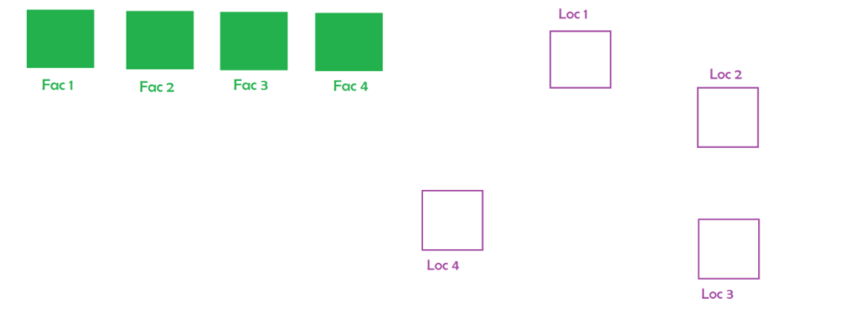In the QAP n units(facilities, departments, machines, or electronic components) must be assigned to n locations give the matrixes of flow.

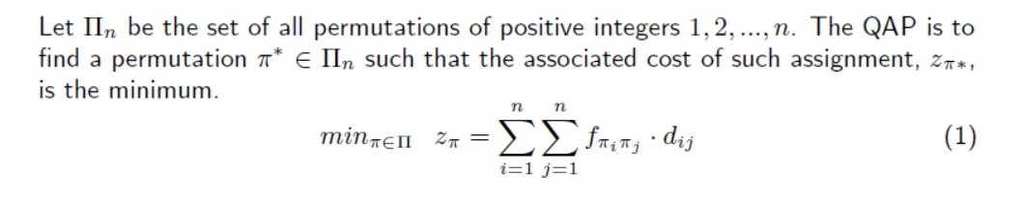**Data:**

The format of the data is as follows:

* Number of points
* Matrix A (d): distance between each location
* Matrix B (f) : flow between each facility

**Problems:**

**Tai12a.dat**

**Tai12b.dat**

**Tai15a.dat**

**Tai17a.dat**

**Tai100a.dat**

**Optimal Solutions:**

[**https://coral.ise.lehigh.edu/data-sets/qaplib/qaplib-problem-instances-and-solutions/#Ta**](https://coral.ise.lehigh.edu/data-sets/qaplib/qaplib-problem-instances-and-solutions/#Ta)

|  |  |  |  |  |
| --- | --- | --- | --- | --- |
| # | C.Code | Grup | Std.Id | Algorithm |
| 1 | CMPE536 | 01 | 23501719 | 1 |
| 2 | CMPE536 | 01 | 23501860 | 2 |
| 3 | CMPE536 | 01 | 23502050 | 3 |
| 4 | CMPE536 | 01 | 23502094 | 4 |
| 5 | CMPE536 | 01 | 23502287 | 5 |
| 6 | CMPE536 | 01 | 23502464 | 6 |
| 7 | CMPE536 | 01 | 23600301 | 7 |
| 8 | CMPE536 | 01 | 23600334 | 1 |
| 9 | CMPE536 | 01 | 24500508 | 2 |
| 10 | CMPE536 | 01 | 24500557 | 3 |
| 11 | CMPE536 | 01 | 24501272 | 4 |
| 12 | CMPE536 | 01 | 24501392 | 5 |
| 13 | CMPE536 | 01 | 24502189 | 6 |
| 14 | CMPE536 | 01 | 24502218 | 7 |
| 15 | CMPE536 | 01 | 24502260 | 1 |
| 16 | CMPE536 | 01 | 24600021 | 2 |
| 17 | CMPE536 | 01 | 24600114 | 3 |
| 18 | CMPE536 | 01 | 24600163 | 4 |
| 19 | CMPE536 | 01 | 24600419 | 5 |