 **EASTERN MEDITERRANEAN UNIVERSITY**

**COMPUTER ENGINEERING DEPARTMENT**

**CMPE 312 – SOFTWARE ENGINEERING**

**Quiz: Totally** 5 points

**12 June 2020, 10.30,** DURATION: 110 min,

**Instructor: Assoc. Prof. Dr. Alexander Chefranov** Alexander.chefranov@emu.edu.tr

|  |  |  |  |  |  |  |  |  |  |  |
| --- | --- | --- | --- | --- | --- | --- | --- | --- | --- | --- |
| **QUESTION** | **Q1** | **Q2** | **Q3** | **Q4** | **Q5** | **Q6** | **Q7** | **Q8** | **Q9** | **Total** |
| **Out of 100%** | 7 | 7 | 26 | 7 | 23 | 10 | 8 | 8 | 4 | 100%=5 points |
| **Grade** |  |  |  |  |  |  |  |  |  |  |

**Please, consider the instructions below. The questions follow them.**

* Your answers shall be hand-written
* On each page, at the top, write a header: “CMPE312 Quiz 12.06.2020”, followed by your Name, Surname, Student ID, page number
* There are **9** questions in total. Try answering each question. There are 7 pages in total.
* You may rewrite the text of the question in your paper, or not. It is up to you. But at the beginning of an answer, write “Question <i> answer:” substituting <i> by a particular question number
* Open book, open notes, work yourself
* Copies are not allowed and will be zero graded
* In **30 minutes after the exam finishing**, you shall do **all** the following. 1. Make photo of each your page so that its full content, including the header, is in the image, and clearly readable. 2. Then, the images shall be assembled in the page number order into a pdf file named “CMPE312 Quiz12062020 <stid>.pdf” with <stid> substituted by your student identification number. 3. **Finally,** e-mail it to Alexander.chefranov@emu.edu.tr
* Good Luck!

**Questions:**

**Q1 (7 points).** What two approaches shall be used in the problem-solving management style according to the Weinberg’s model of a team leader’s abilities? Explain their meaning.

* Concentrate on understanding the problem to be solved;
* Manage the flow of ideas

Concentrating on the problem understanding is very important, because without the problem understanding, it is not possible successfully finishing a project. Flow of ideas means that the team shall exchange their understanding of the problem, of the approach to solve it. Knowledge exchange, or transfer is vital in the team working allowing people effectively working on the problem together.

**Q2. (7 points)** In which conditions and why the Controlled Centralized

Team Model is more preferable compared to the Controlled Decentralized one?

The Controlled Centralized (CC) model assumes existence of a team leader who is responsible for the top-level problem solving and team members coordination. In Controlled Decentralized (CD) model, the team leader communicates with the leaders of of sub-teams created by the leader for particular problems solving. The team leader communicates with the sub-team leaders. CC model is preferable for solving tasks similar to those solved previously. It is because of the perspective solutions are known in advance, and do not require much creativity.

**Q3. (26 points)** Draw an activity network diagram for the following work breakdown:

|  |  |  |
| --- | --- | --- |
| **Task** | **Duration(Days)** | **Dependencies** |
| T1  T2 | 5  8 | -  - |
| T3  T4 | 6  11 | -  T1, T2(M1) |
| T5  T6 | 8  5 | T1,T3(M2)  T2,T3(M3) |
| T7  T8 | 9  12 | T2(M4)  T3(M5) |
| T9  T10 | 10  8 | T1,T5(M6)  T6,T7(M7) |
| T11  T12 | 6  9 | T1, T5(M6)  T6, T7(M7) |

Define the minimal project duration and the reasonable number of software engineers to work on it. Show your calculations. Give necessary explanations.

T1

T4

T2

T3

T7

T5

T8

T6

T10

T9

5

11

8

6

9

8

12

5

8

10

T11

12

T12

9

To find the minimal project duration, it is necessary finding the longest (critical) path. Enumerate the paths:

P1: T1, T4=>5+11=16; P2: T1, T11 => 5+12 = 17; P3: T1, T9 => 5+10 = 15; P4: T2, T4 => 8+11 = 19; P5: T2, T7, T10 => 8+9+8 = 25; **P6: T2, T7, T12=>8+9+9=26**; P7: T2,T6,T10=>8+5+8=21; P8: T2, T6, T12 => 8+5+9 = 22; **P9: T3, T5, T11 =>6+8+12=26**; P10: T3, T5, T9 => 6+8+10 = 24; P11: T3, T6, T10 =>6+5+8=19; P12: T3, T6, T12 => 6+5+9 = 20;

The longest paths are P6 and P8, the minimal project duration is 26.

The maximal width of the graph is 6 (T4, T8, T9, T10, T11, T12); it means, the maximal number of the software engineers in the team can be 6.

**Q4. (7 points)** What are the two main reasons for the evolutionary prototyping use? Explain them.

1. Clarify requirements (throw-away prototyping)
2. Decide on the best solution (exploratory prototyping)

**Q5. (23 points)** Calculate adjusted function points count under the following conditions: the number of

* EI - external inputs 2 (each with 3 data elements and 2 file type records, FTR), **Low – complexity, here and below, in bold, are defined from the tables below; arrows and boxes clarify the way of making decisions**
* EO - external outputs 5 (two of them with 5 data elements -**Average** and 5 FTRs, and the rest, with 4 data elements and 7 FTRs **Average**)
* EQ -external enquiries 7 (three of them with 4 data elements and 6 FTRs **Average**, and the rest, with 3 data elements and 8 FTRs **Average**),
* ILF - internal logical files 3 (two of them with 5 data elements and 5 Record Element Types, RET **Low**, and other with 6 data elements and 8 RETs **Ave**)
* EIF - external interfaces 8 (four of them with 3 data elements and 7 Record Element Types, RET **Average**, and other with 4 data elements and 20 RETs **Average**).

Assume, 7 adjusting factors, Fj, are equal to 3 (Average), and other 7 are equal to 4 (Significant). Show details of your calculations. Make necessary assumptions and give explanations. ***Redraw the tables you use, and show, by arrows and words, what and how you use!!!***

**Hints:**



133

6

2*

25

5*

28

7*

24

1*

2**

56

8*



Adjusting factor =0.65+0.01*(7*3+7*4)=0.65+0.49=1.14

FP=133*1.14=152 function points

Each of the following tables assists in the ranking process (the numerical rating is in parentheses). For example, an EI that references or updates 2 File Types Referenced (FTR’s) and has 7 data elements would be assigned a ranking of average and associated rating of 4. Where FTR’s are the combined number of Internal Logical Files (ILF’s) referenced or updated and External Interface Files referenced.

3

**EI Table**

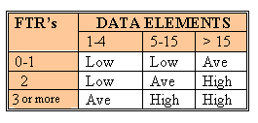

5, 7, 4, 3

2

**Shared EO and EQ Table**

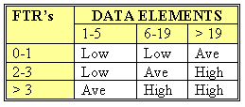

2, 7,6, 8

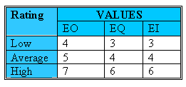

For both ILF’s and EIF’s the number of record element types and the number of data elements types are used to determine a ranking of low, average or high. A Record Element Type is a user recognizable subgroup of data elements within an ILF or EIF. A Data Element Type (DET) is a unique user recognizable, non-recursive (non-repeating) field on an ILF or EIF.

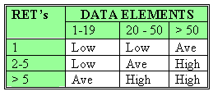

5, 6, 3, 4

8, 7, 20

5

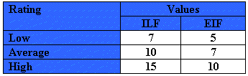

**Q6. (10 points)** For COCOMO intermediate embedded model, estimate effort and development time if the project size is 112 KLOC. Show your calculations, specify units for values defined. Make necessary assumptions and give explanations.

**Hints:**

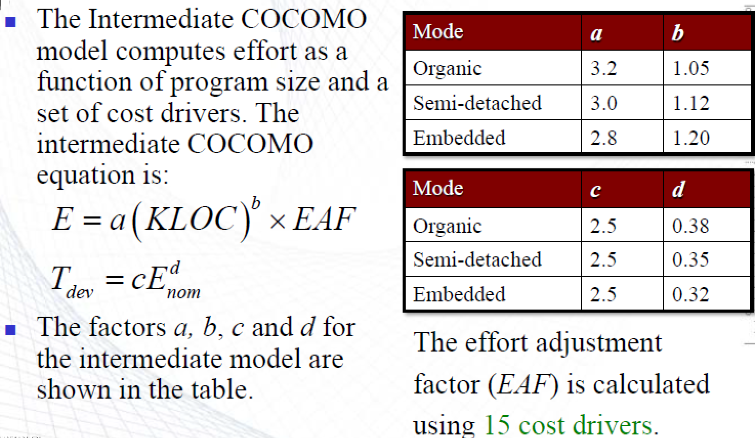

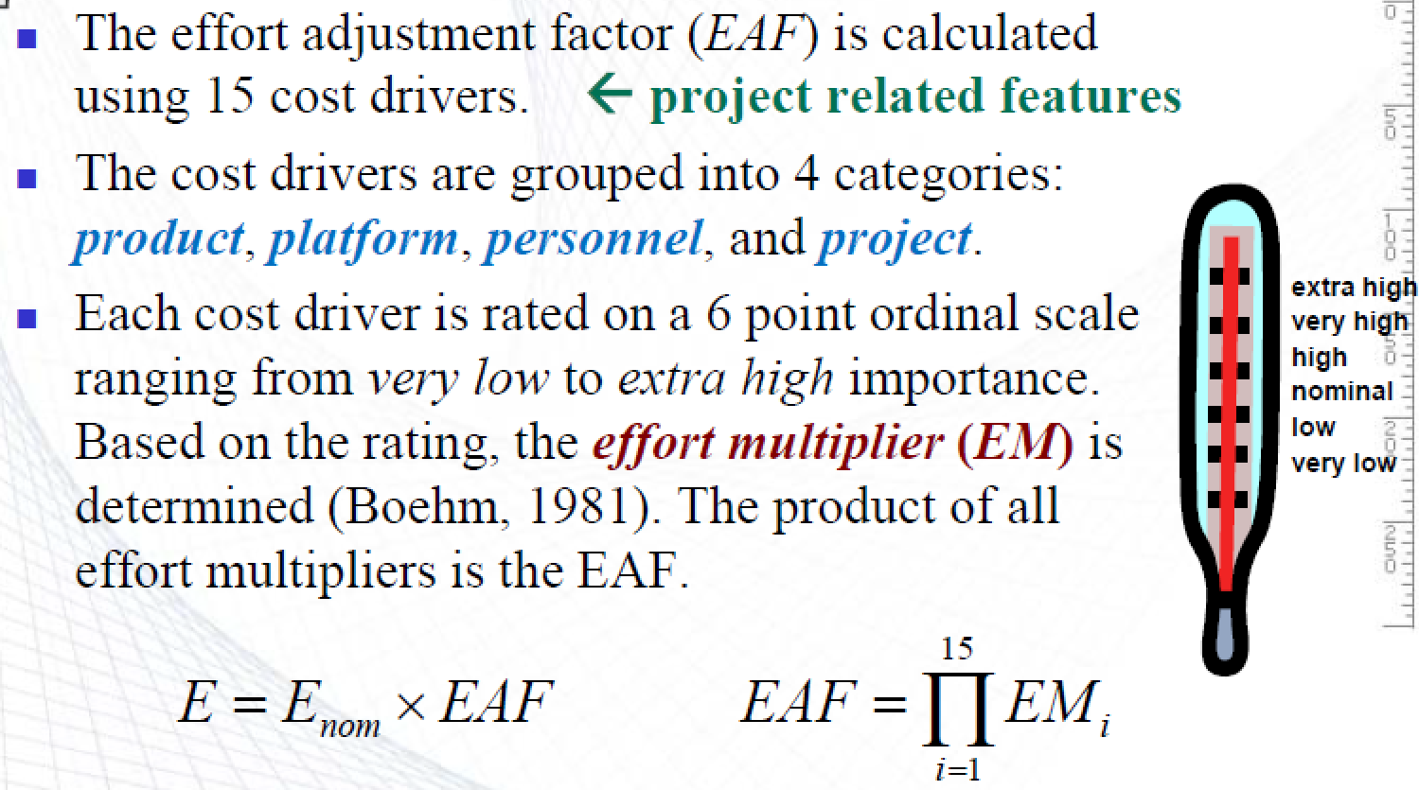

E=2.8*112^1.2=806 PM; T=2.5*806^0.32=21 months

**Q7. (8 points)** What is shown in the figure below?

How it is called? What are the parts of the picture? How they are called? Explain the meaning of stick figures, ellipses, edges, edges’ labels.

The figure is a use-case diagram. It has the parts: actors (stick figures), box (system as a whole), ellipses inside the box (use-cases – functionalities – services provided by the system to the actors), edges (connect actors to the services provided to them by the system). Labels of the edges are used to specify the roles of the actors or services for a particular service.

**Q8. (8 points)** For causes enlisted in the table below, build a Pareto diagram. Specify cumulative percentage of the two most influential complaint categories. Show your calculations. Give necessary explanations.

|  |  |  |
| --- | --- | --- |
| # | Complaint category | Frequency/week |
| 1 | System is not available too long | 29 |
| 2 | User interface is not understandable | 4 |
| 3 | System help is not enough | 98 |
| 4 | Too complicated queries used | 69 |
| 5 | Mobile version is slow | 43 |

The total number of problems #1,..,#5 revealed: T = 29 + 4 + 98 + 69 + 43 = 33 + 167 + 43 = 243

Percentages are: #1% = 29/243*100 = 11.9%; #2% = 4/243*100% = 1.6%; #3% = 98/243*100 = 40.3%; #4% = 69/243*100% = 28.4%; #5% = 43/243*100% = 17.7%;

Check that the sum of the percentages is 100%: 11.9 + 1.6 + 40.3 + 28.4 + 17.7 = 13.5 + 68.7 + 17.7 = 82.2 + 17.7 = 99.9%. Hence, let us take #2% = 1.7%.

Sort the problems by descending the percentages: #3 (40.3), #4 (28,4), #5 (17.7), #1 (11.9), #2 (1.7). Cumulative percentages are: 40,3; 68,7; 86,4; 98,3; 100, shown in the figure below:

The cumulative percentage of the two most influential problems, #3 and #4, is 68.7%

**Q9. (4points)** What a software configuration item is?

Computer program (sources, executables), documentation, or data