CMPE312 “Software Engineering” Term Project Spring 2020
28.02.2020
CMPE-312 Term Project “University Student Registration System (USRS)” – 40 points
Develop an application for a single host computer providing concurrent (parallel) work of four actors (participants) of the University Student Registration System (USRS): Student (S), Academic advisor (AA), Vice-Chair (VC), Vice-Dean (VD), System Administrator (SA). Implement USRS using data for the Faculty of Engineering, CMPE Department [1], Computer and Software Engineering Programs. Use information on the staff of CMPE and other necessary Departments from EMU and CMPE web-sites [1, 2]. Sample screenshots are shown in Figures 1-6.
The work shall be done in teams of 3-10 people. Reports are prepared by teams. Any programming language/environment and Database management system may be used.
Bonus (5 points): Develop on-line USRS
Functional requirements for USRS actors:
- Student:
  - View the list of courses offered in the registration priority order (failed and withdrawn courses (F, D-, W) shall be on the top, followed by not taken courses, followed by passed courses ordered by their reference code) [2, 3].
  - Add courses for a program. Normal load is 3-5 courses. Prerequisite courses shall be already passed [2, 3].
  - Delete courses from a program
  - Change group of a course in the program
  - View time-table of a group
- Academic advisor:
  - All Student’s functionalities
  - Program courses confirmation (single/all) for students advised by this AA.
- Vice-Chair:
  - All AA’s functionalities
  - Assigning S to AA inside VC’s Department
  - View/insert/delete/update departmental course information
- Vice-Dean:
  - View courses of all Faculty Departments
  - View programs of all students of the Faculty
- System Administrator
  - Introduce use to the system (give user name and password)
  - Assign role to a user (S, AA, VC, VD, SA)
Non-functional requirements;
- USRS shall provide interface similar to shown in Figures 1-6
- USRS shall provide security by the use of usernames and passwords.
The project has three phases:
- Proposal – presentation on March 23, 2020, Monday, 10.30-12.20, CMPE-137 (8 points)
- Design - presentation on April 27, 2020, Monday, 10.30-12.20, CMPE-137 (12 points)
- Implementation and testing - presentation on May 18, 2020, Monday, 10.30-12.20, CMPE-137 (20 points)
Report templates are provided in Homework . Reports shall be printed and have CD’s with all related to the project information (Report, design materials, sources, executables, etc.)
References
- CMPE Department
- EMU Web-site
- CMPE Curriculum
- CMSE Curriculum
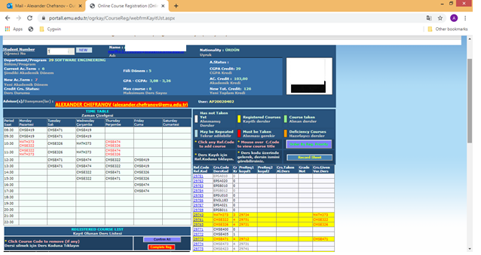
Figure 1. Program with clashes
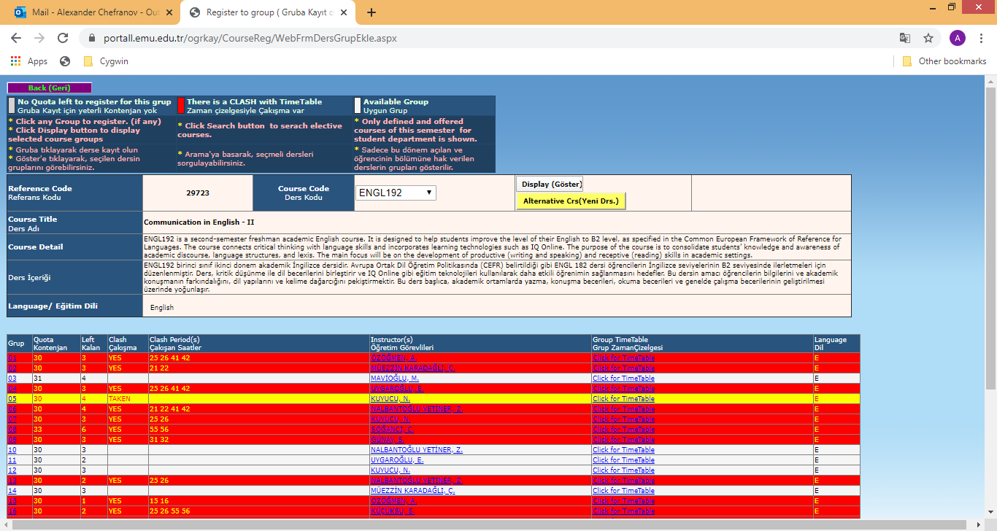
Figure 2. Selected group (yellow) and other with clashes, number of places left, group time-tables, teachers
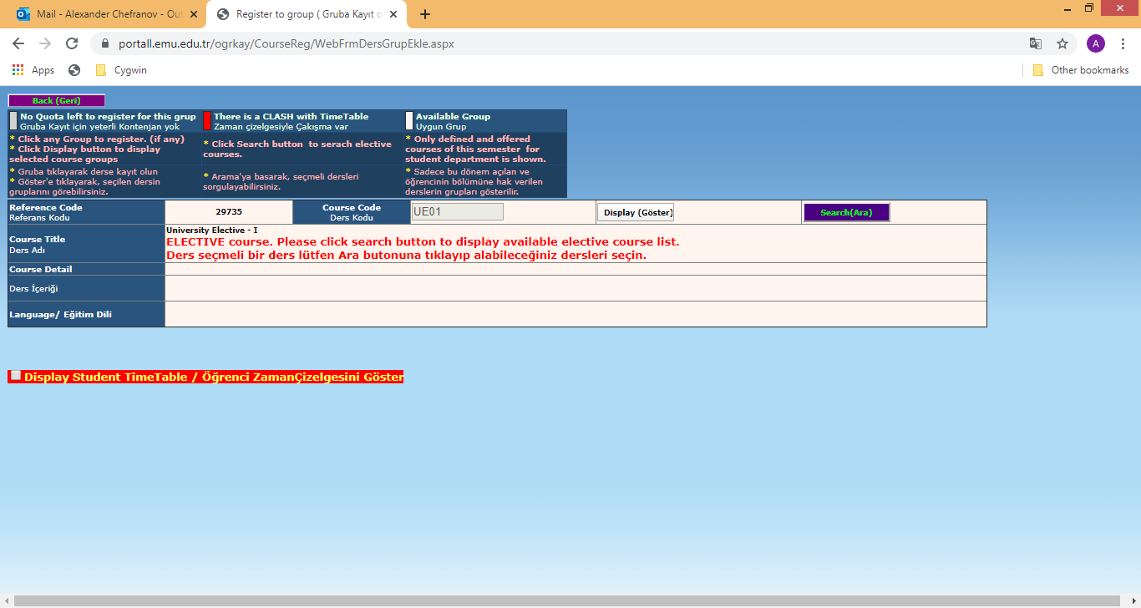
Figure 3. A screen to select from elective courses (click Select)

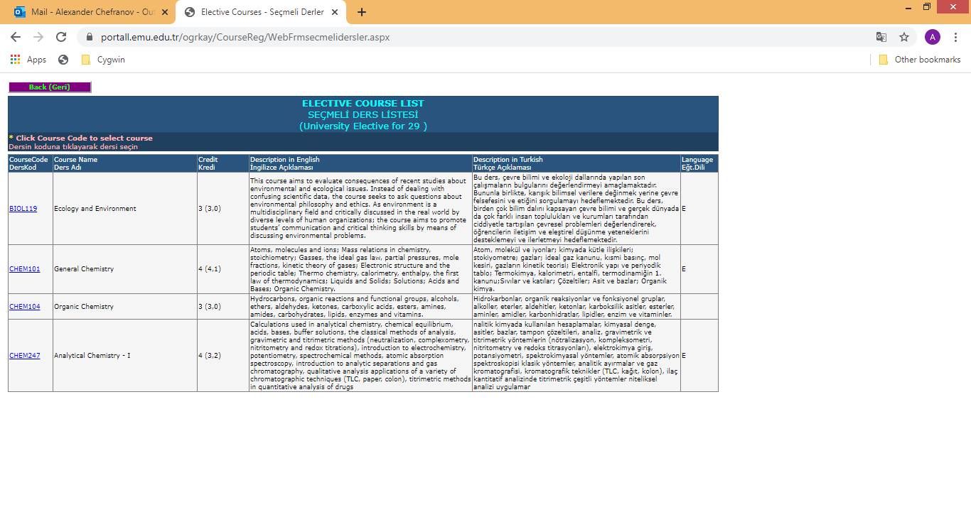
Figure 4. List of elective courses
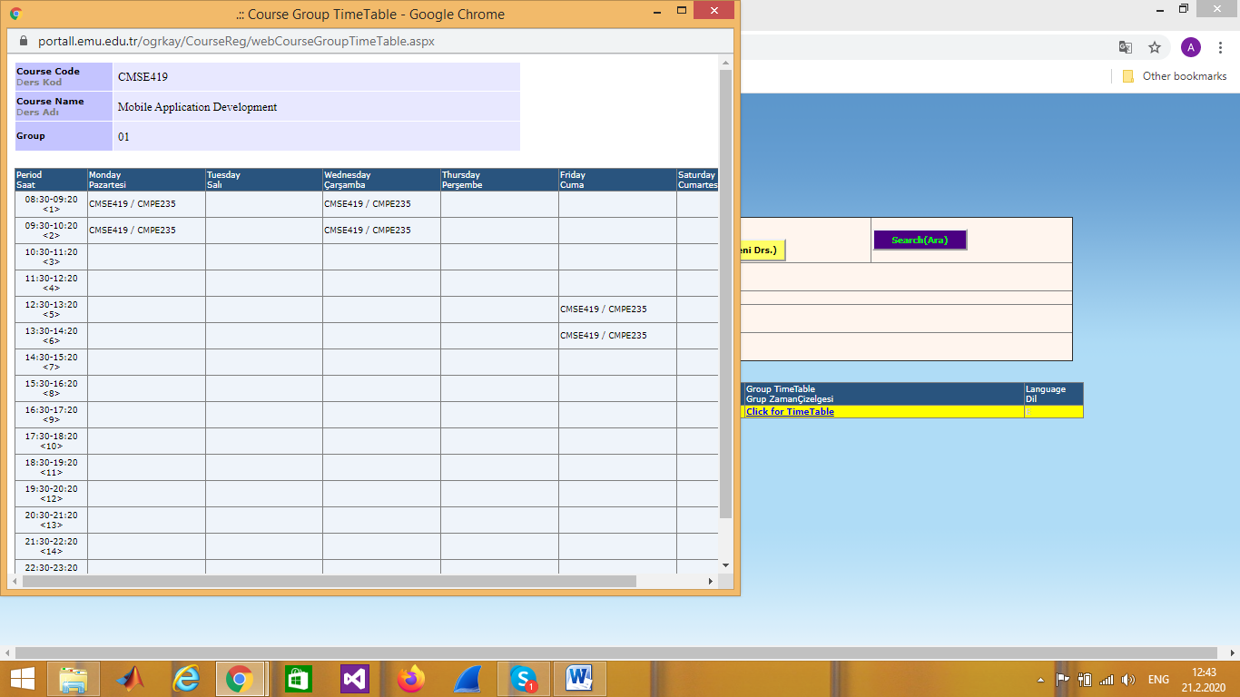
Figure 5. Pop-up window with a group time-table
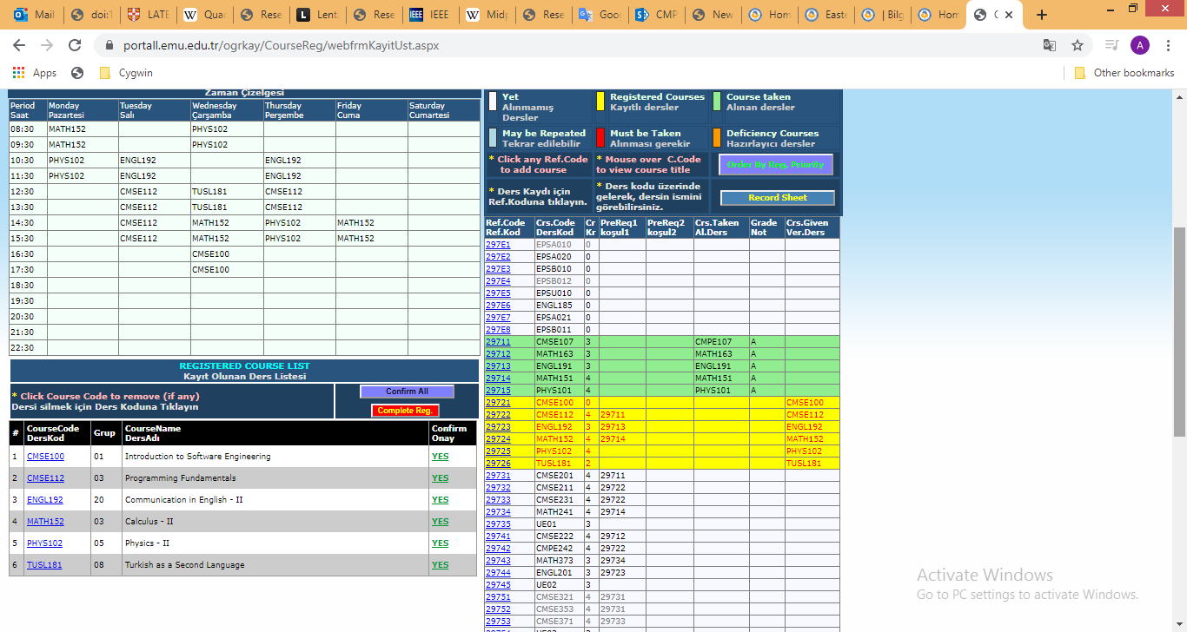
Figure 6. Time-table, selected courses, passed courses with grades

