**CMPE-412 Software Engineering**

**Spring 2018**

**Problem Session 6.04.2018**

**Function points**











From http://www.softwaremetrics.com/fpafund.htm

External Inputs (EI) - is an elementary process in which data crosses the boundary from outside to inside. This data may come from a data input screen or another application. The data may be used to maintain one or more internal logical files. The data can be either control information or business information. If the data is control information it does not have to update an internal logical file.  The graphic represents a simple EI that updates 2 ILF's (FTR's).

.[Please check out the online self paced function point training.](http://www.softwaremetrics.com/fponline.html)

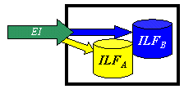

External Outputs (EO) - an elementary process in which derived data passes across the boundary from inside to outside. Additionally, an EO may update an ILF. The data creates reports or output files sent to other applications. These reports and files are created from one or more internal logical files and external interface file.  The following graphic represents on EO with 2 FTR's there is derived information (green) that has been derived from the ILF's

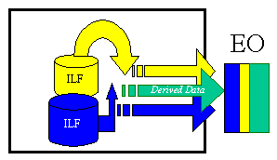

External Inquiry (EQ) - an elementary process with both input and output components that result in data retrieval from one or more internal logical files and external interface files. The input process does not update any Internal Logical Files, and the output side does not contain derived data. The graphic below represents an EQ with two ILF's and no derived data.

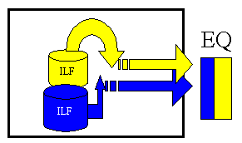

Internal Logical Files (ILF’s) - a user identifiable group of logically related data that resides entirely within the applications boundary and is maintained through external inputs.

External Interface Files (EIF’s) - a user identifiable group of logically related data that is used for reference purposes only. The data resides entirely outside the application and is maintained by another application. The external interface file is an internal logical file for another application.

After the components have been classified as one of the five major components (EI’s, EO’s, EQ’s, ILF’s or EIF’s), a ranking of low, average or high is assigned. For transactions (EI’s, EO’s, EQ’s) the ranking is based upon the number of files updated or referenced (FTR’s) and the number of data element types (DET’s). For both ILF’s and EIF’s files the ranking is based upon record element types (RET’s) and data element types (DET’s). A record element type is a user recognizable subgroup of data elements within an ILF or EIF. A data element type is a unique user recognizable, non recursive, field.

Each of the following tables assists in the ranking process (the numerical rating is in parentheses). For example, an EI that references or updates 2 File Types Referenced (FTR’s) and has 7 data elements would be assigned a ranking of average and associated rating of 4. Where FTR’s are the combined number of Internal Logical Files (ILF’s) referenced or updated and External Interface Files referenced.

**EI Table**

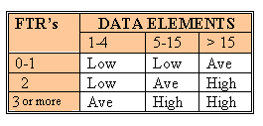

**Shared EO and EQ Table**

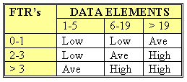

**Values for transactions**

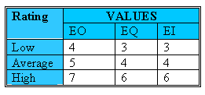

Like all components, EQвЂ™s are rated and scored. Basically, an EQ is rated (Low, Average or High) like an EO, but assigned a value like and EI. The rating is based upon the total number of unique (combined unique input and out sides) data elements (DETвЂ™s) and the file types referenced (FTRвЂ™s) (combined unique input and output sides). If the same FTR is used on both the input and output side, then it is counted only one time. If the same DET is used on both the input and output side, then it is only counted one time.

For both ILF’s and EIF’s the number of record element types and the number of data elements types are used to determine a ranking of low, average or high. A Record Element Type is a user recognizable subgroup of data elements within an ILF or EIF. A Data Element Type (DET) is a unique user recognizable, non-recursive (non-repeating) field on an ILF or EIF.

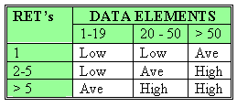

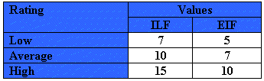

The counts for each level of complexity for each type of component can be entered into a table such as the following one. Each count is multiplied by the numerical rating shown to determine the rated value. The rated values on each row are summed across the table, giving a total value for each type of component. These totals are then summed across the table, giving a total value for each type of component. These totals are then summoned down to arrive at the Total Number of Unadjusted Function Points.

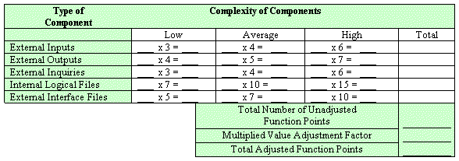

For Figure 23.2:

1. EI Table: EI#=3, FTR#=1 (ILF: system conf file)=> Low (3)
2. EO Table: EO#=2, FTR#=0 =>Low (4)
3. EQ Table: EQ#=2, FTR#=1(ILF: system conf file) => Low (3)
4. ILF Table: RET#=1, DET#= |{pwd, user, sensor, zone}| =4 => Low (7)
5. EIF Table: RET#=|{test sensot (1 DET), zone setting (1 DET), activate/deactivate (1 DET), alarm alert (1 DET)}| =4 => Low (5)