24.03.2023

**CMPE-455 Term Project “GPA/CGPA Online Calculator”**

**Task**

Develop an **on-line** application on at **least two host computer systems** providing concurrent (parallel) work of a server and a client of the GPA/CGPA Online Calculator (GOC): Sysadmin, Staff, User. Sysadmin is responsible for introducing users to the system. Staff is responsible for entering/updating student’s records (see Appendix 1). User chooses a record he/she has access to, and can request GPA or CGPA calculation (see Appendix 2) for it. Students’ records are stored encrypted by DES. DES secret key is created/updated periodically by Staff. Server has public/private RSA key pair. RSA digital signature is used when returning student’s GPA/CGPA calculated. RSA key pair is created/updated by Staff. Hash function (56 bits) used for the digital signature is obtained by XOR of DES ciphertext blocks.

**It is a team work. Reports on the Term Project shall be submitted 05.06.2023, via Teams and handed to in hard copy before 12.00 to the Lab Coordinator** [**NADA IBRAHIM S. M. S. KOLLAH**](https://cmpe.emu.edu.tr/tr/hakkimizda/personel/personel-detayi?sid=268&n=nada-ibrahim-s-m-s-kollah)**.**

Report shall have

* 1. Cover page (University, Department, Course, Semester, Year, City, Country, Term Project subject, Team members, Lecturer, Lab assistants)
  2. Outline
  3. Problem definition (see **Task** above)
  4. GOC description
  5. Description of the tools used for the GOC implementation (programming tools, distributed system organization tools, communication tools, synchronization tools, database management system tools, web-server tools, etc.)
  6. Description of GOC implementation in your programming language/operating system
  7. Description of the system architecture including at least two host computers
  8. Description of the database structure used for GOC
  9. Description of the implementation of actors: Sysadmin, Staff, User
  10. Description of the data structures used for implementation of Sysadmin, Staff, User
  11. Description of the algorithms used for implementation of Sysadmin, Staff, User
  12. Description of the tests conducted and their results, **screenshots** of them
  13. Conclusion
  14. References
  15. Appendices with the code developed (shall be referred when giving explanations required in item 6 above. Appendices shall be structured, e.g., Appendix 1. Source code of the Sysadmin process)

**Hard copies of the reports shall have attached CD’s with all related to the project information (report, design materials, sources, executables, etc.). Soft copies submitted via Teams shall be archived and also contain all related to the project information (report, design materials, sources, executables, etc.).**

**Appendix 1. Example of the student records**

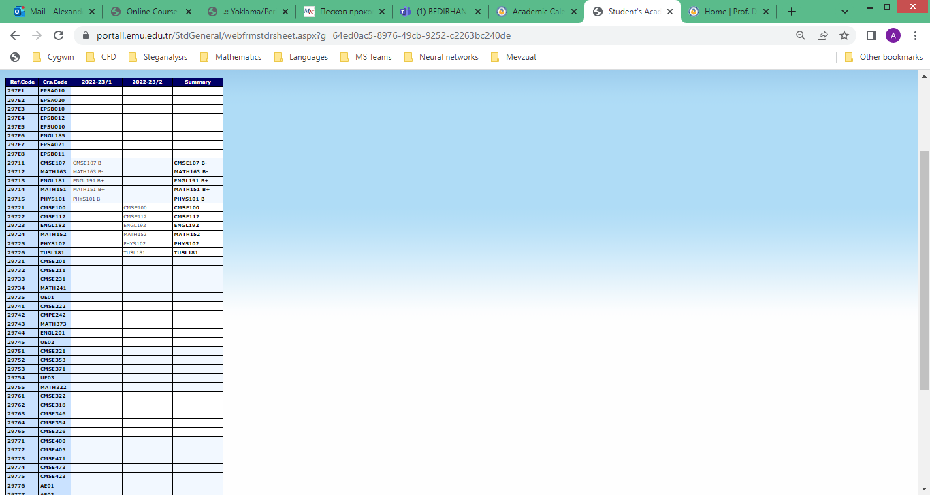

Fig. 1 Student’s record example (1st part)

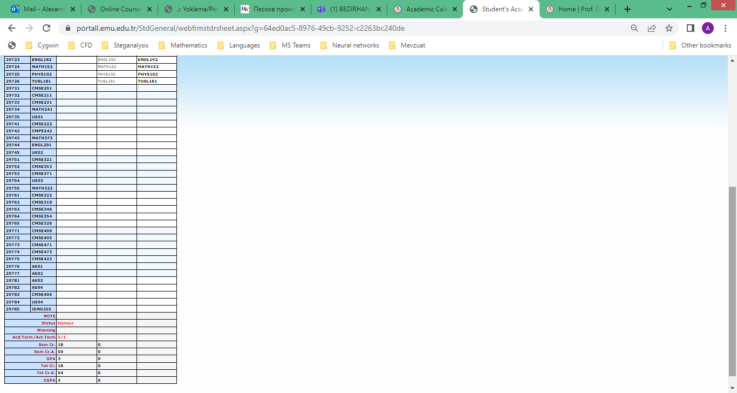

Fig. 2 Student’s record example (2nd part)

Appendix 2. GPA/CGPA calculation

<https://mevzuat.emu.edu.tr/5-1-4-Rules-examinations_and_evaluations.htm>

<https://ie.emu.edu.tr/Documents/MANE-Web_CGPA_Calculator-27-09-2017.xlsx>

