Ch 5 Network Security (from Introduction to Computer Security, M.T. Goodrich, R. Tamassia, Pearson, 2011, ISBN 10: 0-321-70201-8)

5.1. Network Security Concepts
Internet was originally a military project. For robustness, it communicates by sequences of data packets rather than using switched paths. A data packet is a finite-length set of bits, which is divided into two parts: a header which specifies where the packet is going and contains related details, and a payload, which is the actual information that is being communicated. Local area network (LAN) is composed of computers in relatively close proximity. Internet is a wide area network (WAN) composed of many machines and smaller networks. The routers in WANs on the Internet are partitioned into clusters called autonomous systems (ASs). Each AS is controlled by a single organizational entity which determines how packets will be routed among the nodes in that AS Typically, this routing within an AS is done using shortest paths, so that the number of hops to route a packet from one node to another in this AS is minimized and routing cycles are avoided. The routing between multiple ASs, on the other hand, is determined by contractual agreements, but it is still designed to avoid loops.
Five Layers
- Physical layer moves actual bits
- Link layer transfers data between a pair of network nodes or between nodes in a LAN and detects errors that occur at the physical layer. It finds good routing paths in a LAN. It includes such protocols at Ethernet which is used to route packets between computers sharing a common connection. The link layer provides a grouping of bits into ordered records called frames. The link layer uses 48-bit addresses called media access control addresses (MAC addresses).
- Network layer also known as the Internet layer for the Internet, is to provide for the moving of packets between any two hosts, on a best effort basis. Best-effort delivery describes a network service in which the network does not provide any guarantees that data is delivered or that a user is given a guaranteed quality of service level or a certain priority. In a best-effort network all users obtain best-effort service, meaning that they obtain unspecified variable bit rate and delivery time, depending on the current traffic load. It provides a way of individually addressing each host using a numerical label called its IP address. The main protocol provided by this layer is the Internet Protocol (IP), which is subdivided into a version 4 (IPv4), which uses 32-bit IP addresses, and a version 6 (IPv6), which uses 128-bit IP addresses. If the reliable delivery is required by an application, it will have to be provided by a higher layer.
- Transport layer is to support communication and connections between applications, based on IP addresses and port, which are 16-bit addresses for application-level protocols to use. The transport layer provides a protocol, the Transmission Control Protocol (TCP), which establishes a virtual connection between a client and a server and guarantees delivery of all packets in an ordered fashion, and a protocol, the User Datagram Protocol (UDP), which assumes no prior setup and delivers packets as quickly as possible with no delivery guarantees.
- Application layer is to provide protocols that support useful functions on the Internet, based on the services provided by the transport layer. Examples include HTPP, which uses TCP and supports web browsing, DNS, which uses UDP and supports the use of useful names for hosts instead of IP addresses, SMTP and IMAP, which use TCP and support electronic mail, SSL, which uses TCP and supports secure encrypted connections, and VoIP, which uses UDP and supports Internet telephone messaging.
In Open System Interconnection Model (OSI), application layer is split into three layers: application layer, presentation layer, and session layer for inter-host communications

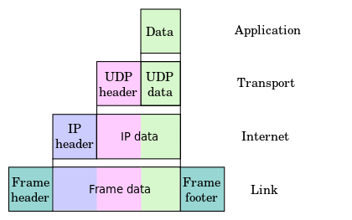
Fig. 5.2. Packet encapsulation in the Link, Network, Transport, and Application layers of the Internet Protocol Stack. Each packet from the higher layer becomes the data for the next lower-layer packet, with headers added to the beginning, and for frames, a footer added at the end. https://en.wikipedia.org/wiki/Encapsulation_(networking)
Confidentiality – standard protocols for each layer do not encrypt the contents of either their headers or their data. Encryption can be done at the application layer (as in the HTTPS protocol) or by revising a lower-layer protocol to include encryption, such as in the IPsec specification. Internet Protocol Security (IPsec) is a network protocol suite that authenticates and encrypts the packets of data sent over a network. IPsec includes protocols for establishing mutual authentication between agents at the beginning of the session and negotiation of cryptographic keys to use during the session. IPsec can protect data flows between a pair of hosts (host-to-host), between a pair of security gateways (network-to-network), or between a security gateway and a host (network-to-host).^{[1]} Internet Protocol security (IPsec) uses cryptographic security services to protect communications over Internet Protocol (IP) networks. IPsec supports network-level peer authentication, data-origin authentication, data integrity, data confidentiality (encryption), and replay protection.
Integrity is provided by validation of the simple checksums for data and/or header contents. These checksums are effective at determining if a small number of bits have been altered but they are not cryptographically secure, so they do not provide integrity in the computer security sense. If true integrity is required, then this should be done at the application layer or with alternative protocols at lower levels.
Availability can be attacked by bombarding web servers with data requests. To achieve availability, we need network applications that can scale with increases in communication requests and/or block attacks from illegitimate requests.

Also, Assurance, Authenticity, Anonymity shall be provided

The Link Layer
One of the most popular ways to transmit Internet traffic is Ethernet, which refers to both the physical medium used (typically a cable) as well as the link-layer protocol standardized as IEEE 802.3. When a frame is transmitted on an Ethernet cable, an electrical impulse is sent through the cable and received by other machines that are logically connected to that cable on the same LAN. For example, the original twisted pair Ethernet using repeater hubs was a logical bus topology carried on a physical star topology. The portion of a LAN that has the same logical connection is called a network segment. If two machines on the same network segment each transmit a frame at the same time, a collision occurs and these frames must be discarded and retransmitted. The Ethernet protocol deals with such events using a random-wait strategy (Fig. 5.5).

Fig. 5.6. Hub vs. switch: (a) A hub copies and transmits traffic to all attached devices. (b) A switch only transmits to frames to the appropriate destination device.
When devices are first connected to a switch, it acts like a hub, sending out frames to all connected machines. Over time, however, a switch learns addresses of the machines that are connected to its various ports. The selectivity reduces the possibility of collisions, increases bandwidth, and decreases the risks of network eavesdropping.
Media Access Control (MAC) Addresses
MAC address is a 48-bit identifier assigned to a network interface by its manufacturer. It is usually represented as a sequence of six pairs of hexadecimal digits, e.g., 00:16:B7:29:E4:7D, and every device that connects to a network has one.
MAC addresses are used in the link layer to identify the devices in a network. MAC addresses are expected to be unique for each interface. Typically, the first 24 bits are a prefix specifying the organization that issued that MAC address (the prefixes are issued by IEEE). The remaining 24 bits are left to a manufacturer to set so that each of its different model instances have unique MAC addresses.
MAC addresses can be also changed by the software through the network driver interface. Network administrators can issue their own MAC addresses to the network devices. These locally administered MAC addresses differ from the unique manufacturer MAC addresses by a standardized identifier bit. In a locally administered MAC address, the second least-significant bit of the most significant byte is set to 1, while in a manufacturer-issued MAC address, this bit is set to 0.
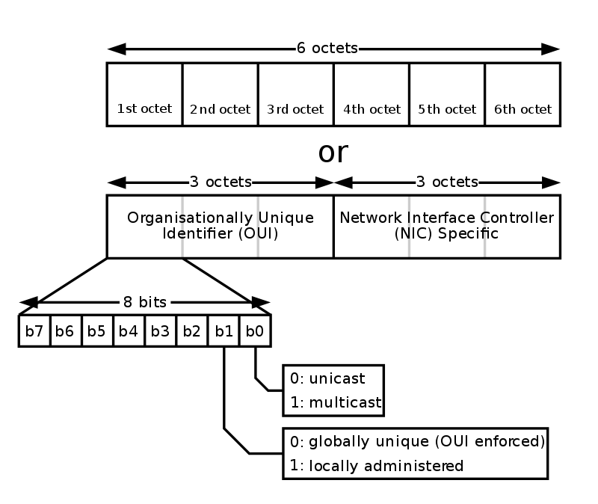
Figure is from https://en.wikipedia.org/wiki/MAC_address#/media/File:MAC-48_Address.svg
62:c4:42:a1:db:e4
https://olavmrk.github.io/html-macgen/
MAC addresses are used at the lınk layer to facılıtate the routıng of frames to the correct destınatıon. Switches learn the location of the network devices from their MAC addresses and they forward frames to the appropriate segments based on this knowledge. The format of the Ethernet frame is depicted on Fig. 5.7.
802.3 Ethernet packet and frame structure
Layer | Preamble | Start of frame delimiter | MAC destination | MAC source | 802.1Qtag (optional) | Ethertype(Ethernet II) or length (IEEE 802.3) | Payload | Frame check sequence(32-bit CRC) | Interpacket gap
 | 7 octets | 1 octet | 6 octets | 6 octets | (4 octets) | 2 octets | 46-1500 octets | 4 octets | 12 octets
Layer 2 Ethernet frame |  |  | ← 64–1522 octets →
Layer 1 Ethernet packet & IPG | ← 72–1530 octets → |  |  |  |  |  |  |  | ← 12 octets →

Each such frame contains its source and destination MAC addresses, a CRC-32 checksum for confirming data integrity, and a payload section, which contains data from higher layers such as the IP layer. The CRC-32 checksum is a simple function of the contents of the frame and it is designed to catch transmission errors, such as if a 0 bit in the frame is accidentally changed to 1 while travelling. It is not designed for strong authentication.
From https://en.wikipedia.org/wiki/Cyclic_redundancy_check :
Function CRC32
Input:
Data: Bytes Array of bytes
Output:
crc32: UInt32 32-bit unsigned crc-32 value
Initialize crc-32 to starting value
crc32 ← 0xffffffff
for each byte in data do
nLookupIndex ← (crc32 xor byte) and 0xFF;
crc32 ← (crc32 shr 8) xor CRCTable[nLookupIndex] //CRCTable is an array of 256 32-bit constants
Finalize the CRC-32 value by inverting all the bits
crc32 ← crc32 xor 0xFFFFFFFF
return crc32

ARP Spoofıng
The Address Resolutıon Protocol (ARP) is a link-layer protocol that provides services to the network layer.
Internet Protocol (IPv4) over Ethernet ARP packet
Octet offset | 0 | 1
0 | Hardware type (HTYPE)
2 | Protocol type (PTYPE)
4 | Hardware address length (HLEN) | Protocol address length (PLEN)
6 | Operation (OPER)
8 | Sender hardware address (SHA) (first 2 bytes)
10 | (next 2 bytes)
12 | (last 2 bytes)
14 | Sender protocol address (SPA) (first 2 bytes)
16 | (last 2 bytes)
18 | Target hardware address (THA) (first 2 bytes)
20 | (next 2 bytes)
22 | (last 2 bytes)
24 | Target protocol address (TPA) (first 2 bytes)
26 | (last 2 bytes)
From https://en.wikipedia.org/wiki/Address_Resolution_Protocol
ARP is used to find a host’s hardware address given its network layer address. Most commonly, it is used to determine the MAC address associated with a given IP address, which is clearly a valuable service. Unfortunately, there is a man-in-the middle attack against this protocol, which is called ARP spoofing.
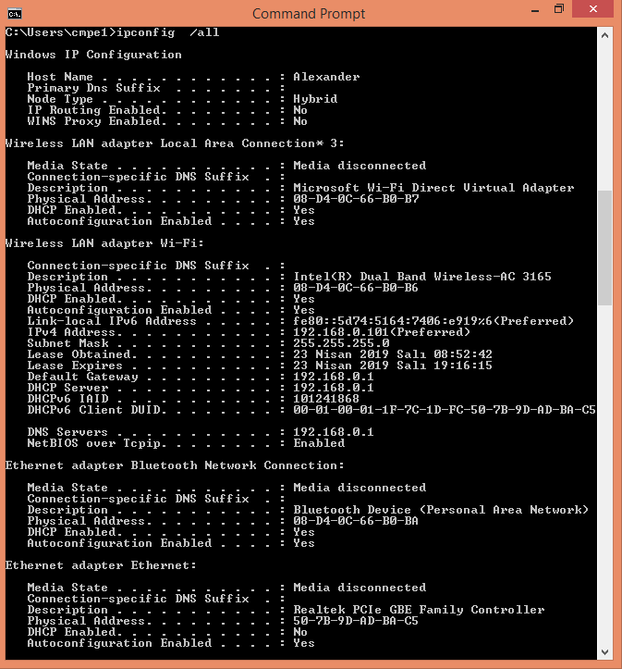
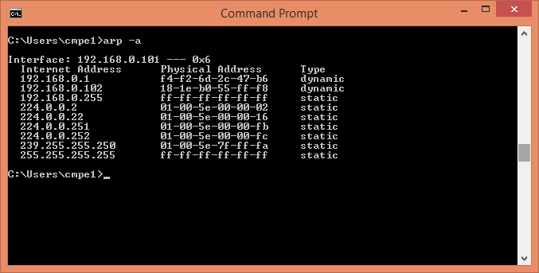
Suppose, a source machine wants to send a packet to a destination machine on the LAN. At the network layer, the source machine knows the destination machine IP address. Since the sending of the packet is delegated to the link layer, however, the source machine needs to identify the MAC address of the destination machine. In the ARP protocol, the resolution of IP addresses to MAC addresses is accomplished by means of a broadcast message that queries all the network interfaces on a LAN, so that the proper destination can respond.
An ARP request for an IP address, such as 192.168.181.125, is of the type:
“Who has IP address 192.168.181.125? Tell 192.168.181.132”
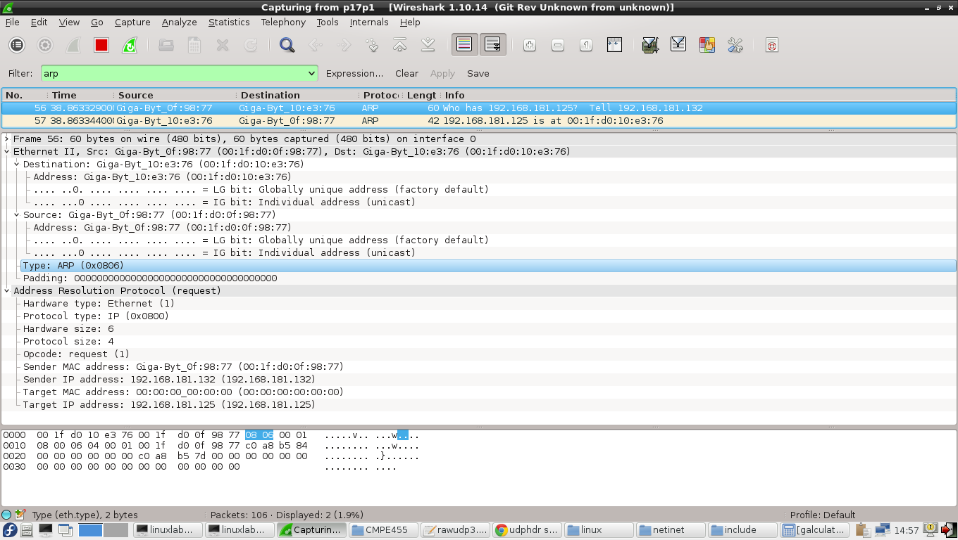
The request is sent to all the machines on the LAN. The machine with IP address 192.168.181.125, if any, responds with an ARP reply of the type:
“192.168.181.125 is at 00:1f:d0:10:e3:76”
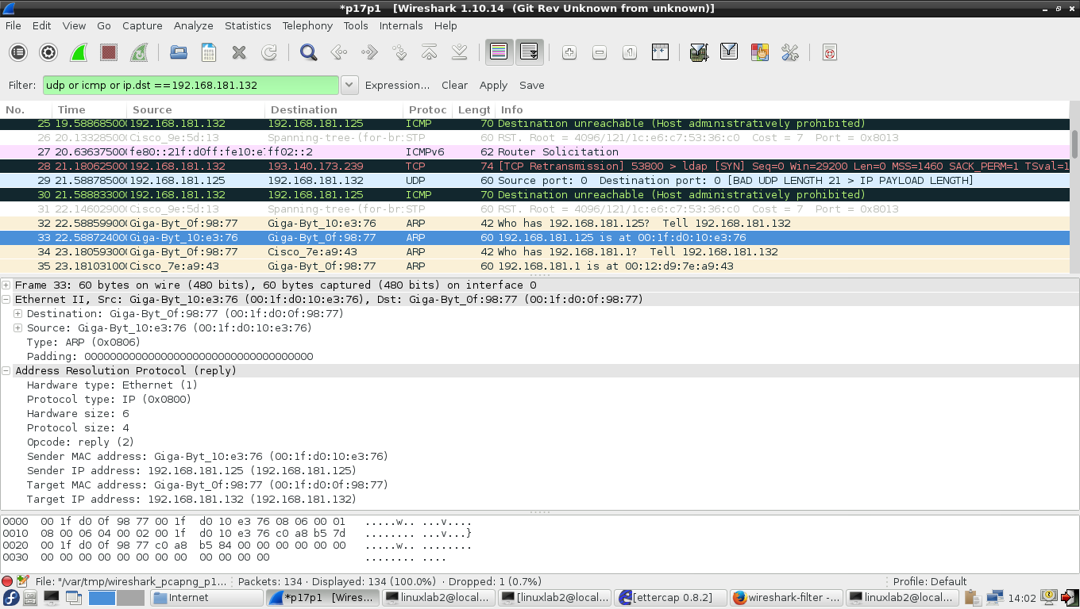
One more example on ARP request broadcasting:
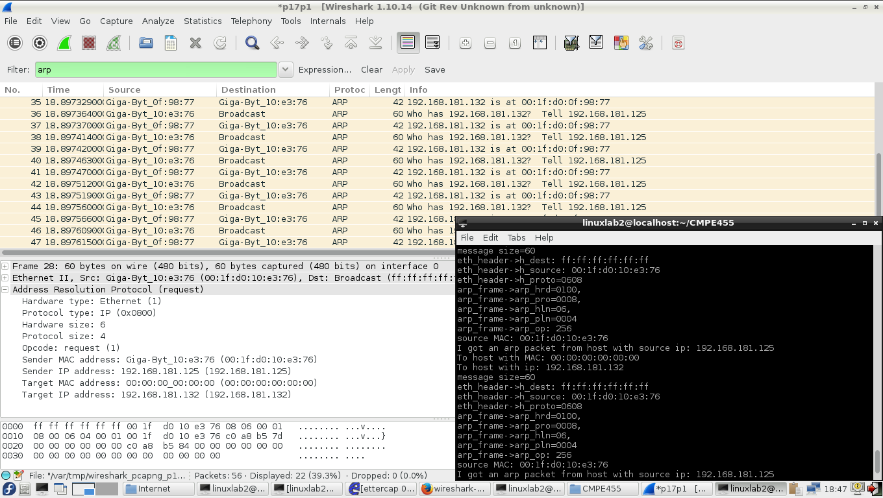
This ARP reply is transmitted in a frame addressed only to the machine that made the ARP request. When the machine receives the ARP reply, it stores the IP-MAC address pair locally in a table called ARP cache, so it does have to continuously resolve that particular IP address. After this ARP resolution, the source can finally send its data to the destination.
The ARP protocol is simple and effective, but it lacks an authentication scheme. Any computer on the LAN could claim to have the requested IP address. In fact, any machine that receives an ARP reply, even if it was not preceded by a request, will automatically update its ARP cache with the new association. Because of this shortcoming, it is possible for malicious parties on a LAN to perform the ARP spoofing attack.
This attack is relatively straightforward. An attacker, Eve, simply sends an ARP reply to a target, who we will call Alice, who associates the IP address of the LAN gateway , who we will call Bob, with Eve’s MAC address. Eve also sends an ARP reply to Bob associating Alice’s IP address with Eve’s MAC address. After this ARP cache poisoning has taken place, Bob thinks Alice’s IP address is associated with Eve’s MAC address, and Alice thinks Bob’s IP address is associated with Eve’s MAC address. Thus, all traffic between Alice and Bob (who is the gateway to the Internet) is routed through Eve, as depicted in Fig. 5.8.
Once accomplished, this establishes a man-in-the-middle scenario, where the attacker, Eve, has control over the traffic between the gateway, Bob, and the target, Alice. Eve can choose to passively observe the traffic allowing her to sniff passwords and other sensitive information, or she can even tamper with the traffic, altering everything that goes between Alice and Bob. A simple denial-of-service attack is also possible.
Sending ARP reply without request ten times from 192.168.181.125 to 192.168.181.132 spoofing MAC address of 192.168.181.126:
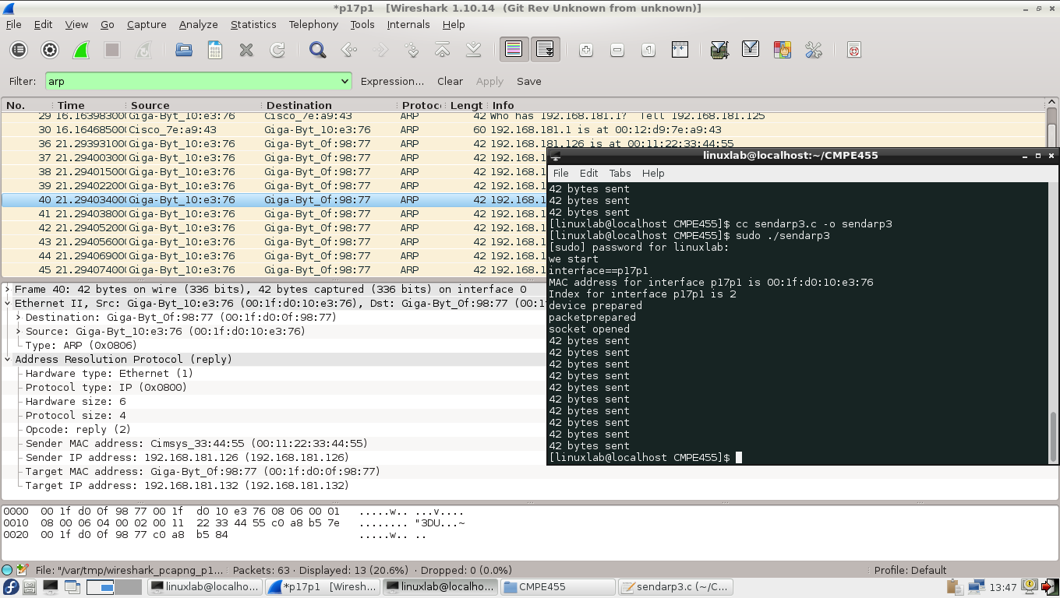
After spoofing in 192.168.181.132, ARP table is poisoned:
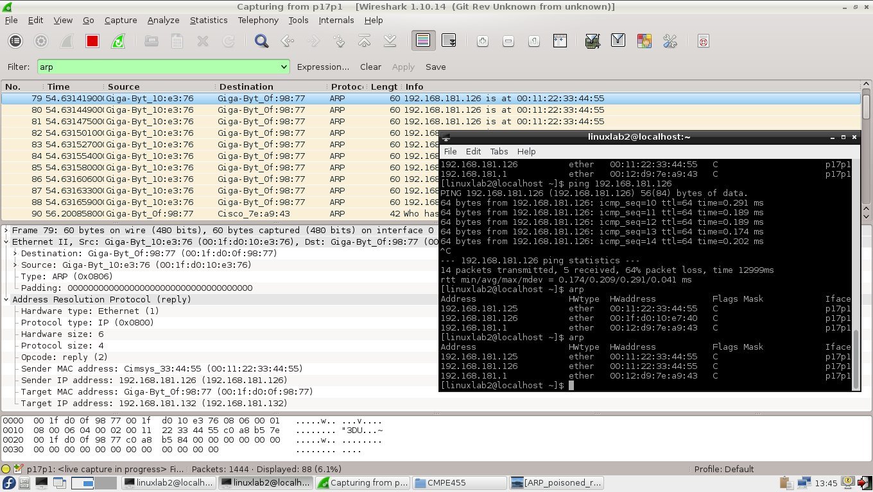
The power of ARP spoofing is derived from the lack of identity identification in the Internet’s underlying mechanisms. This attack requires users to take caution in securing their local networks. Fortunately, there are several means of preventing ARP spoofing, besides restricting LAN access to trusted users. One simple technique involves checking for multiple occurences of the same MAC address on the LAN, which may be an indicator of possible ARP spoofing.
Another solution, known as static ARP tables, requires a network administrator to manually specify a router’s ARP cache to assign certain MAC addresses to specfic IP addresses. When using static ARP tables, ARP requests to adjust the cache are ignored, so ARP spoofing of that router is impossible. This requires the inconvenience of having to manually add entries for each device on the network, however, and reduces flexibility when a new device joins the network, but significantly mitigates the risk of ARP cache poisoning. Moreover, this solution does prevent an attacker from spoofing a MAC address to intercept traffic intended for another host on the network.

Network Layer
The task of the network layer is to move packets between any two hosts in a network, on a best effort basis. It relies on the services provided by the link layer.

IP
The Internet Protocol (IP) is the network-level protocol that performs a best effort to route a data packet from a source node to a destination node in the Internet. In IP, every node is given a unique numerical 32-bit number under version 4 (IPv4) and a 128-bit number under version 6 (IPv6). Both the source and destination of any transmission are specified by an IP address.
A host, such as a desktop PC, smartphone, or server, employs a simple algorithm for routing packets from that host (see Fig. 5.9):
- İf the packet is addressed to a machine on the same LAN as the host, then the packet is directly transmitted on the LAN, using the ARP protocol to determine the MAC address of the destination machine.
- İf the packet is addressed to a machine that is not on the LAN, then the packet is transmitted to a specially designated machine on the LAN, called a gateway, which will handle the next step of the routing. The ARP protocol is used to determine the MAC address of the gateway.
Once a packet has reached a gateway node, it needs to be furher routed to its final destination on the Internet. Gateways and other imtermediate network nodes that handle the routing of the packets on the Internet are called routers. They are typically connected to two or more LANs and use internal data structures, known as routing tables, to determine the next router to which the packet should be sent. Given a data packet with destination, t, a routing table lets a router determine which of its neighbors it should send this packet to. The determination is based on the numerical address, t, and the routing protocol that encodes the next hop from this router to each possible destination.
Fig. 5.9. Routing on the Internet. A first packet, from the client to Server A, is sent directly over LAN A. The transmission of the first packet is shown with a dashed arrow. A second packet, from the source to Server B, is sent to the gateway of LAN A, then forwarded by several intermediate routers, and finally delivered to Server B by the gateway of LAN B. The path followed by the second packet is shown with black solid arrows. Adjacent routers are themselves connected via LANs. The route of a packet may not be the shortest path (in terms of the number of edges or total delay) between the source and destination.
Misconfigurations in the routing tables may cause a packet to travel forever aimlessly along a cycle of routers. To prevent this possibility and other error conditions that keep unroutable packets on the network, each IP packet is given a time-to-live (TTL) count by its source. This TTL value, also known as a hop limit, can be as large as 255 hops and is decremented by each router that processes the packet. If a packet’s TTL ever reaches zero, then the packet is discarded and an error packet is sent back to the source. A packet with TTL equal to zero is said to be expired and should be discarded by a router that sees it.

The Structure of the Internet
Routers are designed to be very fast. For each packet received, the router performs one of the three possible actions:
- Drop – if the packet is expired, it is dropped
- Deliver – if the destination is a machine on one of the LANs to which the router is connected, then the packet is delivered to the destination
- Forward – if the destination of the packet does not belong to the LANs of the router, then the packet is forwarded to the neıghborıng router.
There are two primary protocols that determine how the next hops are encoded in Internet routing tables, Open Shortest Path First (OSPF), and Border Gateway Protocol (BGP). OSPF determines how packets are routed within an autonomous system and is based on a policy that packets should travel along shortest paths. BGP, on the other hand, determines how packets are routed between autonomous systems (ASs), and it is based on policies dictated by the contractual agreements between different ASs. The routes established by BGP may not be shortest paths.
Note the difference between a router and a switch. A switch is a simple device that handles forwarding of packets on a single network and uses learned associations to reduce the use of broadcasting. A router, on the other hand, is a sophisticated device that can belong to multiple networks and uses routing tables to determine how to forward packets, thereby avoiding broadcast altogether.
The bits in an IP packet have a careful structure. Each IP packet consists of the fixed-length header, which is partitioned into various fields, shown in Fig. 5.10, followed by a variable-length data portion. Note that the header has specific fields, including the total length of the packet, the time-to-live (TTL) for the packet, the source IP address, and the destination IP address.
Although it does not guarantee that each packet successfully travels from its source to its destination, IP does not provide a means to detect if the packet headers are damaged along the way. Each IP packet comes with a checksum value, which is computed on its header contents. Any host or router wishing to confirm that this header is intact simply needs to recompute the checksum function and compare the computed checksum value to the checksum value that is stored inside the packet. Since some parts of the header, like the TTL, are modified with each hop, this checksum value must be checked and recomputed by each router that processes that packet. The protocol field of an IP packet specifies the higher level protocol that should receive the payload of the packet, such as ICMP, TCP, or UDP of the transport layer. The Internet Control Message Protocol (ICMP) is a supporting protocol in the Internet protocol suite. It is used by network devices, including routers, to send error messages and operational information indicating, for example, that a requested service is not available or that a host or router could not be reached.^{[1]} ICMP differs from transport protocols such as TCP and UDP in that it is not typically used to exchange data between systems, nor is it regularly employed by end-user network applications (with the exception of some diagnostic tools like ping and traceroute).
The Internet is divided into ASs, so routing tables have to be able to direct traffic to clusters of nodes, not just individual destination. To facilitate this ability, the IP addressing scheme takes into account the fact that networks are partitioned into logical groupings known as subnetworks, or more commonly, subnets. As mentioned, IPv4 addresses are 32-bit numbers that are stored as binary but typically written as 4 bytes, such as 192.168.1.100. IP addresses can be divided into two portions, a network portion that denotes an IP prefix used by all machines on a particular network, and a host portion, which identifies a particular network device. These two portions are differentiated by providing a subnet mask along with the IP address. The network portion of the IP address can be identified by bitwise ANDing the subnet mask with the IP address, and the host portion can be defined by XORing this result with the IP address (see Table 5.1).
Subnet masks are used to define the address range of a particular network. Ranges of IP addresses are based on the size of the organization in question. A Class A network, which is the largest, has a subnet mask of at least 8 bits and includes up to 2²⁴=16,777,216 unique IP addresses. Class A networks are typically reserved for large government organizations and telecommunications companies. Class B networks have at least 16-bit subnet mask and up to 2¹⁶=65,536 unique addresses; they are usually allocated for Internet Service Providers (ISPs) and large businesses. Finally, Class C networks have at least a 24-bit subnet mask, include up to 2⁸=256 unique addresses, and are assigned to smaller organizations. IP addresses with the host portion consisting of all zeros and all ones have a special meaning and are not used to identify machines. Thus, a Class C network has 254 usable IP addresses.

Internet Control Message Passing Protocol
ICMP is used by hosts to perform a number of basic testing and notifications tasks. ICMP is primarily used for network diagnostic tasks, such as determining if a host is alive and finding the path followed by a packet. ICMP packets carry various types of messages, including the following:
- Echo request – Asks the destination machine to acknowledge the receipt of the packet
- Echo response – Acknowledge the receipt of a packet in reply to an echo request
- Time exceeded – Error notification that a packet has expired , that is, its TTL is zero
- Destination unreachable – Error notification that the packet could not be delivered
Several network management tools use the above ICMP messages, including ping and tracert utilities. Ping sends ICMP echo request messages to the destination host, which in turn replies with ICMP echo response message. This remarkably simple protocol is often the first diagnostic tool used to test if hosts work properly.
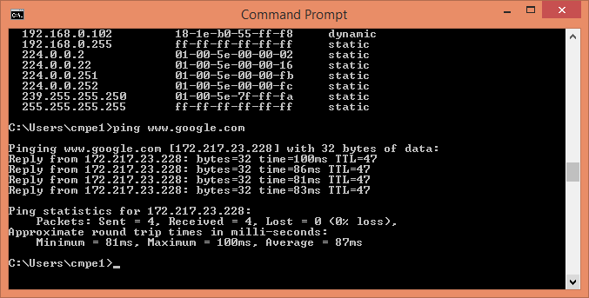
Tracert utililty uses ICMP messages to determine the path a packet takes to reach another host, either on a local network or on the Internet. It accomplishes that task with a clever use of the TTL field in the IP packet header. First, it attempts to send a packet to the target with a TTL of 1. On receiving a message with TTL =1, an intermediate router discards it and replies to the sender with an ICMP time exceeded message, revealing the first machine along the path to the target. Next, tracert sends a packet with TTL=2. On reaching the first router in the path, the TTL is decremented by one and forwarded to the next router, which in turn sends an ICMP packet to the orıgınal sender. By incrementing the TTL field in this way, tracert cn determine each host along the path to the target. The tracert utility is illustrated in Fig. 5.11
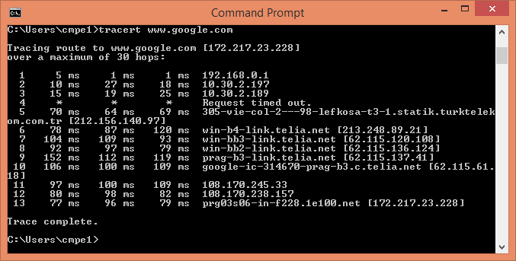

IP Spoofing
Each IP packet includes a place to specify the IP addresses of the destination and source nodes of the packet. The validity of the source address is never checked, however, and it is trivial for anyone to specify a source address that is different from their actual IP address. In fact, nearly every operating system provides an interface by which it can make network connection with arbitrary IP header information, so spoofing an IP address is a simple matter of specifying the desired IP in the source field of an IP packet data structure before transmitting that data to the network. Such modification of the source address to something other than the sender’s IP address is called IP spoofing (see Fig. 5.12). The attacker has not any response from the destination that may be used for the Denial of Service attack.

