( W. Stallings'ten, KRİPTOGRAFİ VE AĞ GÜVENLİĞİ İLKELERİ VE UYGULAMALARI, BEŞİNCİ BASKI, 2011)

Eliptik Eğriler

Şekil 10.4 Eliptik Eğrilere Örnek
Abelian grubu aşağıdaki aksiyomları karşılar:

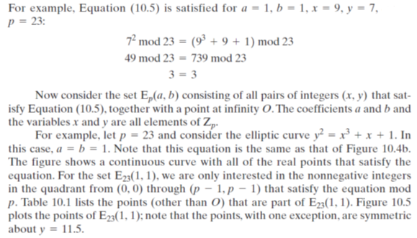
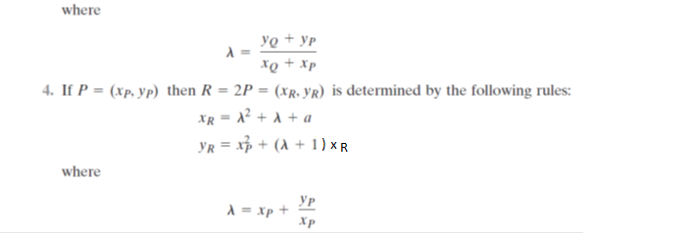
Let $P=\left(g^{5},g^{3}\right),$ let’s find $R=2P=P+P$. Calculate $λ=x_{P}+\frac{y_{P}}{x_{P}}=x_{P}+y_{P}∙x_{P}^{-1}$
Calculate $x_{P}^{-1}={(g}^{5} mod {(g}^{4}+g+{1))}^{-1} mod {(g}^{4}+g+1)={(g}^{2}+{g)}^{-1} mod {(g}^{4}+g+1)$. Use EEA:
- A=(1,0, $g^{4}+g+1$), B=(0,1, $g^{2}+g$)
- Q=A3/B3=$g^{2}+g+1$
Dividend | Divisor | quotient
$$g^{4}+g+1$$  +  $g^{4}+g^{3}$ | $$g^{2}+g$$ | $$g^{2}+g+1$$
$$g^{3}+g+1$$
+
$$g^{3}+g^{2}$$
$$g^{2}+g+1$$
+
$$g^{2}+g$$
1 remainder
T=A-Q*B=(1, $g^{2}+g+1$,1)
- T3=1=>T2=$g^{2}+g+1$=${{(g}^{2}+g)}^{-1}=x_{P}^{-1}$
Check it: $\left(g^{2}+g+1\right)\left(g^{2}+g\right)=g^{4}+g^{3}+g^{2}+g^{3}+g^{2}+g=g^{4}+g mod \left(g^{4}+g+1\right)=1$
Hence, $λ=x_{P}+\frac{y_{P}}{x_{P}}=x_{P}+y_{P}∙x_{P}^{-1}=g^{5}+g^{3}\left(g^{2}+g+1\right)=g^{5}+g^{5}+g^{4}+g^{3}=g^{4}+g^{3}=g^{3}+g+1$
$$x_{R}=λ^{2}+λ+a={(g^{3}+g+1)}^{2}+g^{3}+g+1+g^{4}=\left(g^{3}+g+1\right)\left(g^{3}+g\right)+g^{4}=g^{6}+g^{4}+g^{3}+g^{4}+g^{2}+g+g^{4}=g^{6}+g^{4}+g^{3}+g^{2}+g=g^{3}+g^{2}+g+1+g^{3}+g^{2}+g=1$$
$$y_{R}=x_{P}^{2}+\left(λ+1\right)x_{R}={\left(g^{5}\right)}^{2}+\left(g^{3}+g\right)∙1={\left(g^{2}+g\right)}^{2}+g^{3}+g=g^{4}+g^{2}+g^{3}+g=g+1+g^{2}+g^{3}+g=g^{3}+g^{2}+1=1101=g^{13}$$
Hence, $R=\left(x_{R}, y_{R}\right)=\left(1,g^{13}\right)$ present in Table 10.2

Eliptik Eğri Kriptografisi

Eliptik Eğri Dijital İmza Algoritması ( https://en.wikipedia.org/wiki/Elliptic_Curve_Digital_Signature_Algorithm adresinden )

