Final Exam CMPE-523 16.01.2026 (100 points, 180 min)
St. Name, Surname______________________________________ St.Id#_____________
Instructor Alexander Chefranov

Five A4-sized cheat sheets with your own handwritings can be used for your help (printouts, photocopies, etc. are not allowed). Calculators (standalone) can be used. Telephones, other electronic devices are not allowed.

Totally 5 tasks, 100 points, 13 pages
Task | Task 1 | Task 2 | Task 3 | Task 4 | Task 5 | Total
Point | 14 | 19 | 18 | 22 | 27 | 100
Grade
Good Luck!

Task 1. (20 points). Consider Fig. 1-4 from the Lecture notes: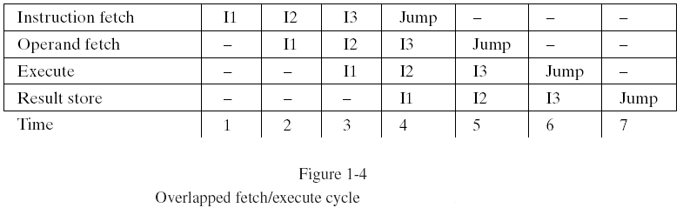
How much time takes execution of the instructions I1-I43 if
- using pipelining

From Fig. 1-4, it is seen that I3 completes at time instance 6.

- not using pipelining
Each instruction takes 4 time units, hence, time to complete I1-I3 is 3*4=12 time units

Explain your answers

Task 2. (19 points). Consider the following code from the Lecture notes:
/* matrix multiply, C=A*B. Compute elements of C by
*/
private i, j , k;
shared a[N,N], b[N,N], c[N,N], N;
/*start N-1 new processes, each for the different column of c*/
for j:=0 step 1 until N-2 fork DOCOL;
/*the original process reaches that point and does the column N-1*/
j:=N-1;
DOCOL:
For i:=0 step 1 until N-1 begin
/*compute a row i element of j-th column of c*/
/*initialize the sum for the inner product*/
c[i,j]:=0;
/*loop over the terms of the inner product*/
for k:=0 step 1 until N-1
/*add the k-th inner product term*/
c[i,j]:=c[i,j]+a[i,k]*b[k,j];
/*end of the product term loop*/
end /*of all rows*/
join N;
- (2 points) What does this code calculate? Why?
It calculates a product of two matrices, A and B, because it implements a formula for the matrix product

- (3 points) What is the target computer system for it (SISD, SIMD, MISD, MIMD)? Why?

The target computer is MIMD because respective constructs as fork, join are used.

- (14 points) Assuming N=3, $A=\left(\begin{matrix}1 & 2 & 3 \\ 4 & 5 & 1 \\ 2 & 3 & 4\end{matrix}\right)$, $B=\left(\begin{matrix}3 & 2 & 1 \\ 1 & 2 & 1 \\ 1 & 3 & 2\end{matrix}\right)$, explain how $C\left(1,1\right),C\left(2,1\right), C(3,1)$ are calculated: specify lines of code (use line numbers 1-18) responsible for these calculations, indicate which shared and local variables are used, trace them (for each instruction, specify affected variables’ new states), check that results obtained are correct
C(1:3, 1), the 1st column of C as C(0:2, 0), is calculated in lines 8-17 labeled by DOCOL by the 1st child created by the master process by fork in line 4. Local variables used are declared in line 1: j, i, and k. Variable j is initialized by 0 when forking in line 4. Shared variables used are A, B, C, N (see line 2).

# | Instruction line number | Action
1 | 8 | I=0
2 | 11 | C[0,0]=0;
3 | 13 | K=0
4 | 15 | C[0,0]=a[0,0]*b[0,0]=1*3=3
5 | 13 | K=1
6 | 15 | C[0,0]=c[0,0]+a[0,1]*b[1,0]=3+2*1=5
7 | 13 | K=2
8 | 15 | C[0,0]= c[0,0]+a[0,2]*b[2,0]=5+3*1=8
9 | 17,8 | I=1
10 | 9 | C[1,0]=0
11 | 13 | K=0
12 | 15 | C[1,0]=0+a[1,0]*b[0,0]=4*3=12
13 | 13 | K=1
14 | 15 | C[1,0]=c[1,0]+a[1,1]*b[1,0]=12+5*1=17
15 | 13 | K=2
16 | 15 | C[1,0]=c[1,0]+a[1,2]*b[2,0]=17+1*1=18
17 | 17, 8 | I=2
18 | 11 | C[2,0]=0
19 | 13 | K=0
20 | 15 | C[2,0]=c[2,0]+a[2,0]*b[0,0]=0+2*3=6
21 | 13 | K=1
22 | 15 | C[2,0]=c[2,0]+a[2,1]*b[1,0]=6+3*1=9
23 | 13 | K=2
24 | 15 | C[2,0]=c[2,0]+a[2,2]*b[2,0]=9+4*1=13
25 | 18
Thus, C[0:2,0]=[8,18,13]. Actually, c[0,0]=1*3+2*1+3*1=8, c[1,0]=4*3+5*1+1*1=18, c[2,0]=2*3+3*1+4*1=13.

Task 3. (18 points). Consider Program 3-9 from the Lecture notes:
X[i]=c[i], (1<=i<=n); /*initialize the x vector making x1 correct*/
For j:=1 step 1 until n-1
X[i]:=x[i]+A[I,j]*x[j], (j+1<=i<=min(j+m,n));
/*do all column j multiplies and add to vector x, completing x[j+1] */
Program 3-9. Column sweep form of a linear recurrence solver
Assuming $A=\left(\begin{matrix}\begin{matrix}0 & 0 \\ 1 & 0\end{matrix} & \begin{matrix}0 & 0 \\ 0 & 0\end{matrix} \\ \begin{matrix}2 & 3 \\ 4 & 5\end{matrix} & \begin{matrix}0 & 0 \\ 6 & 0\end{matrix}\end{matrix}\right)$, $c=\left(\begin{matrix}\begin{matrix}2 \\ 1\end{matrix} \\ \begin{matrix}2 \\ 1\end{matrix}\end{matrix}\right)$, trace the program ((for each instruction, specify affected variables’ new states). Check that solution obtained is correct.
# | Instruction | Effect
1 | X[i]=c[i], (1<=i<=n); | X[1:4]=c[1:4]=[2,1,2,1]
2 | For j:=1 step 1 until n-1 | J=1
3 | X[i]:=x[i]+A[I,j]*x[j], (j+1<=i<=min(j+m,n)); | X[2]=x[2]+a[2,1]*x[1]=1+1*2=3  X[3]=x[3]+a[3,1]*x[1]=2+2*2=6  X[4]=x[4]+a[4,1]*x[1]=1+4*2=9
4 | For j:=1 step 1 until n-1 | J=2
5 | X[i]:=x[i]+A[I,j]*x[j], (j+1<=i<=min(j+m,n)); | X[3]=x[3]+a[3,2]*x[2]=6+3*3=15  X[4]=x[4]+a[4,2]*x[2]=9+5*3=24
6 | For j:=1 step 1 until n-1 | J=3
7 | X[i]:=x[i]+A[I,j]*x[j], (j+1<=i<=min(j+m,n)); | X[4]=x[4]+a[4,3]*x[3]=24+6*15=114
Thus, X[1:4]]=[2,3,15,114]. Actually, x[1]=c[1]=2, x[2]=c[2]+a[2,1]*x[1]=2+1*1=3, x[3]=c[3]+a[3,1]*x[1]+a[3,2]*x[2]=2+2*2+3*3=15, x[4]=c[4]+a[4,1]*x[1]+a[4,2]*x[2]+a[4.3]*x[3]=1+4*2+5*3+6*15=114.

Task 4. (22 points). Consider Program 3-11 from the Lecture notes:
SIMD MATRIX MULTIPLICATION EXAMPLE (CONT 1)
CLOAD ZERO Initialize all
CBCAST PE accumulators
MOVR TOA to zero
STO C,I Zero the I-th row of C
LDXI J,0 Initialize the column index
LDX LIM,N Loop limit is the matrix size
LOOP: LOD A,I Fetch the row I of A
MOVA TOR and set up for routing
BCAST J Broadcast A[I,J] to all PEs
LOD B,J Get row J of B and perform
RMUL A[I,J]xB[J,k] for all k
ADD C,I C[I,k]C[I,k]+A[I,J]xB[J,k]
STO C,I for all k
INCX J,1 Increment column of A
CMPX J,LIM,LOOP Loop if row of C not complete
Program 3-11. Matrix multiply SIMD assembly code for one row of the product matrix
Assuming N=3, $A=\left(\begin{matrix}1 & 2 & 3 \\ 4 & 5 & 1 \\ 2 & 3 & 4\end{matrix}\right)$, $B=\left(\begin{matrix}3 & 2 & 1 \\ 1 & 2 & 1 \\ 1 & 3 & 2\end{matrix}\right)$, trace it (for each instruction, specify affected variables’ new states)
Hints:
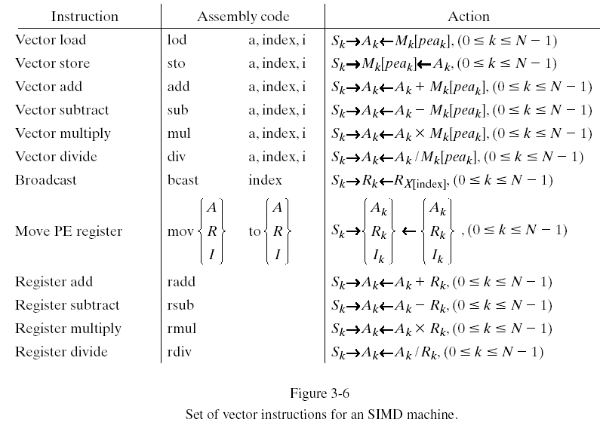
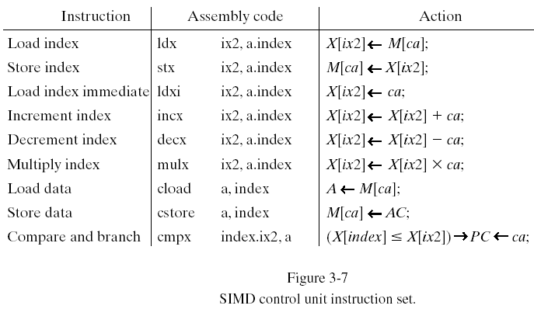
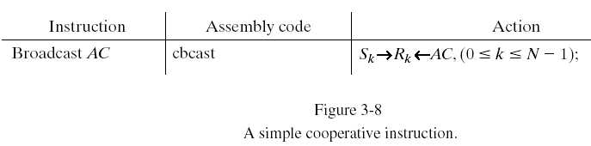
SIMD MATRIX MULTIPLICATION EXAMPLE
N DATA 64 Number of PEs and matrix size
ZERO DATA 0.0 Constant value
I EQUIV 2 Index 2 contains I
J EQUIV 3 Index 3 contains J
LIM EQUIV 1 Index 1 contains the loop limit
A BSS 64x64 Storage space for the arrays A,
B BSS 64x64 B,
C BSS 64x64 and C
Program 3-10. Assembler pseudo-operations to set up the matrix multiply
It is assumed that data will be organized in the k-th memory module as follows:
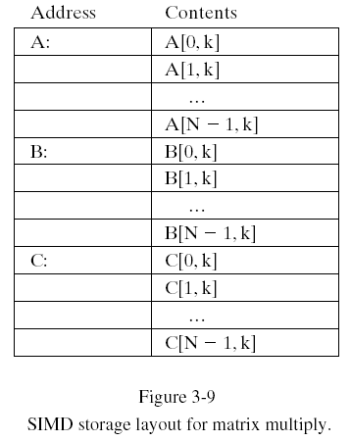
# | Instruction | Effect
 | Cload zero | AC=0
 | cbcast | R[0:2]=[0,0,0]
 | Movr to a | A[0:2]=[0,0,0]
 | Sto, C,i | X[i]=x[2] is not initialized; assume it is initialized by by LDXI, I,0, i.e. x[2]=0. Then C[1,1:3]=[0,0,0]
 | Ldxi J,0 | X[J]=x[3]=0
 | Ldx lim,N | X[lim]=x[1]=3
 | Lod A,I | A[0:2]=A[0,0:2]=[1,2,3] registers A are loaded by the 1st row the matrix A
 | movA toR | R[0:2]=A[0:2]=[1,2,3]
 | Bcast J | R[0:2]=[1,1,1]=[A[x[J=3]], A[x[J=3]], A[x[J=3]]]; A[x[3]]=A[0]=1=A[0,0]
 | Lod B,J | A[0:2]=B[0,0:2]=[3,2,1]
 | Rmul | A[0:2]=A[0:2]*R[0:2]=[3,2,1]*[1,1,1]=[3,2,1]
 | Add C,I | A[0:2]=A[0:2]+C[0,0:2]=[3,2,1]+[0,0,0]=[3,2,1]
 | Sto C,I | C[0,0:2]=A[0:2]=[3,2,1]
 | Incx J,1 | X[J]=x[3]=x[3]+1=1
 | Cmpx J,Lim, Loop | X[j]=x[3]=1<=X[Lim]=X[1]=3 => goto Loop
 | Lod A,I | A[0:2]=A[0,0:2]=[1,2,3]
 | movA toR | R[0:2]=A[0:2]=[1,2,3]
 | Bcast J | R[0:2]=[2,2,2]=[A[x[J=3]], A[x[J=3]], A[x[J=3]]]; A[x[3]]=A[1]=2=A[0,1]
 | Lod B,J | A[0:2]=B[1,0:2]=[1,2,1]
 | Rmul | A[0:2]=A[0:2]*R[0:2]=[1,2,1]*[2,2,2]=[2,4,2]
 | Add C,I | A[0:2]=A[0:2]+C[0,0:2]=[2,4,2]+[3,2,1]=[5,6,3]
 | Sto C,I | C[0,0:2]=A[0:2]=[5,6,3]
 | Incx J,1 | X[J]=x[3]=x[3]+1=2
 | Cmpx J,Lim, Loop | X[j]=x[3]=2<=X[Lim]=X[1]=3 => goto Loop
 | Lod A,I | A[0:2]=A[0,0:2]=[1,2,3]
 | movA toR | R[0:2]=A[0:2]=[1,2,3]
 | Bcast J | R[0:2]=[3,3,3]=[A[x[J=3]], A[x[J=3]], A[x[J=3]]]; A[x[3]]=A[2]=3=A[0,1]
 | Lod B,J | A[0:2]=B[2,0:2]=[1,3,2]
 | Rmul | A[0:2]=A[0:2]*R[0:2]=[1,3,2]*[3,3,3]=[3,9,6]
 | Add C,I | A[0:2]=A[0:2]+C[0,0:2]=[3,9,6]+[5,6,3]=[8,15,9]
 | Sto C,I | C[0,0:2]=A[0:2]=[8,15,9]
 | Incx J,1 | X[J]=x[3]=x[3]+1=3
 | Cmpx J,Lim, Loop | X[j]=x[3]=3<=X[Lim]=X[1]=3 => goto Loop  We see that instead of the termination of the loop on J, the 1st row of C is already correctly calculated to (1*3+2*1+3*1=8,1*2+2*2+3*3=15,1*1+2*1+3*2=9), it continues calculations. Thus, the program shall terminate the loop when J=3. However, it continues.
 | Lod A,I | A[0:2]=A[0,0:2]=[1,2,3]
 | movA toR | R[0:2]=A[0:2]=[1,2,3]
 | Bcast J | R[0:2]=[A[x[J=3]], A[x[J=3]], A[x[J=3]]]; A[x[3]]=A[3], but A[3] does not exist. Hence, the program fails

Task 5. (27 points). Consider Figure 3-16 from the Lecture notes:
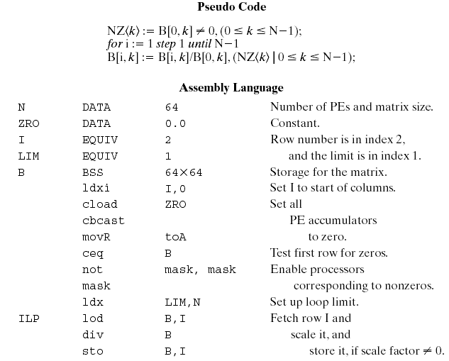
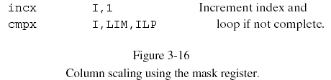
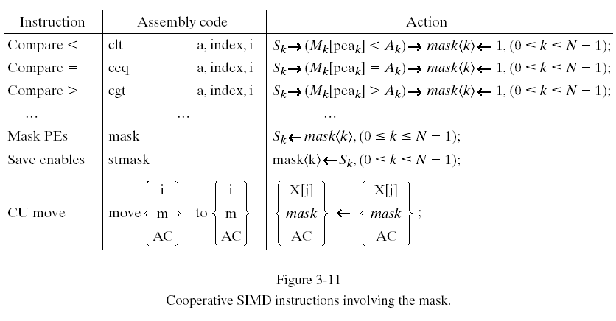
Assuming N=3 processing elements with respective memory blocks in the system
- (12 points) Write a pseudo-code for the matrix $B(N,N)=\left(\begin{matrix}3 & 0 & 1 \\ 0 & 2 & 1 \\ 1 & 3 & 2\end{matrix}\right)$ row scaling (divide columns 2..N by the 1st column)
N:=3;
NZ<k>:=B[k,0]<>0,(0<=k<=N-1);
For i:=1 step 1 until N-1
B[k,i]:=B[k,i]/B[k,0],(NZ<k>|0<=k<=N-1);

- (3 points) Specify distributed memory layout (which variables where located)
Matrix B will be distributed rows allowing getting parallel access to column elements

M0 | M1 | M1
B[0,0]=3 | B[1,0]=0 | B[2,0]=1
B[0,1]=0 | B[1,1]=2 | B[2,1]=3
B[0,2]=1 | B[1,2]=1 | B[2,2]=2

- (12 points) Trace the program (for each instruction, specify affected variables’ new states)
# | Instruction | Effect
1 | N:=3; | N=3
2 | NZ<k>:=B[k,0]<>0,(0<=k<=N-1); | Nz<0:2>=<1,0,1>
3 | For i:=1 step 1 until N-1 | I=1
4 | B[k,i]:=B[k,i]/B[k,0],(NZ<k>|0<=k<=N-1); | B[0:2,1]=[0/3,2,3/1]=[0,2,3]
5 | For i:=1 step 1 until N-1 | I=2
6 | B[k,i]:=B[k,i]/B[k,0],(NZ<k>|0<=k<=N-1); | B[0:2,2]=[1/3,1,2/1]=[1/3,1,2]
Resulting matrix is $\left(\begin{matrix}3 & 0 & 1/3 \\ 0 & 2 & 1 \\ 1 & 3 & 2\end{matrix}\right)$

