MT Exam CMPE-553 08.12.2022 (90 min, 30 points)
St. Name, Surname______________________________________ St.Id#_____________
Mobiles and calculators are not allowed. Three cheat sheets with your own handwritings can be used
Instructor Alexander Chefranov
3 questions, 8 pages

Task 1. (10 points) Encrypt the plaintext “te” by the Three-Rotor machine shown in Fig. 2.7 below. Assume the initial state as in Fig. 2.7, a. Explain you answer
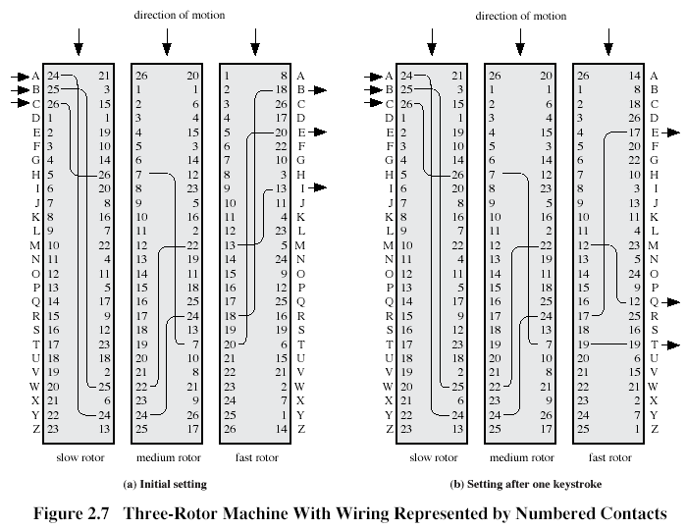

Solution:
- T=>slow rotor: 17=>17=>16 in medium rotor: 16=>16=>11 in fast rotor 11=>11=>J
- State after 1 rotation of the fast rotor is shown in (b)
E=>2=>2=>21 in medium rotor 21=>21=>22 in fast rotor 22=>22=>G
Thus TE is encrypted as JG
Task 2. (10 points) Calculate the result of DES initial permutation, IP, transformation assuming that the plaintext block in hexadecimal is 0x12345678abcdef09. Show result in binary and hexadecimal. Explain you answer
HINT:
IP
58 50 42 34 26 18 10 2
60 52 44 36 28 20 12 4
62 54 46 38 30 22 14 6
64 56 48 40 32 24 16 8
57 49 41 33 25 17 9 1
59 51 43 35 27 19 11 3
61 53 45 37 29 21 13 5
63 55 47 39 31 23 15 7

Solution
Plaintext in binary is
 | 1 | 2 | 3 | 4 | 5 | 6 | 7 | 8
1 | 0 | 0 | 0 | 1 | 0 | 0 | 1 | 0
2 | 0 | 0 | 1 | 1 | 0 | 1 | 0 | 0
3 | 0 | 1 | 0 | 1 | 0 | 1 | 1 | 0
4 | 0 | 1 | 1 | 1 | 1 | 0 | 0 | 0
5 | 1 | 0 | 1 | 0 | 1 | 0 | 1 | 1
6 | 1 | 1 | 0 | 0 | 1 | 1 | 0 | 1
7 | 1 | 1 | 1 | 0 | 1 | 1 | 1 | 1
8 | 0 | 0 | 0 | 0 | 1 | 0 | 0 | 1
After permutation in binary
0 | 1 | 1 | 0 | 1 | 1 | 0 | 0
0 | 0 | 0 | 0 | 1 | 1 | 1 | 1
0 | 1 | 1 | 0 | 0 | 1 | 1 | 0
1 | 1 | 1 | 1 | 0 | 0 | 0 | 0
0 | 1 | 1 | 1 | 0 | 0 | 0 | 0
0 | 1 | 0 | 1 | 1 | 0 | 1 | 0
1 | 1 | 1 | 1 | 1 | 0 | 0 | 0
0 | 1 | 0 | 1 | 0 | 1 | 0 | 1
And in hexadecimal: 0x6c0f66f0705af855
Task 3. (10 points) Calculate {32}*{34}+{56} in GF(2^8) with irreducible polynomial as in AES: . Show your intermediate calculations, and explain them.
Solution: {32}*{34}=(0011 0010)*(0011 0100)=(x^5+x^4+x)*(x^5+x^4+x^2)=x^10+x^9+x^7+x^9+x^8+x^6+x^6+x^5+x^3= x^10+x^8+x^7+x^5+x^3. It is not in GF(2^8), hence, reduce it:
Dividend | Divisor | Quotient
x^10+x^8+x^7+x^5+x^3  +  x^10+x^6+x^5+x^3+x^2= | x^8+x^4+x^3+x+1 | x^2+1
x^8+x^7+x^6+x^2
+
x^8+x^4+x^3+x+1=
x^7+x^6+ x^4+x^3+x^2+x+1 remainder

Thus, as it shall be
dividend=quotient*divisor+ remainder
Check it:
quotient*divisor+ remainder =( x^2+1)*( x^8+x^4+x^3+x+1)+ x^7+x^6+ x^4+x^3+x^2+x+1=x^10+x^6+x^5+x^3+x^2+ x^8+x^4+x^3+x+1+ x^7+x^6+ x^4+x^3+x^2+x+1= x^10+x^5+ x^8+ x^7+x^3= x^10+x^8+x^7+x^5+x^3=dividend, OK
Thus, {32}*{34}=(0011 0010)*(0011 0100)=(x^5+x^4+x)*(x^5+x^4+x^2)= x^7+x^6+ x^4+x^3+x^2+x+1=(1101 1111)={df}
{32}*{34}+{56}={df}+{56}=
1101 1111
+
0101 0110=
1000 1001={89}

