QUIZ CMPE-553 25.11.2022 (90 min, 2 points)
St. Name, Surname______________________________________ St.Id#_____________
Mobiles and calculators are not allowed. Three cheat sheets with your own handwritings can be used
Instructor Alexander Chefranov
3 questions, 8 pages
Task | 1 | 2 | 3 | Total
Point | 0.7 | 0.6 | 0.7 | 2

Task 1. (0.7 points) Encrypt the plaintext “text” by Hill cipher, and decrypt back the ciphertext obtained. The key matrix is $K=\left[\begin{matrix}1 & 2 \\ 1 & 3\end{matrix}\right]$. Use the following encoding
a | b | c | D | e | f | g | h | i | j | k | l | m | n | o | p | q | r | s | t | u | v | w | x | y | z
0 | 1 | 2 | 3 | 4 | 5 | 6 | 7 | 8 | 9 | 10 | 11 | 12 | 13 | 14 | 15 | 16 | 17 | 18 | 19 | 20 | 21 | 22 | 23 | 24 | 25
Show intermediate calculations, explain you answer
Hint: C=KP mod 26
P=K⁻¹C mod 26
mod n
where - is a determinant of sub matrix of A, obtained by deletion of i-th row and j-th column, det(A) – determinant of A
Ciphertext of “TE”=[19 4[:
$$\left[\begin{matrix}1 & 2 \\ 1 & 3\end{matrix}\right]\left[\begin{aligned}19 \\ 4\end{aligned}\right]=\left[\begin{aligned}19+8 \\ 19+12\end{aligned}\right] mod 26=\left[\begin{aligned}1 \\ 5\end{aligned}\right]="\text{B F}\text{"}$$
“X T”=[23 19]
$$\left[\begin{matrix}1 & 2 \\ 1 & 3\end{matrix}\right]\left[\begin{aligned}23 \\ 19\end{aligned}\right]=\left[\begin{aligned}23+38 \\ 23+57\end{aligned}\right] mod 26=\left[\begin{aligned}9 \\ 2\end{aligned}\right]="J C"$$
Thus, ciphertext is “BFJC”
Inverse matrix calculation: det(K)=3-2=1

$$K^{-1}=\left[\begin{matrix}3 & -2 \\ -1 & 1\end{matrix}\right]$$
Check its correctness:

$$K^{-1}K=\left[\begin{matrix}3 & -2 \\ -1 & 1\end{matrix}\right]\left[\begin{matrix}1 & 2 \\ 1 & 3\end{matrix}\right]=\left[\begin{matrix}3-2 & 6-6 \\ -1+1 & -2+3\end{matrix}\right]=\left[\begin{matrix}1 & 0 \\ 0 & 1\end{matrix}\right]$$
Decryption:
Plaintext for “B F:

$$\left[\begin{matrix}3 & -2 \\ -1 & 1\end{matrix}\right]\left[\begin{aligned}1 \\ 5\end{aligned}\right]=\left[\begin{aligned}3-10 \\ -1+5\end{aligned}\right] mod 26=\left[\begin{aligned}-7 \\ 4\end{aligned}\right]mod26=\left[\begin{aligned}19 \\ 4\end{aligned}\right]="\text{T} \text{E}\text{"}$$

Plaintext for “J C”
$$\left[\begin{matrix}3 & -2 \\ -1 & 1\end{matrix}\right]\left[\begin{aligned}9 \\ 2\end{aligned}\right]=\left[\begin{aligned}27-4 \\ -9+2\end{aligned}\right] mod 26=\left[\begin{aligned}23 \\ -7\end{aligned}\right]mod26=\left[\begin{aligned}23 \\ 19\end{aligned}\right]="X \text{T"}$$
Plaintext restored is “TEXT”
Task 2. (0.6 points) Calculate a value of S-box S3 output if the result of XOR inside the function F is 0x123321456654. Show intermediate calculations, explain you answer

Solution:
In binary 0x123321456654 is
0001 0010 0011 0011 0010 0001 0100 0101 0110 0110 0101 0100
S3 input is bits in positions 13-18:
001100
Two end bits, 00, define row number 0, and four middle bits, 0110, define column number 6. On the cross of row=0 and column=6 is value 15, in binary 1111 that is the output of S3.

Hints:
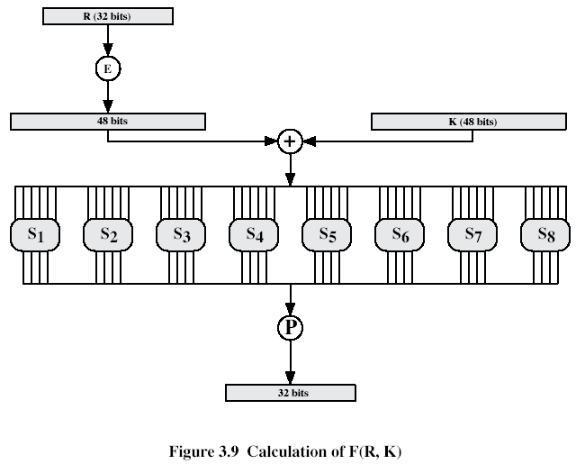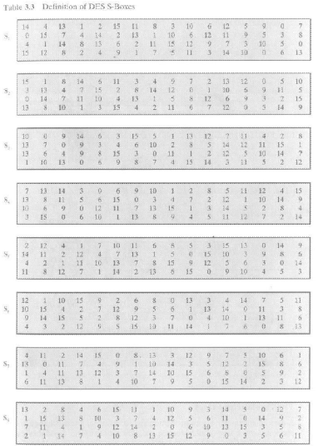.
Task 3. (0.7 points) Calculate result of MixColumn transformation of the he state array S just for, S’(1,2), in the numerical example below that shall be equal to {70}. Show your intermediate calculations and explain them.
Hints:
Mix Column Transformation
The forward mix column transformation, called MixColumns, operates on each column individually. Each byte is mapped into a new value that is a function of all four bytes in the column. The transformation can be defined as the following matrix multiplication on State (Fig. 5.5b):
02 | 03 | 01 | 01 |  | S00 | S01 | S02 | S03 |  | S00’ | S01’ | S02’ | S03’
01 | 02 | 03 | 01 | * | S10 | S11 | S12 | S13 | = | S10’ | S11’ | S12’ | S13’ | (5.3)
01 | 01 | 02 | 03 |  | S20 | S21 | S22 | S23 |  | S20’ | S21’ | S22’ | S23’
03 | 01 | 01 | 02 |  | S30 | S31 | S32 | S33 |  | S30’ | S31’ | S32’ | S33’
Each element in the product matrix is the sum of products of elements of one row and one column. In this case, multiplications and additions are performed in GF(2⁸).
The following is the example of MixColumns;
87 | F2 | 4D | 97 |  | 47 | 40 | A3 | 4C
6E | 4C | 90 | EC | => | 37 | D4 | 70 | 9F
46 | E7 | 4A | C3 |  | 94 | E4 | 3A | 42
A6 | 8C | D8 | 95 |  | ED | A5 | A6 | BC

As was mentioned in Chapter 4, AES uses arithmetic in the finite field GF(2⁸), with the irreducible polynomial .
Solution:
S’(1,2)=(01 02 03 01)*(4d 90 4a d8)={4d}+{02}*{90}+{03}*{4a}+{d8}={4d}+{3B}+{DE}+{d8}=
0100 1101+
0011 1011+
1101 1110+
1101 1000=
0111 0000={70} as expected
{02}*{90}={0000 0010}*{1001 0000}=x*(x^7+x^4)=x^8+x^5 mod x^8+x^4+x^3+x+1=x^5+x^4+x^3+x+1=(0011 1011)={3B}
{03}*{4a}=(0000 0011)*(0100 1010)=(x+1)*(x^6+x^3+x)=x^7+x^4+x^2+x^6+x^3+x= x^7+x^6+x^4+x^3+x^2+x=(1101 1110)={D E}

