Eastern Mediterranean University - Computer Engineering Department
Software Engineering Program
CMSE-201 Fundamentals of Software Engineering - Final Exam

Std Id____________________Std Name____________________________________
Instructor: Prof. Dr. Alexander G. Chefranov
Duration: 120 Minutes June 18, 2022
--------------------------------------------------------------------------------------------------------------
Four A4 sheets of paper with your handwritings (not photocopies, printouts, etc.) may be used for your help. Calculators are allowed. Other electronic devices (phones, laptops, etc.) are not allowed

There are 10 questions (totally, 100 points), 13 pages

Good Luck!

Q1) 7 points SW development processes
- 3 points W-hat the prototyping is?
Prototyping is developing of the draft of the system to see better its features

- 4 points Explain how design and implementation can help to specify requirements?
To get better understanding of the requirements, prototyping (design and implementation) can be used to get feedback from the customer. And prototype development assumes its design and implementation

Q2) 7 points Requirements engineering
- 3 points What a non-functional requirement is?
A non-functional requirement is a requirement to the qualities of the software product such as performance, reliability, security, etc.

- 4 points Why non-functional requirements are important?
Non-functional requirements are important because if the qualities of the product are not satisfactory, it can’t be used,, e.g., if security is provided the use of the product is not possible

Q3) 7 points Project management
- 3 points Why project management is important?
Project management is important because if not properly managed a software product can be delivered not timely, or do expect the customer expextations

- 4 points What are the four success criteria of the project management?
Four success criteria: 1) delivered timely; 2) expenses are inside the budget, 3) functional and non-functional requirements are satisfied, 4) team members are happy working together

Q4) 12 points Project planning
- 5 points What is Early start and Early finish time of a task?
Early start of a task is the work day next after all preceding it tasks have finished
Early finish of the task is the work day of its completion provided that it started at the Early start. For example, if a task has not preceding it tasks, the project start date is Monday, June 20, 2022, and duration is 6 work days, then Early start is June 20, 2022, and early finish is June 27, 2022. Early start of a task dependent on this task only is then June 28, 2022.

- 7 points For the activity network diagram below, define Early start and Early finish time of the tasks T1-T12 and fill in Table 1 below assuming that the project starts 04.04.2022. Calendar-2022 is provided below.
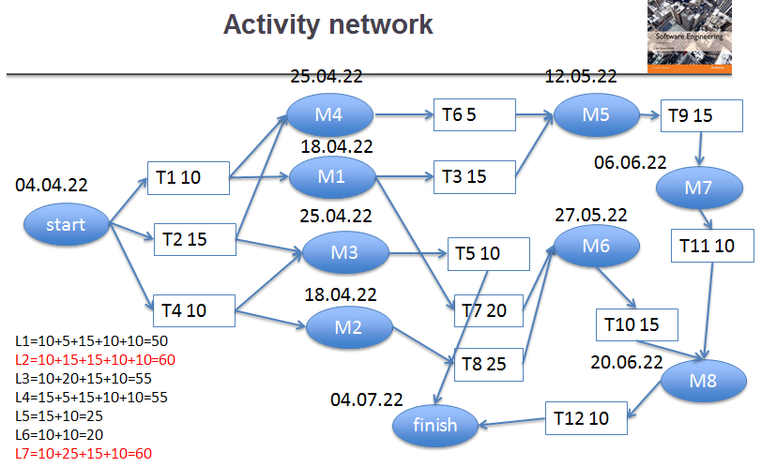

Table 1.
Task | Early start | Early finish | Task | Early start | Early finish
T1 | 04.04.22 | 16.04.22 | T7 | 18.04.22 | 18.05.22
T2 | 04.04.22 | 22.04.22 | T8 | 18.04.22 | 26.05.22
T3 | 18.04.22 | 11.05.22 | T9 | 12.05.22 | 02.06.22
T4 | 04.04.22 | 16.04.22 | T10 | 27.05.22 | 09.06.22
T5 | 25.04.22 | 11.05.22 | T11 | 03.06.22 | 16.06.22
T6 | 25.04.22 | 29.04.22 | T12 | 17.06.22 | 30.06.22

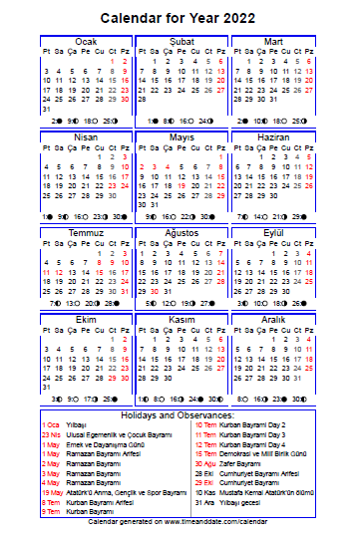
Q5. 14 points COCOMO
- 5 points What are the three modes of the Basic COCOMO?
The three modes are: Organic. Semidetached, and Embedded

- 9 points For the 100 KLOC sized project what is the staff size if using the Organic mode?
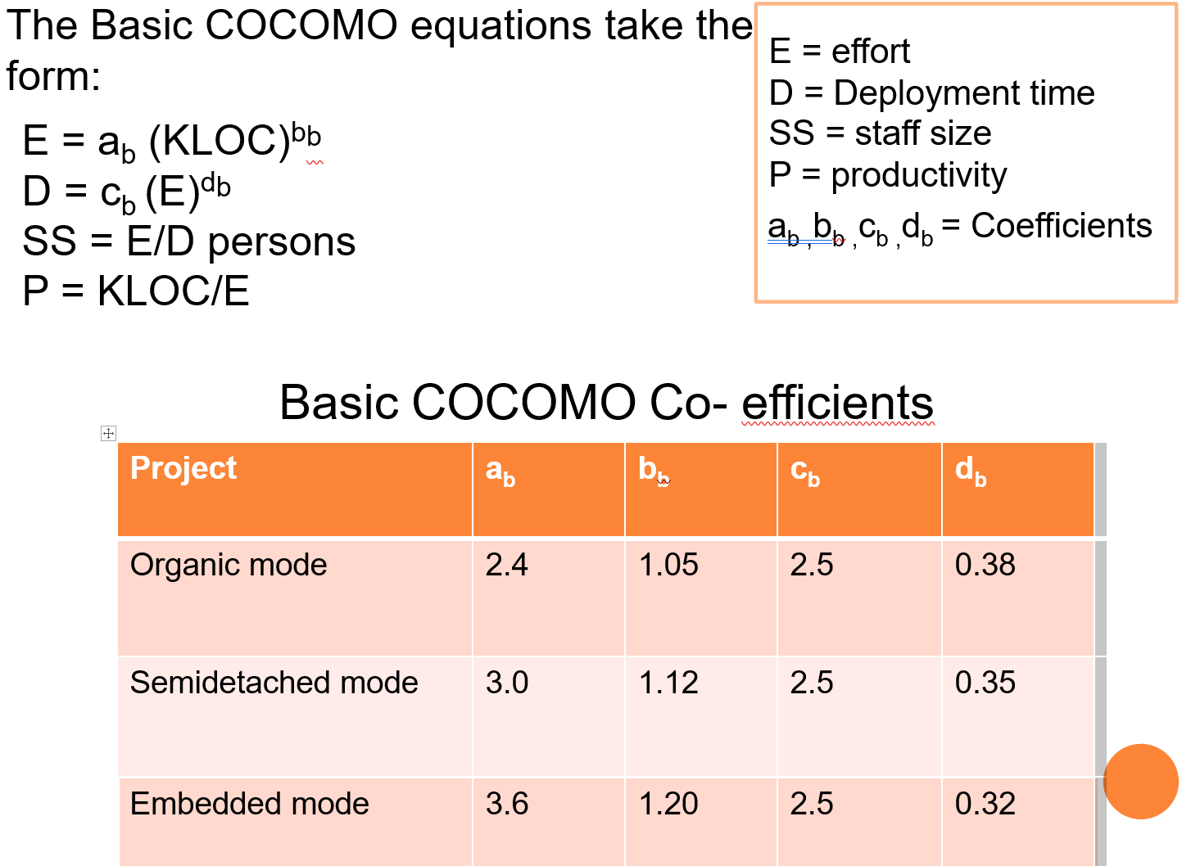
$E=a_{b}∙{size}^{b_{b}}=2.4∙{100}^{1.05}=302$ Person*Month
$D=c_{b}∙E^{d_{b}}=2.5∙{302}^{0.38}=21.9$ Month
$SS=\frac{E}{D}=\frac{302}{21.9}=13.79$ Person

Q6. 9 points Architectural design
- 4 points What a software system architecture is?
A software system architecture is a representation of the system as a collection of communicating subsystems

- 5 points What layered architecture is? What are its benefits? Its drawbacks?
Layered architecture is a representation of a system as a collection layers such that a layer of the level I communicates only with neighboring layers i+1 and i-1. Its benefit is an opportunity of replacing any layer by a new more efficient not touching the rest of the system. Its drawback is performance because to reach some layer it is necessary passing through all intermediate ones.

Q7. 11 points System models
- 5 points What an activity diagram is and what are its elements?
An activity diagram is a representation of interacting activities-processes (ellipses). External systems (sources/sinks of data) are represented by boxes, barrier synchronization (fork-join) by bars, diamonds represent conditions, filled circle is the initial state, and encircled filled circle is the end state, arrows show direction of control flow.

- 6 points Explain the meaning of the elements marked 1, 2 in the following diagram and explain how they are synchronized? What is the use of the element marked 3?
Elements marked by 1, 2 are activities, they run in parallel (forked), and are synchronized by a barrier (the next activity starts when the both complete). Element 3 is a decision checking the state of a patient (dangerous, not dangerous)

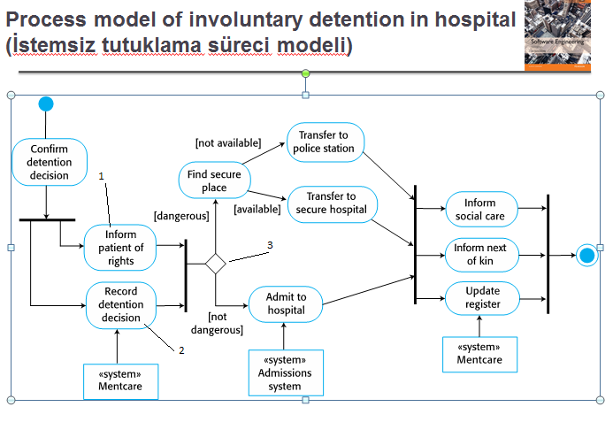
Q8. 12 points Testing
- 4 points What is partition testing?
Partition testing splits the set of input into disjoint partitions (classes), and tests for one representative of each partition. Border cases are also tested.

- 8 points What partitions can you suggest for testing computation represented by the assignment
$x=\sqrt{(a-5)∙(a-2)}$? Explain your answer

Square root calculation requires not negative expression. Possible partitions are:
P1={a<2}, P2={a>2 and a<5}, P3={a>5}
Testing: Test 1:for a=2 and a=5, result is 0
Test 2: For P1 take a=1, result shall be 2
Test 3: For P2 take a=3, there shall be exception (negative expression)
Test 4: For P3, take a=6, result shall be 2.

Q9. 11 points Quality management
- 5 points What the software quality is?
Software quality is a level of satisfying its requirements, functional and non-functional. Also, software quality may be characterized by the level of meeting it standards.

- 6 points Explain the meaning of the diagram below (each element and their interactions):
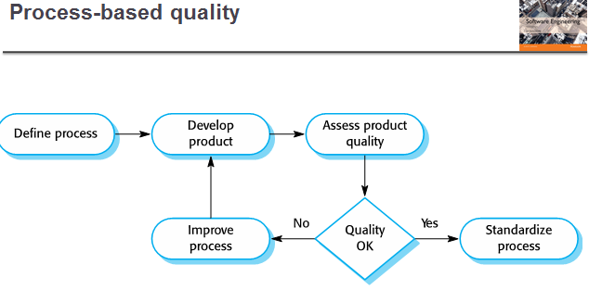
The diagram assumes that the software development process shall comply some definition. Once the product is developed, its quality is assessed, and if it is OK, then the process definition is adopted as a standard. Otherwise, the process definition is revised.

Q10. 10 points Configuration management
- 4 points What the software project configuration is?
A software project configuration is a collection of all related to the project documents and codes formally placed into it. They are called configuration items.

- 6 points What the baseline is and why is it important?
A baseline is a set of configuration items used to build a particular release of a system (subsystem). Baseline is not changed after its definition. It is important because it is possible exactly rebuilding the original release.

