Eastern Mediterranean University - Computer Engineering Department
Software Engineering Program
CMSE-201 Fundamentals of Software Engineering - Midterm Exam

Std Id____________________Std Name____________________________________
Instructor: Prof. Dr. Alexander G. Chefranov
Duration: 110 Minutes April 16, 2022
--------------------------------------------------------------------------------------------------------------
Three A4 sheets of paper with your handwritings (not photocopies, printouts, etc.) may be used for your help. Electronic devices are not allowed

There are 5 questions (totally, 100 points), 7 pages
 |  |  |  |  |  | Total
Question | 15  (5,5,5) | 15  (5,5,5) | 15  (5,5,5) | 15  (5,5,5) | 40  (13, 13, 14) | 100

Good Luck!

Q1) 15 points Introduction to software engineering
- 5 points What are the three key challenges software engineering facing?
Complexity of software products, requirements changing, and necessity to meet deadlines
- 5 points What software dependability and security is?
Dependability means that software reliably perform expected from it functions, and has not undeclared functionalities
Security means that only authorized people can get access to the system for reading and writing, and the system is available according to the agreement

- 5 points What are the eight ACM/IEEE ethical principles?
Public – obey laws, Client and employer – do not harm them, Product – provide high quality, Judgment – be independent, Management – be ethical, Profession – consistent with public interests, Colleagues – be fair, Self – life-long learning
Q2) 15 points SW development model and processes
- 5 points What are the four characteristics of a software development process?
Activities, Product (outcome), Roles, Pre/post conditions
- 5 points What integration and configuration model is? Its benefits? Deficiencies?
The model is based on the existing components reusing by configuring them into the target system. Benefits: no need developing system parts from scratch, Deficiencies: some requirements may not be met because the components can’t fit them in full.

- 5 points What are the four design activities?
Architectural design, interface design, component design, database design
Q3) 15 points Requirements engineering
- 5 points What are the five problems of requirements elicitation?
Stakeholders do not know what they really want; they express requirements in their own terms; requirements can conflict; external factors can affect requirements; requirements can change
- 5 points What are the five parts of a scenario description?
Pre-condition; normal success scenario; alternative scenarios; other concurrent activities; post condition
- 5 points What are the seven parts of a function description?
Name, inputs, outputs, data types used, algorithm, pre/post conditions, side effects
Q4) 15 points Project management
- 5 points What are the five types of risks?
Risks: technological, organizational, people related, requirements related, and estimation related
- 5 points What are the three personality types?
People: task-oriented, interaction-oriented, and self-oriented
- 5 points What are the four factors affecting group communication?
Group size, group structure, group composition, environment
Q5) 40 points Project planning and scheduling
The set of a project tasks is
Task | Effort (person-day) | Duration (day) | Dependence
A | 6 | 4
B | 5 | 5 | A(M1)
C | 3 | 6 | A(M1)
D | 4 | 4 | B(M2)
E | 3 | 3 | C(M3)

Assume that the project starts on April 18, 2022, Monday. Calendar is
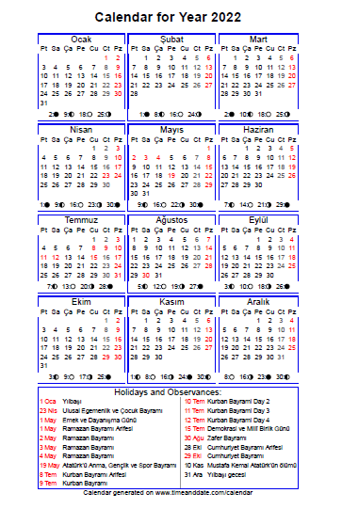
Taking into account actual weekends/holidays:
- 13 points Draw an activity network diagram with milestones and tasks, and define the earliest day of the project completion. Explain your answer.
start
A 4
B 5
C 6
M1
M2
M3
D 4
E 3
Finish
22.04.2022
18.04.2022
5.05.2022
29.04.2022
10.05.2022
The earliest finish date is May 10, 2022. It is obtained by marking milestones by dates according to the calendar and tasks dependencies.

- 13 points Assuming that two software engineers, Abdul and Mary, are available, draw a staff allocation chart (schedule) for the project. Explain your answer.
 | 18.04 | 19.04 | 20.04 | 21.04 | 22.04 | 25.04 | 26.04 | 27.04 | 28.04 | 29.04 | 5.05 | 6.05 | 9.05 | 10.05
Abdul | A |  |  |  | B |  |  |  |  | D
Mary | A |  |  |  | C |  |  |  |  |  | E
The project ends by May 10, 2022.

- 14 points Draw an activity network diagram showing tasks only. For each task of the project, calculate Early start time, Early finish time, Late start time, Late finish time, and slack time. Explain your answer.
A 4
B 5
C 6
D 4
E 3
18.04;21.04
22.04;28.04
29.04;09.05
22.04;29.04
05.05;09.05
29.04;09.05
22.04;28.04
05.05;09.05
22.04;29.04
18.04;21.04

Early start and finish times are shown above the task boxes, and late start and finish times, below them. Since for all the tasks ES=EF and LS=LF, slacks of all the tasks are 0, hence all the tasks are critical.

