Eastern Mediterranean University - Computer Engineering Department
Software Engineering Program
CMSE-201 Fundamentals of Software Engineering - Final Exam

Std Id____________________Std Name____________________________________
Instructor: Prof. Dr. Alexander G. Chefranov
Duration: 120 Minutes June 13, 2023
--------------------------------------------------------------------------------------------------------------
Five A4 sheets of paper with your handwritings (not photocopies, printouts, etc.) may be used for your help. Calculators are allowed. Other electronic devices (phones, laptops, etc.) are not allowed

There are 11 questions (totally, 100 points), 10 pages

Good Luck!

 | Before MT Exam questions (33) |  |  |  |  |  | After MT Exam questions (67) |  |  |  |  | Total
Questions | 1 | 2 | 3 | 4 | 5 | 6 | 7 | 8 | 9 | 10 | 11
Points | 3 | 3 | 5 | 7 | 8 | 7 | 15 | 17 | 17 | 9 | 9 | 100

Q1) 3 points Introduction
- 1.5 points What are the three challenges the software engineering faces?
Diversity of the problems, demands on the reduced delivery time, demands on the reliability

- 1.5 points What are the three application types?
Standalone, embedded, scientific

Q2) 3 points SDLC models
- 1.5 points What are the two benefits of the incremental development model?
Early customer feedback; reduced delivery time

- 1.5 points What are the four phases of the spiral development model?
Planning, Risk analysis, Engineering, Evaluation

Q3) 5 points Requirements engineering
- 2 points What is the difference between the user requirements and the system requirements?
The difference is the level of abstraction (detail): User requirements are more abstract (less detailed), and System requirements are less abstract (more detailed).

- 3 points Give an example of a functional requirement as the user requirement and the system requirement
User FR: the system shall be able solving algebraic equations
System FR: the system shall be able solving algebraic equations with one unknown of the maximal order 5 a5*x^5+ a4*x^4+ a3*x^3+ a2*x^2+ a1*x+ a0=0 specified by its coefficients a0..a5. The user will be asked to enter at most 6 numbers in one of the allowed format such as signed or unsigned integer, fixed point number represented by a.b, or floating point number represented by mEp. The numbers entered are assigned to respective coefficients (the first number to the first coefficient, etc.). If the number of the numbers entered is less than 5, all not assigned coefficients are set to 0.

Q4) 7 points Project management
- 2 points What is the risk management? Why the risk management is important?
Risk management is a process of identifying risks and defining strategies to minimize the risk consequences

- 5 points Consider the below materials from the lecture notes and explain the meaning of the calculations
There is  ctitical fault  NO  ctitical fault  CONDITIONS | 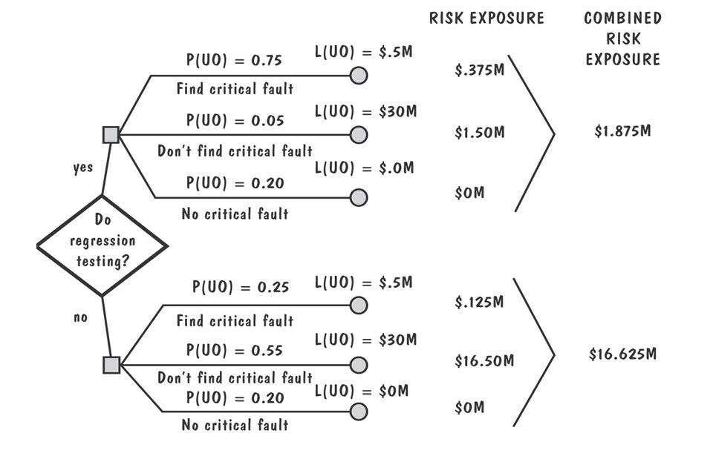

The calculations assess the expected losses in millions of dollar in the case of doing and not doing regression testing if there is a risk of the critical fault. The expectation is calculated by multiplying the probability of the risk by the maximal possible loss resulting from the risk happening.
Q5) 8 points Project planning
For the task set given in tabular form as
Task | Preceding tasks | Duration (work day)
A | - | 5
B | A | 6
C | A | 7
D | B | 3
E | C | 4
F | D,E | 5

- 2 points Build an activity network diagram. Give necessary explanations.
A
B
C
D
E
F
The tasks are shown with the connections according to the dependences specified in the table.
- 6 points For the tasks A,B,..,F, calculate Early start, Early finish, Late start, Late finish time, critical path, and its length. Give necessary explanations, show your calculations.
Since the calendar and start date are not specified, assume that the project start time is 0, and do not take into account weekends and holidays
Task | Duration | Early Start | Early Finish | Late Start | Late Finish | Critical path task
A | 5 | 0 | 5 | 0 | 5 | Yes
B | 6 | 5 | 11 | 7 | 13
C | 7 | 5 | 12 | 5 | 12 | yes
D | 3 | 11 | 14 | 13 | 16
E | 4 | 12 | 16 | 12 | 16 | yes
F | 5 | 16 | 21 | 16 | 21 | yes
A task is on a critical path if its early start = late start (early finish = late finish). The tasks A, C,E, and F are on the critical path. The critical path length is equal to the sum of the durations of the tasks on the critical path: 5+7+4+5=21. It is the minimal project completion time.
Q6. 7 points COCOMO
For the 123 KLOC-sized project what is the time to complete if using the Basic COCOMO Semidetached mode? Explain your calculations.
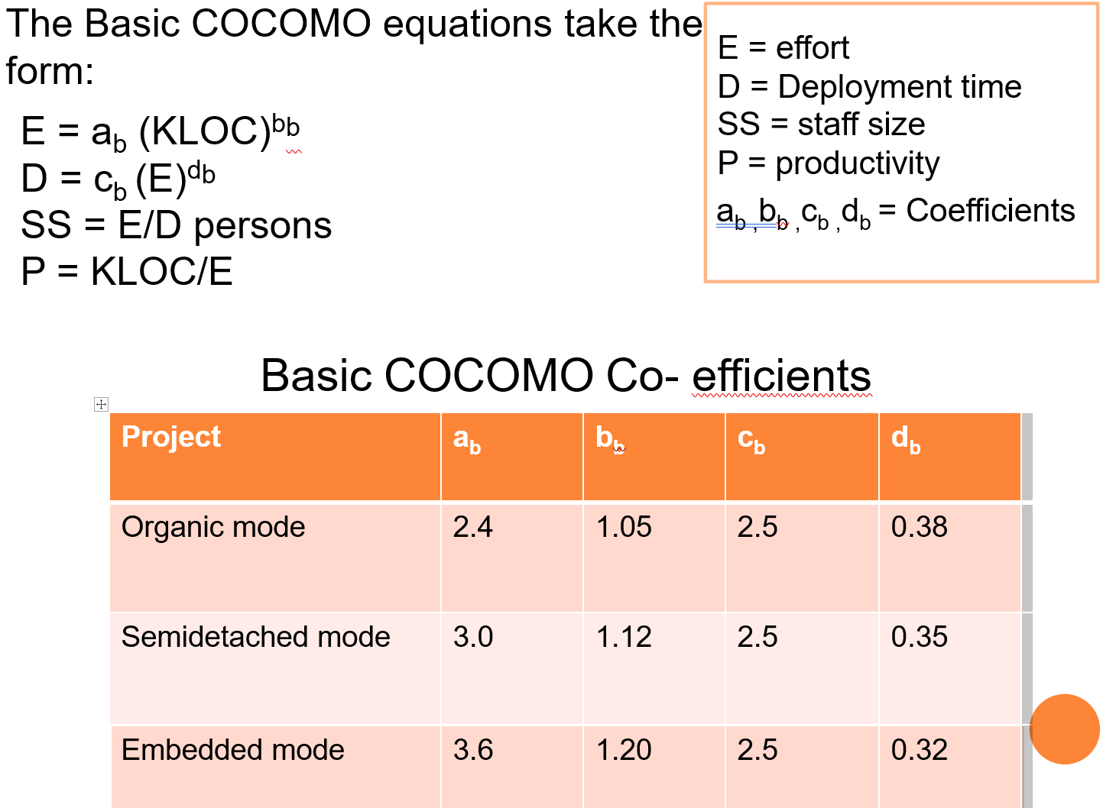
E=a*KLOC^b=3*123^1.12=3*219.13=657.39 person*month
D=c*E^d=2.5*657.39^0.35= 2.5*9.69 = 24.22 month
Q7. 15 points Architectural design
- 5 points How box-and-line diagrams are used to represent a system architecture?
Boxes are used to show subsystems, and lines represent connections of the subsystems

- 10 points Draw a box-and-line diagram representing a system architecture with the User interface, Data processing and Data storage layers
User interface
Data processing
Data storage
Q8. 17 points System models
- 5 points What the inheritance diagram is, what are its elements? How “parents” and “children” are shown in the diagram? What “children” inherit and from whom?
The inheritance diagram shows inheritance relationships between the parents and the children. The elements of the diagram are boxes representing classes of objects, lines connecting them, and the triangles denoting is-a relationship. The triangles top angle points the parent, and the parent’s children are connected to the triangle’s bottom. The children inherit all their parents’ properties and methods.
- 12 points Draw an inheritance diagram for the objects Student, Teacher, Doctor of general practice, Surgeon, Neurosurgeon, and Cardiac surgeon with four hierarchy levels. How many nodes are in your diagram? For each node in the diagram, how many children does it have?
Person
Student
Teacher
Doctor

Doctor of General Practice
Surgeon

Neurosurgeon
Cardiac surgeon
The diagram has 8 nodes
Node | Person | Student | Teacher | Doctor | General practice doctor | Surgeon | Neurosurgeon | Cardiac surgeon
Number of children | 3 | 0 | 0 | 2 | 0 | 2 | 0 | 0

Q9. 17 points Testing
- 5 points Why partition testing is useful?
It is useful because allows testing using less effort
- 12 points What partitions can you suggest for testing the computation represented by $y=\left\{\begin{aligned}x^{2}+1, if x<-1 \\ 2x+4, x∈\left[-1,1\right] \\ x^{2}+5, x>1\end{aligned}\right.$? What test cases you can suggest? Explain your answer

The expression has three cases with respective regions which can used as partitions.
Test cases
TC1: Partition x<1; let x=-2 (inner case), then expected output is 5; Let x=-0.9 (boundary case), then output is 1.81
TC2: Partition -1<=x<=1; let x=0 (inner case), then expected output is 4; let x=-1 (left boundary), then output is 2; let x=1 (right boundary), then output is 6
TC3: Partition x>1: let x=1.1 (border case), the output is 6.21; let x=10 (inner case), the output is 105.
Q10. 9 points Quality management
What is the software process? How it can be standardized?
The software process is the set of activities accomplished in the course of the software product developing. It can be standardized by issuing rules and recommendations which shall be obeyed by the software product developers. The rules are obtained by accumulating the best practices of the organization, country, and worldwide.
Q11. 9 points Configuration management
Why configuration management is important for the software engineering? What are the three possible types of a configuration item?
It is important because changes are inevitable and the previous versions shall be preserved may be for the further use and analysis. The three types of the configurations items are: program source codes, requirement specifications, test cases.

