Eastern Mediterranean University - Computer Engineering Department
Software Engineering Program
CMSE-201 Fundamentals of Software Engineering - Final Exam

Std Id____________________Std Name____________________________________
Instructor: Prof. Dr. Alexander G. Chefranov
Duration: 120 Minutes June 24, 2026
--------------------------------------------------------------------------------------------------------------
Five A4 sheets of paper with your handwritings (not photocopies, printouts, etc,) may be used for your help. Calculators are allowed. Other electronic devices (phones, laptops, etc,) are not allowed

There are 11 questions (totally, 100 points), 11 pages

Good Luck!

Task | Q1 | Q2 | Q3 | Q4 | Q5 | Q6 | Q7 | Q8 | Q9 | Q10 | Q11 | Total
Point | 3 | 3 | 4 | 3 | 20 | 16 | 9 | 20 | 16 | 4 | 2 | 100
Grade

Before MT Exam questions Q1-Q5 (33 points)
Q1) 3 points Introduction
What are the two main parts of the software cost?
Development cost and maintenance cost

Q2) 3 points SDLC models
What are the four activities in the software design phase?
- High-level design, 2) Design review, 3) Design revisions, 4) Design approval

Q3) 4 points Requirements engineering
What are the three software requirement types? Give a particular example of each of them
- Functional: provide calculation of taxes
- Non-functional: response time within 0.1 sec
- Domain requirements: gravitational acceleration is 9.81 m/s^2

Q4) 3 points Project management
What are the four software management success criteria? Explain briefly importance of each of them
- Deliver software timely
- Do not excess the budget
- Meet requirements
- Maintain consistent development team

Q5) 20 points Project planning and scheduling
For the task set given in the tabular form as
Task | Duration (days) | Dependencies
T1 | 10
T2 | 15
T3 | 15 | T1
T4 | 10
T5 | 10 | T2, T4
T6 | 5 | T1, T2
T7 | 20 | T1
T8 | 25 | T4
T9 | 15 | T3, T6
T10 | 15 | T7, T8

- 8 points Draw an activity network diagram, Give necessary explanations,
T1
T2
T4
T3
T5
T6
T7
T8
T9
T10

- 12 points Fill in the table below by the tasks’ T1,..,T10 Early start, Early finish, Late start, and Late finish time. Indicate (by Yes, No in the column 7) critical path tasks. Define the critical path length. Show and explain your calculations.
Task | Duration | Early Start | Early Finish | Late Start | Late Finish | Critical path task (yes, no)
T1 | 10 | 0 | 10 | 5 | Min(LS(T3, T6,T7)=15 | N
T2 | 15 | 0 | 15 | 5 | Min(LS(T5, T6)=20 | N
T3 | 15 | EF(T1)=10 | 25 | 20 | LS(T9)=35 | N
T4 | 10 | 0 | 10 | 0 | Min(LS(T5,T8)=10 | Y
T5 | 10 | Max(EF(T2,T4))  =15 | 25 | 40 | Max(EF)=50 | N
T6 | 5 | Max(EF(T1,T2))=15 | 20 | 30 | LS(T9)=35 | N
T7 | 20 | EF(T1)=10 | 30 | 15 | LS(T10)=35 | N
T8 | 25 | EF(T4)=10 | 35 | 10 | LS(T10)=35 | Y
T9 | 15 | Max(EF(T6, T3)=25 | 40 | 35 | Max(EF)=50 | N
T10 | 15 | Max(EF(T7,T8))=35 | 50 | 35 | 50 | Y
Hints: “
- Activity: a specific task or set of tasks that is part of the scope of a project
- Path: sequence of activities
- Event: Beginning and End of activity
- LS: Late Start time ES: Early Start time -----FORWARD PASS
- LF: Late Finish time EF: Early Finish time ---BACKWARD PASS
- Slack: Amount of play in the system;
- Difference between critical path time and time required for a given path.
=LS-ES or LF-EF
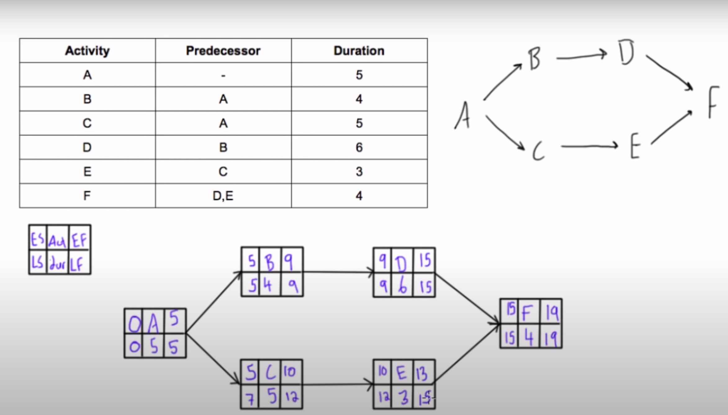
“
ES, EF, LS, LF are Early start, Early finish, Late start, and Late finish
At first, ES and EF are defined for the tasks starting from the task without predecessors. ES of the tasks having predecessors is the maximum of the predecessors’ EF.
Late finish of the tasks T5, T9, and T10, not having successors is set to the maximal obtained EF=50=EF(10).
Late finish of the tasks having successors is defined as minimum of the successors’ LS.
The critical path is (T4, T8, T10) comprising the tasks denoted Y, where ES=LS and EF=LF. The critical path length=EF(T10)=50=Dur(T4)+Dur(T8)+Dur(T10)=10+25+15.

After MT Exam questions Q6-Q11 (67 points)
Q6) 16 points COCOMO
For a 2561 KLOC-sized project what is the staff size if using the Intermediate COCOMO Embedded mode and the project needs high reliability? Show and explain your calculations.
Hints:
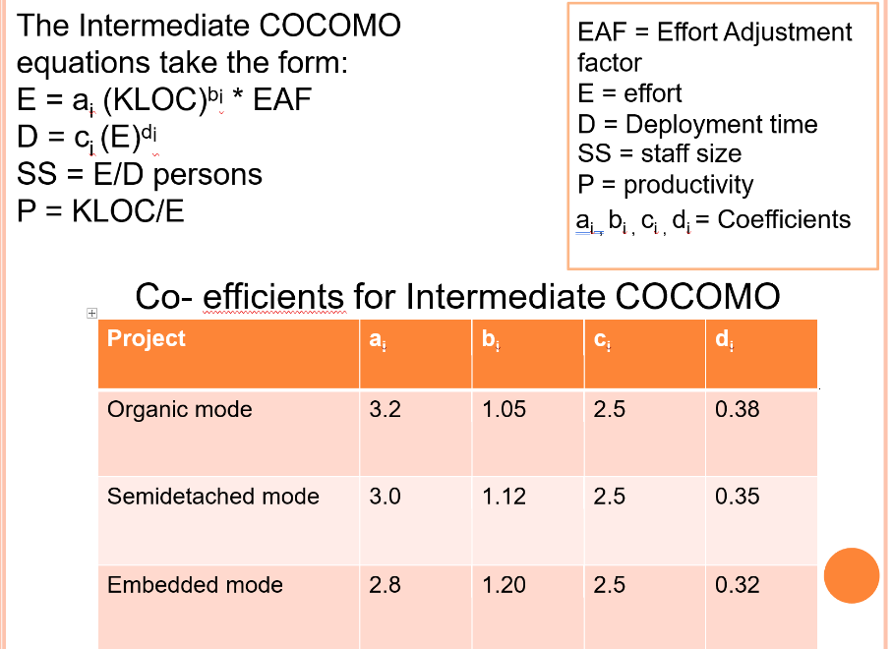 | 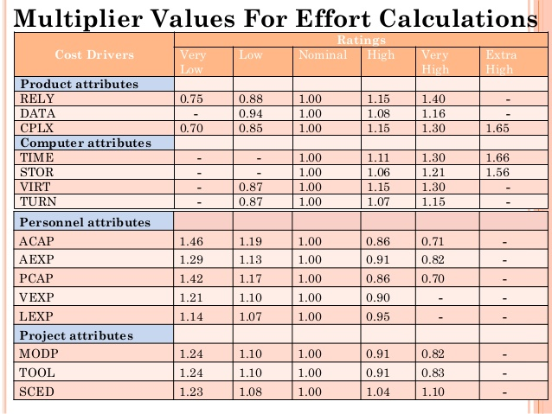
1. Product attributes  a. Required software reliability (RELY)  b. Database size (DATA)  - Product complexity (CPLX)  2. Computer attributes  a. Execution time constraint (TIME)  b. Main store constraint (STOR)  c. Virtual machine volatility (VIRT)  d. Computer turnaround time (TURN)  3. Personnel attributes | a. System Analyst capability (ACAP)  b. Application experience (AEXP)  c. Programmer capability (PCAP)  d. Virtual machine experience (VEXP)  e. Programming Language experience (LEXP)  4. Project attributes  a. Modern programming practices (MODP)  b. Use of software tool (TOOL)  c. Required development schedule (SCED)

EAF=1.15
Size=2561 KLOC
E=ai*Size^bi*EAF=2.8*2561^1.2*1.15=39623 p*m
D=ci*E^di=2.5*39623^0.32=74 m
SS=E/D = 39623/74= 535.45 persons
Q7) 9 points Architectural design
What is the “Model-View-Controller” architectural pattern? What is the aim of each its part?
Model, View, and Controller are the three parts of the architectural pattern
Model is responsible for data keeping and processing, Controller interacts with the user, and View renders results in the convenient for the user form.

Q8) 20 points System modeling
Consider a diagram from the Lecture Notes Ch8 System models slide #30

- (5 points) What is the diagram type? What does it describe?
It is the sequence diagram. It describes a scenario (sequence of interactions) for a particular use-case

- (15 points) Explain the meaning of the
- stick figure and horizontal boxes;
The stick figure represents a human actor, and the boxes stand for non-human actors

- P: PatientInfo
It is an actor, object P of the PatientInfo class

- vertical lines and vertical boxes aligned to them;
The lines represent time axes, and vertical boxes show activity intervals of the actors

- horizontal arrows right and left directed;
The right-directed arrow specify requests, and the left-directed specify responses

- ALT box
ALT box is used to show possible alternatives in the responses, and its parts describe respective actions for each alternative

Q9) 16 points Testing
What is the stub? What is the driver? What for are they used in the testing? Give an example of a situation when a stub shall be used for testing
Hints:
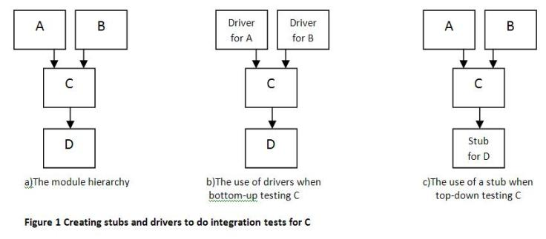

The stub is a dummy module representing not yet developed lower level functional module. It is used just for checking correctness of its call from the higher level already functional developed modules.
The driver is a dummy module representing not yet developed functional module of the higher level which is used to check functionality of the already developed lower level functional modules.
A stub can be used for example, if login interface is already developed but underlying database processing checking correctness of the users’ credentials is not yet developed. The stub can substitute database processing just returning yes (authentic person) for all incoming authentication requests.

Q10) 4 points Quality management
What are the five items of the quality plan structure?
1) Product introduction
2) Product plans
3) Process descriptions
4) Quality goals
5) Risks and risk management

Q11) 2 points Configuration management
What is the baseline? What is the mainline? What is the difference between them?
The baseline is a collection of the components versions comprising a particular build
The mainline is a sequence of the baselines of the system
The difference is that a baseline represents a particular system version, whereas a mainline represents a sequence of the system versions.

