Q1Q2Q3Q4Q5Q6Q7

Eastern Mediterranean University
Computer Engineering Department
CMSE-353 Security of Software Systems
Midterm Exam
Five A4 sheets of handwritten paper may be used for your help. Photocopies, printouts, etc. are not allowed! Electronic devices are not allowed

Duration: 110 Minutes November 28, 2018

Std Id________________Std Name________________________________________________
Instructor Alexander Chefranov

Totally 6 questions, 9 pages
 |  |  |  |  |  | 7. | Total
10 | 15 | 15 | 15 | 15 | 15 | 15 | 100
Q1. (10 points). Consider a system with the users Emre, John, Simon, and Ahmed, objects O1, O2, O3, O4, O5. Emre can read O1 and owns O3, John is an owner of O2 and can read O1 and O4, Simon can read and write O2 and execute O4, Ahmed is an owner of O1, O4, and O5. Construct an Access Control List to keep the privileges described.

Objects
O1
O2
O3
O4
O5
Emre: r
John: r
Ahmed: owner
John: owner
Simon: r,w
Emre: owner
Ahmed: owner
Ahmed: owner
John: r
Simon: e

Q2. (15 points). Encrypt and decrypt back the following English language message “Software Security” using English alphabet substitution cipher with a key phrase: “MPs to vote on May's Brexit deal on 11 December”. Construct a substitution table. Give necessary explanations.
0 | 1 | 2 | 3 | 4 | 5 | 6 | 7 | 8 | 9 | 0 | 1 | 2 | 3 | 4 | 5 | 6 | 7 | 8 | 9 | 0 | 1 | 2 | 3 | 4 | 5
A | B | c | d | e | f | g | h | i | j | k | l | m | n | o | p | q | r | s | t | u | v | w | x | y | z
m | p | s | t | o | v | e | n | a | y | b | r | x | i | d | l | c | f | g | h | j | k | q | u | w | Z

Plaintext | s | o | f | t | w | a | r | e | s | e | c | u | r | i | t | Y
Ciphertext | g | d | v | h | q | m | f | o | g | o | s | j | f | a | h | W
Decrypted | s | o | f | t | w | a | r | e | s | e | c | u | r | i | t | y

Q3. (15 points). Using Hill cipher with size 2 block,
- Encrypt the first block of the following message “Hello, World!” preserving blanks, commas, and exclamation marks.
What numerical codes of the symbols you use? Construct an appropriate key matrix. What conditions must be satisfied by the key matrix? What modulo value shall be used? Show that the matrix you construct satisfies the conditions. Calculate inverse of the key matrix.
- Decrypt back the first ciphertext block encrypted in a)
Give necessary explanations.
Code table
a | b | c | d | e | f | g | h | ı | j | k | l | m | n | o | p | q | r | s | t | u | v | w | x | y | z | ‘ ‘ | , | !
0 | 1 | 2 | 3 | 4 | 5 | 6 | 7 | 8 | 9 | 10 | 11 | 12 | 13 | 14 | 15 | 16 | 17 | 18 | 19 | 20 | 21 | 22 | 23 | 24 | 25 | 26 | 27 | 28
N=29
Encryption matrix; $K=\left[\begin{matrix}1 & 2 \\ 3 & 4\end{matrix}\right]$; Conditions: $detK≠0, detK≠0 mod N,\gcd\left(detK,N\right)=1$
$$detK=4-6=-2;detK=-2≠0, detK=-2=27≠0 mod 29,\gcd\left(detK, N\right)=\gcd\left(-2,29\right)=1$$
The first block of the plaintext is $p_{1}=$“he”= [7 4], $c_{1}=Kp_{1}modN=\left[\begin{matrix}1 & 2 \\ 3 & 4\end{matrix}\right]\left[\begin{matrix}7 \\ 4\end{matrix}\right]=\left[\begin{matrix}7+8 \\ 21+16\end{matrix}\right]mod 29=\left[\begin{matrix}15 \\ 8\end{matrix}\right]=$”pi”
$$K_{ij}^{-1}=\frac{{\left(-1\right)}^{i+i}D_{ji}}{detK} mod N={\left(-1\right)}^{i+i}D_{ji}{(detK)}^{-1}mod N$$

$${(detK)}^{-1} mod N={27}^{-1}mod 29$$
Apply Extended Euclid algorithm to find ${27}^{-1}mod 29$:
- A=(1,0,29), B=(0,1,27)
q=floor(29/27)=1
T=A-qB=(1,-1,2)
- A=(0,1,27), B=(1,-1,2)
q=floor(27/2)=13
T=A-qB=(-13, 14,1), hence, ${27}^{-1}mod 29=14$. Check it:
$$14∙27=14∙\left(-2\right)=-28=1 mod 29$$

$$K_{11}^{-1}={\left(-1\right)}^{1+1}D_{11}∙14mod 29=4∙14mod 29=27$$
$$K_{12}^{-1}={\left(-1\right)}^{1+2}D_{21}∙14mod 29=-2∙14mod 29=-28mod29=1$$
$$K_{21}^{-1}={\left(-1\right)}^{2+1}D_{12}∙14mod 29=-3∙14mod 29=-13 mod29=16$$
$$K_{22}^{-1}={\left(-1\right)}^{2+2}D_{22}∙14mod 29=1∙14mod 29=14$$
Thus,
$$K^{=1}=\left[\begin{matrix}27 & 1 \\ 16 & 14\end{matrix}\right]$$
Let us check that the inverse matrix is calculated correctly:
$$K∙K^{-1}=\left[\begin{matrix}1 & 2 \\ 3 & 4\end{matrix}\right]\left[\begin{matrix}27 & 1 \\ 16 & 14\end{matrix}\right]=\left[\begin{matrix}27+32 & 1+28 \\ 81+64 & 3+56\end{matrix}\right]mod29=\left[\begin{matrix}59 & 29 \\ 145 & 59\end{matrix}\right]mod29=\left[\begin{matrix}1 & 0 \\ 0 & 1\end{matrix}\right]$$
Let us decrypt back now the 1st ciphertext block
$K^{-1}c_{1}=\left[\begin{matrix}27 & 1 \\ 16 & 14\end{matrix}\right]\left[\begin{matrix}15 \\ 8\end{matrix}\right]mod 29=\left[\begin{matrix}-30+8 \\ 240+112\end{matrix}\right]mod29=\left[\begin{matrix}-22 \\ 8+25\end{matrix}\right]mod29=\left[\begin{matrix}7 \\ 4\end{matrix}\right]$=”he”=$p_{1}$

Q4. (15 points). DES round key generation procedure is described in the text below and Figure 3.8 from the Lecture notes:

“KEY GENERATION
Input key has 64 bits. But each 8th bit is not used: bits 8,16,24,32,40,48,56,64 are not further used. The 56-bit key is first subjected to permutation Permuted Choice 1:
Permuted Choice 1 (PC-1)
57 49 41 33 25 17 9
1 58 50 42 34 26 18
10 2 59 51 43 35 27
19 11 3 60 52 44 36
63 55 47 39 31 23 15
7 62 54 46 38 30 22
14 6 61 53 45 37 29
21 13 5 28 20 12 4
The resulting 56-bit key is then treated as two 28-bit quantities, labeled C0 and D0. At each round, C_{i-1} and D_{i-1} are separately subjected to a circular left shift, or rotation, of 1 or 2 bits as governed by the following:
Schedule of Left Shifts
Round number 1 2 3 4 5 6 7 8 9 10 11 12 13 14 15 16
Bits rotated 1 1 2 2 2 2 2 2 1 2 2 2 2 2 2 1
These shifted values serve as input to the next round. They also serve as input to Permuted Choice 2, which produces a 48-bit output that serves as input to the function.
Permuted Choice 2 (PC-2)
14 17 11 24 1 5 3 28
15 6 21 10 23 19 12 4
26 8 16 7 27 20 13 2
41 52 31 37 47 55 30 40
51 45 33 48 44 49 39 56
34 53 46 42 50 36 29 32
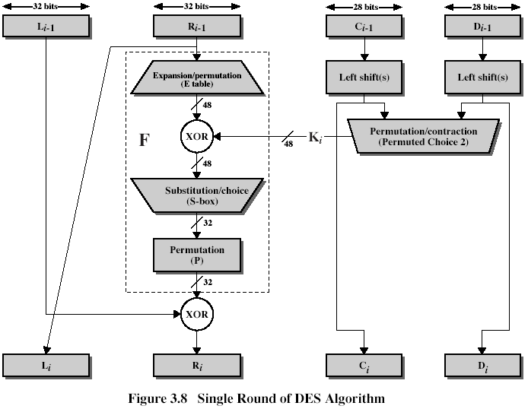
“
The general DES schema is
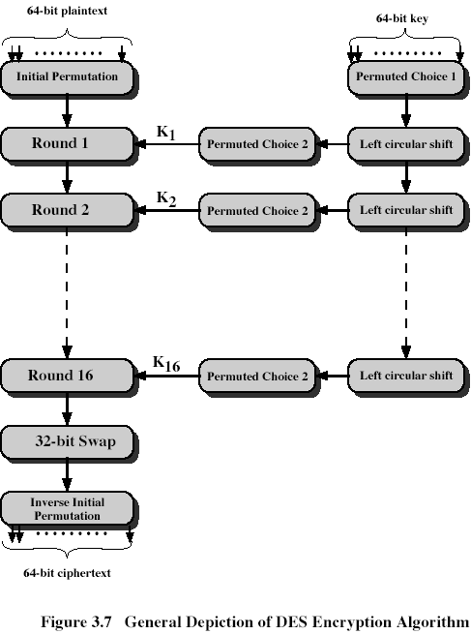

A master 64-bit key, K, specified by a user in hexadecimal form is as follows, K=0x12bcde8932781121. Get the first round-key, K₁. Give necessary explanations
$K=\left[\begin{aligned}\begin{matrix}\begin{matrix}0 & 0 \\ 1 & 0\end{matrix} & \begin{matrix}0 & 1 \\ 1 & 1\end{matrix} \\ \begin{matrix}1 & 1 \\ 1 & 0\end{matrix} & \begin{matrix}0 & 1 \\ 0 & 0\end{matrix}\end{matrix}\begin{matrix}\begin{matrix}0 & 0 \\ 1 & 1\end{matrix} & \begin{matrix}1 & 0 \\ 0 & 0\end{matrix} \\ \begin{matrix}1 & 1 \\ 1 & 0\end{matrix} & \begin{matrix}1 & 0 \\ 0 & 1\end{matrix}\end{matrix} \\ \begin{matrix}\begin{matrix}0 & 0 \\ 0 & 1\end{matrix} & \begin{matrix}1 & 1 \\ 1 & 1\end{matrix} \\ \begin{matrix}0 & 0 \\ 0 & 0\end{matrix} & \begin{matrix}0 & 1 \\ 1 & 0\end{matrix}\end{matrix}\begin{matrix}\begin{matrix}0 & 0 \\ 1 & 0\end{matrix} & \begin{matrix}1 & 0 \\ 0 & 0\end{matrix} \\ \begin{matrix}0 & 0 \\ 0 & 0\end{matrix} & \begin{matrix}0 & 1 \\ 0 & 1\end{matrix}\end{matrix}\end{aligned}\right]$, $PC-1\left(K\right)=\left[\begin{aligned}\begin{matrix}0 & 0 & 0\end{matrix}\begin{matrix}0 & 1 & 11\end{matrix} \\ \begin{matrix}0 & 0 & 0\end{matrix}\begin{matrix}1 & 0 & 01\end{matrix} \\ \begin{matrix}0 & 0 & 1\end{matrix}\begin{matrix}0 & 1 & 10\end{matrix} \\ \begin{matrix}0 & 1 & 0\end{matrix}\begin{matrix}0 & 1 & 11\end{matrix} \\ \begin{matrix}0 & 0 & 0\end{matrix}\begin{matrix}1 & 0 & 10\end{matrix} \\ \begin{matrix}1 & 0 & 0\end{matrix}\begin{matrix}0 & 0 & 01\end{matrix} \\ \begin{matrix}1 & 0 & 0\end{matrix}\begin{matrix}0 & 1 & 01\end{matrix} \\ \begin{matrix}1 & 1 & 0\end{matrix}\begin{matrix}0 & 1 & 11\end{matrix}\end{aligned}\right]$
$$LS-1\left(PC-1\left(K\right)\right)=\left[\begin{aligned}\begin{matrix}0 & 0 & 0\end{matrix}\begin{matrix}1 & 1 & 10\end{matrix} \\ \begin{matrix}0 & 0 & 1\end{matrix}\begin{matrix}0 & 0 & 10\end{matrix} \\ \begin{matrix}0 & 1 & 0\end{matrix}\begin{matrix}1 & 1 & 00\end{matrix} \\ \begin{matrix}1 & 0 & 0\end{matrix}\begin{matrix}1 & 1 & 10\end{matrix} \\ \begin{matrix}0 & 0 & 1\end{matrix}\begin{matrix}0 & 1 & 01\end{matrix} \\ \begin{matrix}0 & 0 & 0\end{matrix}\begin{matrix}0 & 0 & 11\end{matrix} \\ \begin{matrix}0 & 0 & 0\end{matrix}\begin{matrix}1 & 0 & 11\end{matrix} \\ \begin{matrix}1 & 0 & 0\end{matrix}\begin{matrix}1 & 1 & 10\end{matrix}\end{aligned}\right]K_{1}=\left[\begin{aligned}\begin{matrix}0 & 0 \\ 0 & 1\end{matrix}\begin{matrix}0 & 0 \\ 0 & 1\end{matrix}\begin{matrix}0 & 1 \\ 0 & 1\end{matrix}\begin{matrix}0 & 0 \\ 0 & 1\end{matrix} \\ \begin{matrix}1 & 0 \\ 1 & 0\end{matrix}\begin{matrix}1 & 0 \\ 1 & 0\end{matrix}\begin{matrix}1 & 0 \\ 0 & 1\end{matrix}\begin{matrix}1 & 0 \\ 0 & 0\end{matrix} \\ \begin{matrix}0 & 0 \\ 0 & 1\end{matrix}\begin{matrix}1 & 1 \\ 1 & 1\end{matrix}\begin{matrix}0 & 1 \\ 1 & 0\end{matrix}\begin{matrix}0 & 0 \\ 0 & 0\end{matrix}\end{aligned}\right]$$
K1=0x 04 55 aa a4 34 78

Q5. (15 points). Assume that 48-bit result of XOR with the round-key, Ki, in Figure 3.8, is as follows, Res=0x12dcbd560abc, in hexadecimal. What are the 4 bits output by S-box S2. Expansion/permutation table from Figure 3.8
Expansion/Permutation (E table)
32 | 1 2 3 4 | 5
4 | 5 6 7 8 | 9
8 | 9 10 11 12 | 13
12 | 13 14 15 16 | 17
16 | 17 18 19 20 | 21
20 | 21 22 23 24 | 25
24 | 25 26 27 28 | 29
28 | 29 30 31 32 | 1

Figure 3.9 illustrating work of S-boxes
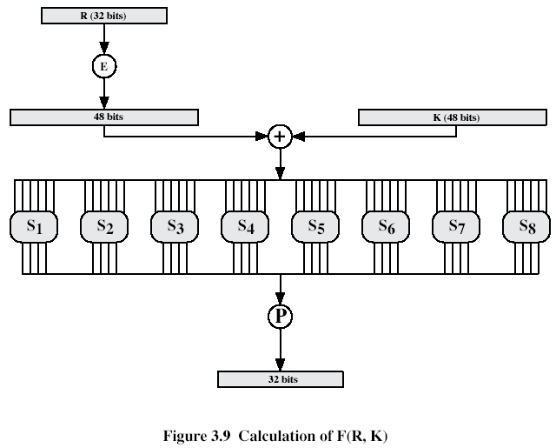
and Table 3.3 showing each S-box
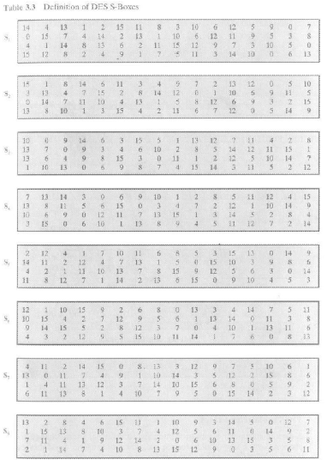

In binary,
$$Res=\left[\begin{aligned}\begin{matrix}0 & 0 & 0 \\ 1 & 0 & 1\end{matrix}\begin{matrix}1 & 0 & 0 \\ 1 & 0 & 1\end{matrix} \\ \begin{matrix}1 & 1 & 0 \\ 1 & 1 & 1\end{matrix}\begin{matrix}0 & 1 & 0 \\ 1 & 0 & 1\end{matrix} \\ \begin{matrix}0 & 1 & 0 \\ 1 & 0 & 0\end{matrix}\begin{matrix}1 & 0 & 1 \\ 0 & 0 & 0\end{matrix} \\ \begin{matrix}1 & 0 & 1 \\ 1 & 1 & 1\end{matrix}\begin{matrix}0 & 1 & 0 \\ 1 & 0 & 0\end{matrix}\end{aligned}\right]$$
Input to S2 is (101101), Row#=(11)=3, Col#=(0110)=6. On the cross of the Row=3 and Col=6, we find 4=(0100) that are the bits output by S2.
Q.6. (15 points) Write the formula defining a multiplicative inverse in Z_{n}? Find 131⁻¹ mod 200 using Extended Euclid’s algorithm. Show your calculations. Check correctness of your calculations using the multiplicative inverse defining formula.
Hint:
EXTENDED EUCLID(m,b)
- (A1,A2,A3):=(1,0,m); (B1,B2,B3):=(0,1,b);
- if B3=0 return A3=gcd(m,b); no inverse
- if B3=1 return B3 = gcd(m,b); B2= b⁻¹ mod m
- Q=
- (T1,T2,T3):=(A1-QB1, A2-QB2, A3-QB3)
- (A1,A2,A3):= (B1,B2,B3)
- (B1,B2,B3):= (T1,T2,T3)
- goto 2

- A=(1,0,200), B=(0,1,131)
q=floor(200/131)=1
T=A-qB=(1,-1,69)
- A=(0,1,131), B=(1,-1,69)
q=floor(131/69)=1
T=A-qB=(-1, 2, 62)
- A=(1,-1,69), B=(-1,2,62)
q=floor(69/62)=1
T=A-qB=(2,-3,7)
- A=(-1,2,62), B=(2,-3,7)
q=floor(62/7)=8
T=A-qB=(-17,26,6)
- A=(2,-3,7), B=(-17,26,6)
q=floor(7/6)=1
T=A-qB=(19,-29,1), hence, 131⁻¹ mod 200 = -29=171
Let us check it:
$$131∙171=131\left(-29\right)=\left(130+1\right)\left(-30+1\right)=-3900-30+130+1=-3799=-19∙200+1=1 mod 200$$
Q.7. (15 points) Consider the materials below on the AES S-box construction
“
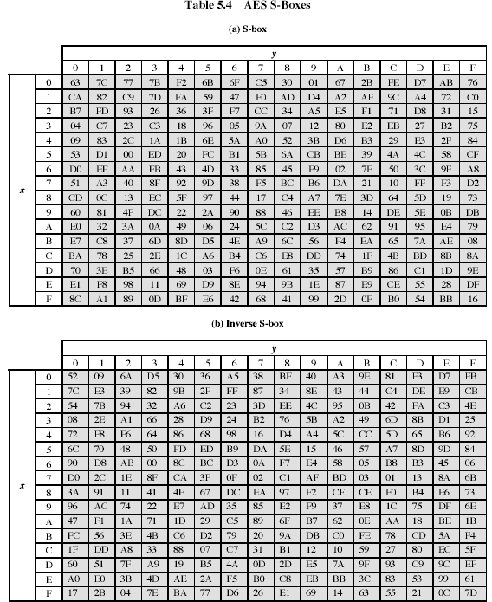

The S-box is constructed in the following fashion:
- Initialize the S-box with the byte values in ascending order row by row. Thus, the value of the byte at row x, column y is {xy}
- Map each byte in the S-box to its multiplicative inverse in the finite field GF(2⁸), ; the value {00} is mapped to itself.
- Consider that each byte in the S-box consists of 8 bits labeled (b7,b6,b5,b4,b3,b2,b1,b0). Apply the following transformation to each bit of each byte in the S-box:
(5.1)
where c_{i} is the i-th bit of byte c with the value {63}, that is, (c7c7c5c4c3c2c1c0)=(01100011). The prime indicates that the variable is to be updated by the value on the right. The AES standard depicts this transformation in matrix form as follows:
B₀’ |  | 1 | 0 | 0 | 0 | 1 | 1 | 1 | 1 |  | B₀ |  | 1
B₁’ |  | 1 | 1 | 0 | 0 | 0 | 1 | 1 | 1 |  | B₁ |  | 1
B₂’ |  | 1 | 1 | 1 | 0 | 0 | 0 | 1 | 1 |  | B₂ |  | 0
B₃’ | = | 1 | 1 | 1 | 1 | 0 | 0 | 0 | 1 | x | B₃ | + | 0 | (5.2)
B₄’ |  | 1 | 1 | 1 | 1 | 1 | 0 | 0 | 0 |  | B₄ |  | 0
B₅’ |  | 0 | 1 | 1 | 1 | 1 | 1 | 0 | 0 |  | B₅ |  | 1
B₆’ |  | 0 | 0 | 1 | 1 | 1 | 1 | 1 | 0 |  | B₆ |  | 1
B₇’ |  | 0 | 0 | 0 | 1 | 1 | 1 | 1 | 1 |  | B₇ |  | 0
Each element in the product matrix is the bitwise XOR of elements of one row and one column. Further, the final addition, shown in (5.2), is a bitwise XOR.
As an example, consider the input value {95}. The multiplicative inverse in GF(2⁸) is {95}⁻¹ ={8a}, which is 10001010 in binary. Using equation (5.2),
1 | 0 | 0 | 0 | 1 | 1 | 1 | 1 |  | 0 |  | 1 |  | 1 |  | 1 |  | 0
1 | 1 | 0 | 0 | 0 | 1 | 1 | 1 |  | 1 |  | 1 |  | 0 |  | 1 |  | 1
1 | 1 | 1 | 0 | 0 | 0 | 1 | 1 |  | 0 |  | 0 |  | 0 |  | 0 |  | 0
1 | 1 | 1 | 1 | 0 | 0 | 0 | 1 | x | 1 | + | 0 | = | 1 | + | 0 | = | 1
1 | 1 | 1 | 1 | 1 | 0 | 0 | 0 |  | 0 |  | 0 |  | 0 |  | 0 |  | 0
0 | 1 | 1 | 1 | 1 | 1 | 0 | 0 |  | 0 |  | 1 |  | 0 |  | 1 |  | 1
0 | 0 | 1 | 1 | 1 | 1 | 1 | 0 |  | 0 |  | 1 |  | 1 |  | 1 |  | 0
0 | 0 | 0 | 1 | 1 | 1 | 1 | 1 |  | 1 |  | 0 |  | 0 |  | 0 |  | 0
The result is {2a}, which should appear in row {09} column {05} of the S-box. This is verified by checking Table 5.4a.”

Calculate according to the description above S-box entry (2,2).
(xy)=(22)=(0010 0010)=$x^{5}+x$ and we need inverting it. Use Extended Euclid algorithm
- A=(1,0,$m\left(x\right)=x^{8}+x^{4}+x^{3}+x+1$), B=(0,1,$x^{5}+x$)
$$q=x^{3}, r=x^{3}+x+1$$
T=A-qB=(1,$x^{3}$, $x^{3}+x+1$)
- A=(0,1,$x^{5}+x$), B=(1,$x^{3}$, $x^{3}+x+1$)
$$q=x^{2}+1, r=x^{2}+1$$
T=A-qB=($x^{2}+1$, 1+$\left(x^{2}+1\right)x^{3}=x^{5}+x^{3}$, $x^{2}+1$),
- A=(1,$x^{3}$, $x^{3}+x+1$), B=($x^{2}+1$, $x^{5}+x^{3}+1$, $x^{2}+1$)
$$q=x, r=1$$
T=A-qB=($x^{3}+x+1$, $x^{3}+x(x^{5}+x^{3}+1)$, 1)= ($x^{3}+x+1$, $x^{3}+x\left(x^{5}+x^{3}+1\right)=x^{6}+x^{4}+x^{3}+x$, 1),
hence, ${{(x}^{5}+x)}^{-1}mod {(x}^{8}+x^{4}+x^{3}+x+1)=x^{6}+x^{4}+x^{3}+x$
Let us check it:
$${(x}^{5}+x)\left(x^{6}+x^{4}+x^{3}+x\right)=x^{11}+x^{9}+x^{8}+x^{6}+x^{7}+x^{5}+x^{4}+x^{2}=x^{11}+x^{9}+x^{8}+x^{7}+x^{6}+x^{5}+x^{4}+x^{2}=\left(x^{3}+x+1\right)\left(x^{8}+x^{4}+x^{3}+x+1\right)+1=1 mod m(x)$$
Hence, ${22}^{-1}=x^{6}+x^{4}+x^{3}+x=0101 1010=5a$
Using matrix multiplication and addition:
1 | 0 | 0 | 0 | 1 | 1 | 1 | 1 |  | 0 |  | 1 |  | 0 |  | 1 |  | 1
1 | 1 | 0 | 0 | 0 | 1 | 1 | 1 |  | 1 |  | 1 |  | 0 |  | 1 |  | 1
1 | 1 | 1 | 0 | 0 | 0 | 1 | 1 |  | 0 |  | 0 |  | 0 |  | 0 |  | 0
1 | 1 | 1 | 1 | 0 | 0 | 0 | 1 | x | 1 | + | 0 | = | 0 | + | 0 | = | 0
1 | 1 | 1 | 1 | 1 | 0 | 0 | 0 |  | 1 |  | 0 |  | 1 |  | 0 |  | 1
0 | 1 | 1 | 1 | 1 | 1 | 0 | 0 |  | 0 |  | 1 |  | 1 |  | 1 |  | 0
0 | 0 | 1 | 1 | 1 | 1 | 1 | 0 |  | 1 |  | 1 |  | 1 |  | 1 |  | 0
0 | 0 | 0 | 1 | 1 | 1 | 1 | 1 |  | 0 |  | 0 |  | 1 |  | 0 |  | 1
Thus S-box(2,2)=(1001 0011)=(93) that is actually seen in the S-box.

