EASTERN MEDITERRANEAN UNIVERSITY
DEPARTMENT OF COMPUTER ENGINEERING

CMSE 443

Real-Time Systems Design
Final Exam

2025/26 Fall Semester

January 12, 2026

Name-Surname : ___________________

Student Number : ___________________

Instructor:

Prof. Dr. Alexander CHEFRANOV

Duration: 150 minutes

Standalone calculators ARE ALLOWED

Mobiles, tablets, and other electronic devices ARE NOT ALLOWED

YOU CAN BRING FIVE A4-SIZED SHEETS OF YOUR HAND-WRITTEN NOTES TO THE EXAM. PHOTOCOPIES, PRINTOUTS, ETC. ARE NOT ALLOWED AND WILL BE COLLECTED.

TRY ALL THE QUESTIONS

GOOD LUCK!
Totally 7 questions, 14 pages

Task | 1 | 2 | 3 | 4 | 5 | 6 | 7 | Total
Point | 17 | 16 | 13 | 13 | 13 | 14 | 14 | 100
Grade

Section I. RTS Hardware (33 points)
Task 1 (17 points) For the expression
r=x-y-z*(x+y)+z*d

  - (4 points) Build a tree representation

=
r
+
-
-
x
y
*
z
+
x
y
*
z
d

  - (4 points) Build the reverse Polish notation using LRN (left-right-node) tree traversal strategy

Rxy-zxy+*-zd*+=

  - (4 points) Write the code using instructions of 0-address machine to implement the expression using its reverse Polish notation filling Column 2 Instruction of the Table 1 below:
Table 1. Code and tracing

Instruction # | Instruction | X=3 in 300 | Y=5 in 302 | Z=6 in 303 | D=7 in 304 | stack
 | Load literal @r |  |  |  |  | 300
 | Load literal @x |  |  |  |  | 300,301
 | load |  |  |  |  | 300,4
 | Load literal @y |  |  |  |  | 300,4,302
 | load |  |  |  |  | 300,4,5
 | Sub |  |  |  |  | 300,-1
 | Load literal @z |  |  |  |  | 300,-1,303
 | load |  |  |  |  | 300,-1,6
 | Load literal @x |  |  |  |  | 300,-1,6,301
 | load |  |  |  |  | 300,-1,6,4
 | Load literal @y |  |  |  |  | 300,-1,6,4,302
 | load |  |  |  |  | 300,-1,6,4,5
 | Add |  |  |  |  | 300,-1,6,9
 | Mul |  |  |  |  | 300,-1,54
 | Sub |  |  |  |  | 300, -55
 | Load literal @z |  |  |  |  | 300,-55,303
 | load |  |  |  |  | 300,-55,6
 | Load literal @d |  |  |  |  | 300,-55,6,304
 | Load |  |  |  |  | 300,-55,6,7
 | Mul |  |  |  |  | 300,-55,42
 | + |  |  |  |  | 300,-13
 | sto |  |  |  | R=-13

r=x-y-z*(x+y)+z*d =4-5-6*(4+5)+6*7=-1-6*9+42=-55+42=-13
Manual calculation and code both return -13.

  - (5 points) Assume that addresses and values of the variables are as follows
# | Name | Address | Value
1 | R | 300 | 3
2 | X | 301 | 4
3 | Y | 302 | 5
4 | Z | 303 | 6
5 | d | 304 | 7

Calculate the expression manually and compare it versus its value calculated by tracing the code generated in Task 1.3. Show all intermediate variables’ values and content of the stack after each instruction completion filling in Columns 3-7 in the Table 1 above.

Assume that the stack grows horizontally from left to right, e.g. a three-element stack is represented by (300, 400, 500) with 500 on the top and 300 on the bottom)

Hints:
0-address machine instruction set is as follows:

0-address machine (reverse Polish)
where the processor has a stack and some supporting hardware, at least a top of stack (TOS) pointer.
Operation | e.g. or comment
load_literal <int> | effect:  TOS:=TOS+1; stack[TOS]:=<int>  load a constant onto the top of stack; this can be used in arithmetic or to get an address onto the stack for use by a load or a store instruction later (it is splitting hairs to argue whether the literal is an address or a constant which might happen to be used as an address elsewhere)
load | effect:  stack[TOS]:=memory[stack[TOS]]  take the top-of-stack as an address, replace the top-of-stack with the contents of that address.
sto | effect:  memory[stack[TOS-1]]:=stack[TOS]; TOS:=TOS-2  store contents of top of stack at the address in stack[TOS-1] then pop the value and the address
<opcd> | where <opcd> is add | sub |...  effect:  stack[TOS-1] := stack[TOS-1] <op> stack[TOS];  TOS:=TOS-1

Task 2 (16 points)
Consider the PLA scheme below:
  - (4 points) What types of gates are used in the schema? What logical operation is done by each gate type? How many inputs and outputs do the gates have?
NOT, AND, and OR gates are used. They do logical NOT, AND, and OR operations. NOT has 1 input and 1 output, AND and OR have 4 inputs and 1 output

  - (4 points) Program the PLA above (connecting the lines by dots $∙$ or crosses $×$ 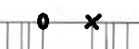in the above schema) to implement a ROM with four memory cells keeping the following four numbers: (15, 7, 14, 5) exactly in this order.
  - (4 points) What is the binary representation of the numbers?
15: 1111 7: 0111 14: 1110 5: 0101

  - (4 points) Explain how the numbers 7 and 14 can be read out from the ROM (what inputs shall be used, where and what outputs shall be found)
We assume that the numbers are located in the cells number 0,1,2,3 which are represented in binary as (a,b)=(00),(01),(10), and (11). The numbers are represented in binary as (x1,x2,x3,x4), where x1 in the most-significant bit, and x4 is the least-significant bit. To read 7 from the cell 01, (a,b)=(0,1), and the 2nd AND outputs 1 which is used as input to the 2nd, 3rd , and 4th OR gates. Hence, (x1,x2,x3,x4)=(0111)=7. To read 14 from the cell 10, (a,b)=(1,0), and the 3rd AND outputs 1 which is used as input to the 1st, 2nd, and 3rd OR gates. Hence, (x1,x2,x3,x4)=(1110)=14.

Section II. RTS Operating Systems (67 points)

Task 3. (13 points) Build an Earliest-Deadline First (EDF) schedule for two periodic tasks:
Task# | E | P
1 | 2 | 3
2 | 1 | 5
What are the utilization and hyperperiod for this set of tasks? Are the deadlines met by the EDF schedule? Explain why they are met (not met)?
Hints:
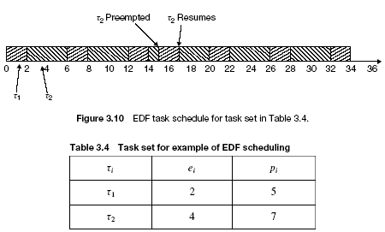
U=2/3+1/5=10/15+3/15=13/15; H=3*5=15
Phase of the tasks is not specified; hence, by default, it is 0
Relative deadline of the tasks is not specified; hence, it is equal to the period.
1
2
1
1
2
1
1
1
1
2
1
1
1
1
2
We see that in the hyperperiod H, 13 time units CPU is busy, and 2 time units is idle.
Task | Release | Release time | Deadline | Completion time
1 | 1 | 0 | 3 | 2
 | 2 | 3 | 6 | 5
 | 3 | 6 | 9 | 8
 | 4 | 9 | 12 | 11
 | 5 | 12 | 15 | 14
2 | 1 | 0 | 5 | 3
 | 2 | 5 | 10 | 6
 | 3 | 10 | 15 | 12

From the table above, it is seen that all the deadlines are satisfied (completion time is not greater than respective deadline).
Task 4. (13 points) Assume, three parallel processes, A, B, and C, run concurrently with the dependency graph as follows:
Processes B and C wait for a data from A, process it, and provide their outputs back to A waiting for them. Write a pseudo-code using binary semaphores to provide required synchronization of the processes A, B, and C. Define necessary data structures. Show initial settings of the global semaphores you use.
A
B
C
Hints: sem busy=0 /*closed*/, done=0;
Driver{ while(1){
if(data_for_I/O){
prepare(command);
V(busy); P(done);}
}
}
Controller{while(1){
P(busy);
exec(command);
V(done);
}
}

Semaphore sem_to_B=0, sem_to_C=0, sem_from_B=0, sem_from_C=0; //0 is closed state
ProcessA(){  While(1){  Prepare_data_for_BC();  V(sem_to_C);  V(sem_to_B);  P(sem_from_C);  P(sem_from_B);  }//while  }//A | ProcessB(){  While(1){  P(sem_to_B);  Process_dataB();  V(sem_from_B);  }//while  }//B | ProcessC(){  While(1){  P(sem_to_C);  Process_dataC();  V(sem_from_C);  }//while  }//C

Task 5. (13 points) Assume that a system has 5 processes and resources of two types: processors (totally available free 10) and memory (total available number of free memory blocks is 15). Processes do not have any resources already allocated to them. Their current and maximal requirements are as follows:
Process | Processors currently required | Processors maximal required | Memory currently required | Memory maximal required
1 | 2 | 3 | 4 | 5
2 | 2 | 5 | 3 | 6
3 | 2 | 4 | 2 | 4
4 | 2 | 3 | 3 | 6
5 | 1 | 4 | 1 | 6
Use the Banker’s algorithm to decide on the safety of granting the currently required resources. Show all the steps of the algorithm you make to come to your decision.
Hints:
The Banker’s Algorithm
The case of multiple resources. Initial resource state:
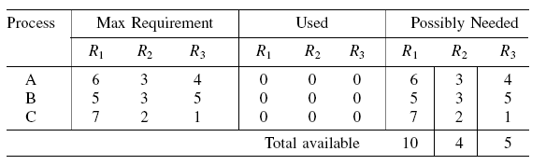
Safe state with safe sequence A, C, B:
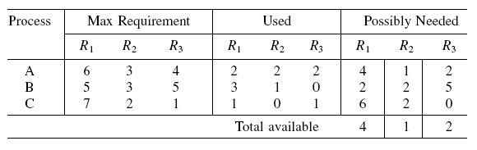

Current state of the resources is safe because the number of available processors (10) and the number of memory blocks (15) is greater than each process’ maximal requirement, and they can be passed serially one-by-one. If satisfying current requirements, available processors p and memory blocks b will be
P=10-2-2-2-2-1=1, b=15-4-3-2-3-1=1
The maximal possible needs, NPi, NBi, i=1,,5 of the processes for processors and memory will be
NP1=3-2=1, NB1=5-4=1
NP2=5-2=3, NB2=6-3=3
NP3=4-2=2, NB3=4-2=2
NP4=3-2=1, NB4=6-3=3
NP5=4-1=3, NB5=5-4=1
We try to build a safe sequence, S, of the processes including all of them. If it is found then the resource state is safe and the current requests can be satisfied, otherwise the state is not safe, and the current requirements shall not be satisfied.
S={}
Since NP1=1<=P=1, NB1=1<=B=1, S can be extended by P1: S={P1}
After termination of P1 its resources will be returned back and P and B will be increased:
P=P+2=1+2=3, B=B+4=1+4=5
Since NP2=3<=P=3, NB2=3<=B=5, S can be extended by P2: S={P1,P2}
After termination of P2 its resources will be returned back and P and B will be increased:
P=P+2=3+2=5, B=B+4=5+4=9
Since NP3=2<=P=5, NB3=2<=B=9, S can be extended by P3: S={P1,P2,P3}
After termination of P3 its resources will be returned back and P and B will be increased:
P=P+2=5+2=7, B=B+4=9+2=11
Since NP4=1<=P=7, NB4=3<=B=11, S can be extended by P4: S={P1,P2,P3,P4}
After termination of P4 its resources will be returned back and P and B will be increased:
P=P+2=7+2=9, B=B+3=11+3=14
Since NP5=3<=P=9, NB5=1<=B=14, S can be extended by P5: S={P1,P2,P3,P4,P5}
After termination of P5 its resources will be returned back and P and B will be increased:
P=P+1=9+1=10, B=B+1=14+1=15,
Thus, we see that after termination of the processes in S, the number of available resources is restored back to 10 processors and 15 memory blocks.
Since S includes all five processes, it is safe to satisfy the processes’ current requirements.

Task 6. (14 points) Assume, we have a priority preemptive system (without time sharing for same priority tasks) and the following system of processes:
Process | Priority | Execution sequence | Release time
A | 1 (highest) | EVEV | 3
B | 3 | EVQQE | 4
C | 2 | EVVE | 2
D | 4 (lowest) | EQVVE | 0
Show time diagrams of execution for each process, if Immediate Ceiling Priority Protocol is used. Calculate response time for each process A, B, C, D. Specify dynamic priority for each task and each time unit when it runs.
Hints:
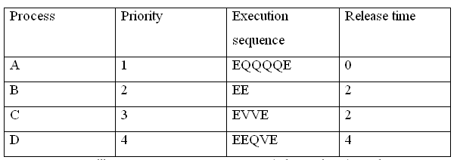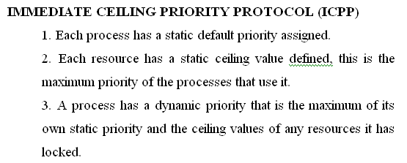
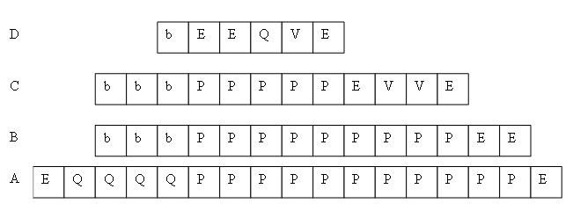
Ceiling priority of Q is 3, and ceiling priority of V is 1
E
Q
P
P
P
P
P
P
P
P
P
P
E
P
P
P
P
V
V
E
P
P
P
V
E
V
E
V
V
E
P
P
P
P
P
P
E
V
Q
Q
E
D
C
A
B
Response time of A is 7-3=4, of B is 15-4=11, of C is 10-2=8, and of D is 18-0=18.
Task A runs on its own priority 1. Task B on priority 1 when using V (from time instance 11 to 12), and the rest of the time on priority 3. Task C runs on priority 1 from time instance 7 to 9, and the rest of the time on its priority 2. Task D runs from time instance 1 to 2 on priority 3, from 15 to 17 on priority 1, and the rest of the time on its own priority 4.

Task 7. (14 points) Assume the memory has 4 memory blocks, and the reference string is 2 4 6 8 9 2 4 6 8 9 2 4 6 8 9, where virtual page 2 is referenced at time t=0 Answer the questions below and show (filling in the tables below) which virtual pages (2, 4, 6, 8, or 9) will stay in which physical memory pages (1, 2, 3,and 4) when using
7.1 (7 points) FIFO
What page is replaced by FIFO? A page which stays longest in memory is replaced.

Physical page\time | 0
1 | 2 | 2 | 2 | 2 | 9 | 9 | 9 | 9 | 8 | 8 | 8 | 8 | 6 | 6 | 6
2 |  | 4 | 4 | 4 | 4 | 2 | 2 | 2 | 2 | 9 | 9 | 9 | 9 | 8 | 8
3 |  |  | 6 | 6 | 6 | 6 | 4 | 4 | 4 | 4 | 2 | 2 | 2 | 2 | 9
4 |  |  |  | 8 | 8 | 8 | 8 | 6 | 6 | 6 | 6 | 4 | 4 | 4 | 4
How many page faults happens for FIFO? At which time moments do they happen?
Page faults happen 15 times, each time moment starting from 0.

7.2 (7 points) LRU
What page is replaced by LRU? A page not used for the longest time is replaced.

Physical page\time | 0
1 | 2 | 2 | 2 | 2 | 9 | 9 | 9 | 9 | 8 | 8 | 8 | 8 | 6 | 6 | 6
2 |  | 4 | 4 | 4 | 4 | 2 | 2 | 2 | 2 | 9 | 9 | 9 | 9 | 8 | 8
3 |  |  | 6 | 6 | 6 | 6 | 4 | 4 | 4 | 4 | 2 | 2 | 2 | 2 | 9
4 |  |  |  | 8 | 8 | 8 | 8 | 6 | 6 | 6 | 6 | 4 | 4 | 4 | 4
How many page faults happens for LRU? At which time moments do they happen?
Page faults happen 15 times, each time moment starting from 0.

Hints:
Replacement algorithms
FIFO, LRU (Least recently used)
If we have 4 page memory and
2 4 6 8 is a a page reference string (page 2 is the least and page 8 is the most recently used) then
2 4 6 8 9 2 4 6 8 9 2 4 6 8 9 will lead to page thrashing
Memory locking, Working sets

