23.10.2025

Term Project task for CMXE-443 REAL-TIME SYSTEMS DESIGN (Fall-2025)

Quadcopter Motion Control (QMC) Real-Time System (RTS) Design

General Task Formulation
Design an RTS for the manual control of a quadcopter, Figure 1.
Figure 1. Quadcopter structure [1]
using its simulator based on a mathematical model from [1] (see formulas (1)-(27) therein, Ref. 1) and [2] (see Sections 3.1, 3.2, p. 8-21, Ref. 2). The quadcopter flight shall be visualized and controlled by inputs received from a user. A user shall see on the screen the flight of the quadcopter, for example, as a scene a pilot of the quadcopter might see (first person view – FPV). Simulator shall solve respective equations numerically using Euler and Runge-Kutta methods. Parameters of a quadcopter shall be modifiable with default values as defined in [2], Appendix H, p. 151. A user shall be able controlling quadcopter flight with dynamically changing scenes (Earth, sky, clouds, etc.) rendered on the monitor similar to that shown in Figure 2.
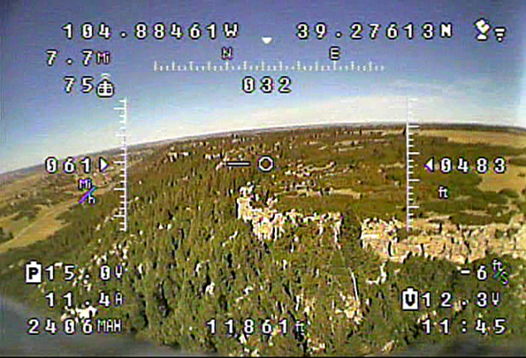
Figure 2. Typical FPV scene from https://en.wikipedia.org/wiki/First-person_view_(radio_control)#/media/File:FPV_OSD.png
Some useful for understanding of the model references are here

What must be done
The system must have the following parts:
- quadcopter simulator;
- quadcopter visualization system;
- user interface.
User interface must support an opportunity to arrange our RTS (introduce quadcopter characteristics – length, mass, initial position and velocity, time step for modeling, time step for controlling; start/stop button, etc.)
Quadcopter visualization system is to output:
- vehicle image, most appropriate to its current state;
- table of the last 10 values of position and velocity;
- current parameters of the system
- assume that motion of the quadcopter is not limited by the screen window
Quadcopter simulator is to determine what must be the quadcopter state at the next moment of visualization depending on its previous state and control action. Frequency of visualization must be approximately 20 times/sec (each 0.05 sec screen must be refreshed).
Mentioned above parts may be implemented by separate developers and then integrated.

Implementation requirements
- Assignment may be performed by teams of 3-4 people.
- Each team submits a report with the names of the participants specified. Copies are not allowed and will be graded by zero if any.
- In the Introduction to the report, responsibilities of each team member must be explicitly shown (what parts out of the mentioned in “What must be done” or what combination of them was realized by each person).
- Report must include: Title (department, course, assignment name, names and ids of participants, semester, year), Introduction (what for the work is to be done), Task definition (what must be done, mathematical model, requirements to implementation), Conceptual design (idea of approach, show parts of the task, their links and interaction), Description of the program implementation (procedures, interfaces, their interactions), Description of testing (separate testing, integration process, integrated testing, what examples have you tried, results of testing, screenshots), Instruction to a user (what, where and how should be installed to make your program working), Conclusion (what was really achieved in comparison with supposed), References to cited sources if any, Appendix (source codes which shall be referred to from the main text).
- Zip file with all related to the Term project materials (report, sources, executables, libraries, etc. allowing installation of the program from it, and its further invocation, user’s guide, etc.) shall be uploaded in Teams assignment by Lab Coordinator HAMIDREZA RAHIMI by Monday, December 25, 2025, 9.00 am.
- LATE SUBMISSION WILL BE fined: 10% per work day of delay (but cut not more than by 50%).
- You are to be ready to demonstrate your program and give necessary explanations on the work done at the time and place which are to be announced later.
- BONUS: 10% out of the Term Project points can be additionally earned if additionally to manual control implementing an automatic PID controller as described in [2], Figs. 10.6-10.9.

References

[1] | Z. Benić, P. Piljek and D. Kotarski, "MATHEMATICAL MODELLING OF UNMANNED AERIAL VEHICLES WITH FOUR ROTORS," Interdisciplinary Description of Complex Systems, vol. 14, no. 1, pp. 88-100, 2016.
[2] | T. Bresciani, "Modelling, Identification and Control of a Quadrotor Helicopter," Lund, Sweden, Master Thesis, 2008, 184 p., ISSN 0280-5316; ISRN LUTFD2/TFRT--5823--SE.

