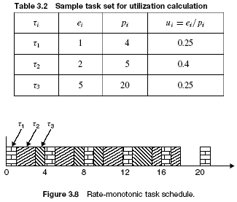
Freq=1MHz F=10MHz
A(10,10)*B(10,10) => operations number = 10^3=1000 multiplications
1 multiplication => 10clocks => 1sec =>100 000multiplications
Execution time = 1000*10clocks/1000000clocks/sec=0.01 sec =>0.001 sec on 10 MHz computer

