# ASSIGNMENT FOR CMSE-443 REAL-TIME SYSTEMS DESIGN (Spring-2020)

# Real-Time System (RTS) Design

# for PD-Control of a Pendulum in the Upper State

### General Task Formulation

### Design a RTS for automatic stabilization of a pendulum of mass m and length , residing on a motor driven car of the mass M, in the upper state (Fig.). Pendulum is controlled by application of the force, u, satisfying proportional-plus-derivative (PD) law of control with the parameters, a, b, satisfying (11). *All references herein are to the following “Description of pendulum-plus-cart PD-controller RTS” part.* Behavior of the pendulum-plus-cart system is modeled by (1), (10), and (16) with initial conditions (15), (17) (assuming values in (15) being small). These equations are to be solved numerically as in Labs 1-2, providing dependency of the state of the system on the time, initial conditions and control actions. Time step for numerical solution should be chosen according to (12)-(14). Time step for actions of PD-controller should be taken as

### 1) =, that corresponds to the analog PD-controller;

2) **=**0.1 sec, that corresponds to the digital PD-controller.

### Current state of the pendulum-plus-cart system should be rendered on the screen each 0.1 sec (generation of moving images and timer issues are considered in Labs 3-4). The system should provide user interface (to define parameters *l, m, M, a, b*, initial values , , , start/stop option, show current parameters and character time (13), which is determined by these parameters). Character time (13) determines real-time behavior of the system: greater this time – slower should be movements. User should be able to vary system parameters and initial conditions, and view process of the pendulum stabilization. This process may be either oscillating, or not – user should be able to observe them.

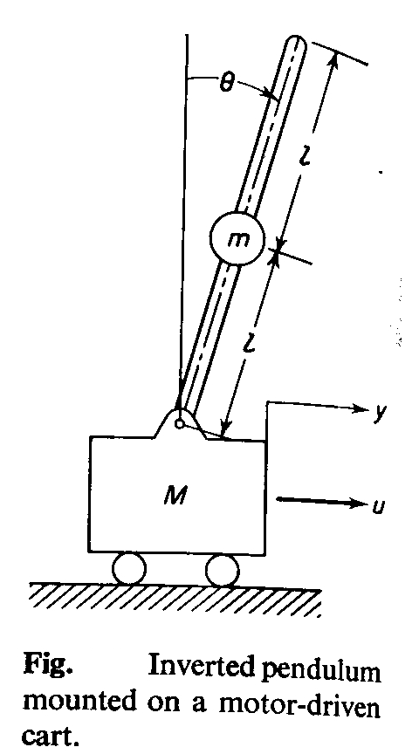

### What must be done

The system **must** have the following parts:

* pendulum and PD-controller simulator;
* pendulum visualization system;
* user interface.

User interface must support an opportunity to arrange our RTS (**introduce pendulum characteristics – length, masses, parameters of PD-control, initial position and velocity, time step for modeling, time step for controlling**; **start/stop**, etc.)

Pendulum visualization system is to output:

* pendulum image, most appropriate to its current state;
* table of the last 10 values (**u**, **y**, );
* current parameters of the system: , *m, M, a, b*, , , , current time
* assume that motion of the cart is not limited from left and right (no walls nor at the left, nor at the right)

Pendulum and PD-controller simulator is to determine what must be the pendulum state at the next moment of visualization depending on its previous state and control action. Frequency of visualization must be approximately **10 times/sec (each 0.1 sec screen must be refreshed**).

Mentioned above parts may be implemented by separate developers and then integrated.

### Implementation requirements

1. Assignment may be performed by teams of **3-7** people.
2. Each team submits **a report** with the names of the participants specified. **Copies are not allowed and will be graded by zero if any.**
3. In the Introduction to the report, **responsibilities of each team member** **must be explicitly shown** (what parts out of the mentioned in “What must be done” or what combination of them was realized by each person).
4. **Printed out** report must include: Title (department, course, assignment name, names and ids of participants, semester, year), Introduction (what for the work is to be done), Task definition (what must be done, requirements to implementation), Conceptual design (idea of approach, show parts of the task, their links and interaction), Description of the program implementation (procedures, interfaces, their interactions), Description of testing (separate testing, integration process, integrated testing, what examples have you tried (see Item 5), results of testing, screenshots), Instruction to a user (what, where and how should be installed to make your program working), Conclusion (what was really achieved in comparison with supposed), References to cited sources if any, Appendix (**source codes which shall be referred to from the main text; *disk* with sources and executables, libraries, etc. allowing installation of the program from it, and its further invocation).**
5. Testing examples:

* view pendulum behavior without control (*a=b=0*); pendulum shall fall down in approximately time  (use  from the table below).
* view pendulum behavior when =(analog PD-control)under the following parameter values:

| Parameter \variant #  (measure) | 1 | 2 | 3 | 4 |
| --- | --- | --- | --- | --- |
| m (kg) | 0.9 | 5.1 | 0.9 | 5.1 |
| M (kg) | 10 | 10 | 10 | 10 |
|  | 0.09 | 0.51 | 0.09 | 0.51 |
| (m) | 1 | 1 | 5 | 5 |
| (m/sec2) | 10.6929 | 14.8131 | 10.6929 | 14.8131 |
| a (m/sec2) | 11 | 15 | 11 | 15 |
| b (m/sec) | 2 | 2 | 1 | 1 |
| (1/sec) | 0.474612 | 0.352596 | 0.212253 | 0.157686 |
| (sec) | 2.106983 | 2.836109 | 4.711358 | 6.341734 |
| Friction= (1/sec) | 1.466933 | 1.330377 | 0.146699 | 0.133038 |
| Discriminant= (1/sec2)  (of the characteristic equation for (10)) | 0.31276 | 0.318152 | -0.03967 | -0.02044 |
| g (m/sec2) | 9.81 |  |  |  |

Variants 1, 2 correspond to the positive value of the discriminant of the characteristic equation corresponding to (10) therefore, in these cases, stabilization should be without oscillations. Variants 3, 4 correspond to the negative value of the discriminant, hence stabilization should be with oscillations.

* view pendulum behavior when =0.1 sec(digital PD-control)for the same as above described four variants of the parameters

Provide screenshots for each variant, describe observed pendulum behavior.

1. Reports submission due date: **Monday, May 18, 2020, 16.00. Hand to the Lab Coordinator Imen Souissi, CMPE-119.** **REPORTS SUMBITTED LATER WILL BE fined: 10% per day of delay.**
2. You are to be ready to demonstrate your program and give necessary explanations on the work done at the time and place which are to be announced later**.**
3. **Description of Pendulum-plus-Cart PD-controller RTS follows below.**

### Description of pendulum-plus-cart pd-controller rts

### Section 1. General Description

Assume that we have a pendulum on the cart in the upper state and the aim of our RTS is to maintain it in this upper, not stable state, applying force to the cart in the respective direction at appropriate time instances. But really we have not such a pendulum, nor devices for interacting with it. So, we are to create a virtual pendulum, which must behave as a real one, and we shall control it using PD-controller. This virtual pendulum will be represented by its mathematical model. From this model, we shall obtain, using shared variables, information on the current pendulum’s state, and apply respective control. To see the current state of the pendulum, we are to visualize it, so its behavior must be reflected on the screen (approximately 10 times/sec), and it must reflect motion of the real object. As far as it will be a virtual pendulum, we shall be able to vary its characteristics influencing its behavior: mass and length of the pendulum, and mass of the cart. These values determine character time scale of the pendulum behavior. Greater length – greater time is needed for its falling, and more possibilities we have to control it. Mass defines scale for force to be applied to control pendulum: greater mass – larger force will be required. In the next sections 2-4 we introduce a mathematical model for a pendulum representation (section 2), consider how to use it for simulation of PD-controller (section 3), and how to visualize the pendulum’s motion (section 4).

### Section 2. Pendulum’s model

Let’s consider a flat physical pendulum (Fig). Suppose, we measure angle  and its derivative  and employ a proportional-plus-derivative PD-controller to produce control force *u*, or

. (1)

Let’s determine conditions on *a, b* so that the system is stable. Assume that there is neither friction at the pivot nor slip at the wheels of the cart. Assume also that  and  are small. These considerations are taken from

Katsuhito Ogata, Modern Control Engineering, Prentice-Hall, Englewood Cliffs, N.J., 1970, pp. 277-279, ISBN 13-590232-0, 836 p. (available in EMU library)

The main law of rotational motion is

 , (2)

where *J* is the moment of inertia of the inverted pendulum,  is the *i*-th rotating force affecting the pendulum,  is a distance from a point of rotating force application to the axis of rotation (in the plane of rotation), sum is taken over all rotating forces. Moment of inertia is calculated as

, (3)

where S – is the square of the cross-section of pendulum (assumed to be constant),  - is the density of the pendulum (assumed to be uniform).

Taking into account that rotating forces are:

* tangential (rotating) part of the gravitational force applied to the center of the pendulum,
* and tangential part of the force of inertia of the pendulum relatively to the cart,

from (2), (3) we have:

, (4)

where g=9.81 m/sec2 – acceleration of free falling. Considering the cart-plus-pendulum system, and taking into account reaction of moving pendulum, we get from the 2nd Newton’s law:

. (5)

Equations (1), (4), (5) describe behavior of the cart-plus-pendulum system.

From (4), we get

. (6)

Substituting (1), (6) in (5), we get

. (7)

From (7), we get

, (8)

where

. (9)

From (8), for small  (, ), we get a linear ordinary differential equation of the 2nd order:

. (10)

For stability of equation (10), coefficients near  and  must be positive (in that case real parts of roots of the characteristic equation will be negative, remind Lab 1).

So, conditions on a, b are

. (11)

If the values of *a, b* are chosen to satisfy these conditions (11), any small tilt may be recovered without having pendulum fall down.

Time characteristics of system (10) depend on coefficient of :

frequency

, (12)

and respective character time of oscillations

 . (13)

Time T may be used as unit of time for numerical solution of (10); usually time step value

 (14)

results in sufficient accuracy.

We have considered in Labs 1-2 how to solve (10) numerically. Expressions (13), (14) together bind physical time of the cart-plus-pendulum system and modeling time (time step should be 0.001-0.01 of the period *T*). From (12), (13), we see that the character time *T* depends on length *l*, mass *m*, and mass *M*; hence, varying these parameters, we can affect on the character time *T*.

We have considered in Lab 1 that way of achieving of the stable state may be either exponential, either oscillating; it depends on the relation between coefficients near  (friction) and  (frequency of free oscillations). So, varying *b, a* which determine respective coefficients, we may see various patterns of pendulum stabilizing (either oscillating, either – not), if its initial position and angle velocity are

. (15)

Motion of the cart is described by (6); in the considered case of small initial values (15), instead of (6) we get

. (16)

Initial values for y:

. (17)

Conclusion: Equations (1), (10), and (16) with initial conditions (15), and (17) give mathematical description of the pendulum-plus-cart system, controlled by the analog PD-controller (with small values in (15)). If to solve these equations (even using discrete time moments, as we have discussed in part concerning (12)-(14)) we shall have description of the analog control. To model digital PD-controller, we are to take into account discrete times of measuring and control. These issues we consider in Section 3.

### Section 3. Modeling digital PD-controller

To model the digital control we are to introduce (in addition to time step (14)) time step of control, , representing the period of measuring of controlled values , and elaborating of control force (1), having this value until the next time moment, when it shall be recalculated, and so on. Case

. (18)

corresponds to modeling of the analog PD-control. In the case of the digital PD-control we have

. (19)

Minimal frequency of affecting control object for human operator is 0.1 sec. We shall use

, (20)

and in that case quality of control will depend on character time of the controlled system: in the case of

 (21)

quality of control should be as for analog control, but otherwise it may not stabilize pendulum.

Conclusion: Expression (21) gives the condition for the high quality of digital PD-control, but if to fix frequency of control by (20) we may view poor results of PD-control (no stabilizing of pendulum).

### Section 4. Visualization of pendulum and its motion

Visualization of pendulum should be also made in discrete time moments. Period of visualization is 0.1 sec. Dynamic images making is considered in Lab 3. Pendulums of various lengths should be reflected on the screen by one and the same size. Size of the pendulum, and masses *m, M* affect on the character time (13); so, the larger size will result in slower in physical time motion of the pendulum.