Final Exam CMSE-520 19.06.2026 (90 min, 100 points)
St. Name, Surname______________________________________ St.Id#_____________
Mobiles and calculators are not allowed. Five cheat sheets with your own handwritings can be used
Instructor Alexander Chefranov
5 questions, 6 pages
Task | 1 | 2 | 3 | 4 | 5 | Total
Point | 6 | 6 | 21 | 33 | 34 | 100
Grade

Task 1. (11 points) What are the three software enhancement activities? Describe briefly each of them
- Enhancement changing requirements and code (evolution)
- Enhancement changing code without requirements change (refactoring)
- Enhancement creating new requirements (code changed, evolution)

Task 2. (11 points) What are the three software types does Lehman’s SPE classification have? Briefly explain each of them.
S-programs (correctness of the program is defined by matching its specification)
P-programs (programs solving problems approximately with acceptable accuracy)
E-programs (programs embedded in the real-world environment and evolving together with it)

Task 3. (11 points) Consider the code below from the Lecture Notes
[1] int i;
[2] int sum = 0;
[3] int product = 1;
[4] for(i = 0; ((i < N) && (i % 2 == 0)); i++) {
[5] sum = sum + i;
[6] product = product * i;
}
[7] printf("Sum = ", sum);
[8] printf("Product = ", product);
FIGURE 4.11 A block of code to compute the sum and product of all the even integers in the range [0, N) for N ≥ 3
For the code above:
- (8 points) Build its control flow graph
for
Sum=+i
Product=*i

Print
print
start
end

- (10 points) Define all its independent paths
P1) Start, for, (sum, product), for, (print, print), end
P2) start, for, (print, print), end

- (3 points) Calculate its cyclomatic complexity
CC=Edges-Nodes+1=7-6+1=2, it is equal to the number of independent paths constructed above

Explain your answers.

Hints:
“
It is proposed to use a graph in which each exit point is connected back to the entry point. In this case, the graph is strongly connected. Here, the cyclomatic complexity of the program is equal to the cyclomatic number of its graph (also known as the first Betti number), which is defined as^{[2]}  $CC=E-N+P$  where E = the number of edges of the graph, N = the number of nodes of the graph, P = the number of connected components.  This may be seen as calculating the number of linearly independent cycles that exist in the graph: those cycles that do not contain other cycles within themselves. Because each exit point loops back to the entry point, there is at least one such cycle for each exit point. | 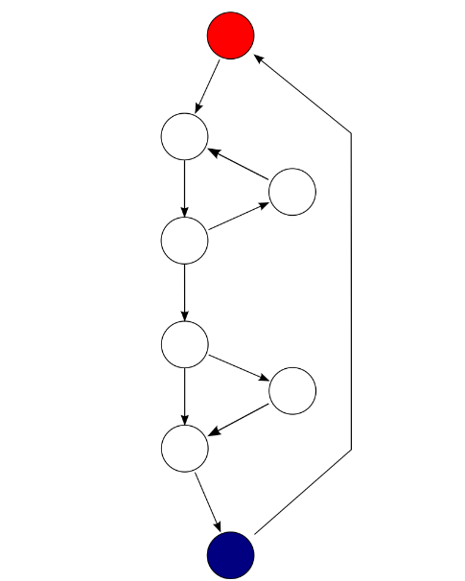  Each exit point is connected back to the entry point. This graph has 10 edges, eight nodes and one connected component, which also results in a cyclomatic complexity of 3 (10 − 8 + 1 = 3).
if (c1())  f1();  else  f2();  if (c2())  f3();  else  f4();  The cyclomatic complexity of the program is 3 (as the strongly connected graph for the program contains 9 edges, 7 nodes, and 1 connected component) (9 − 7 + 1). | 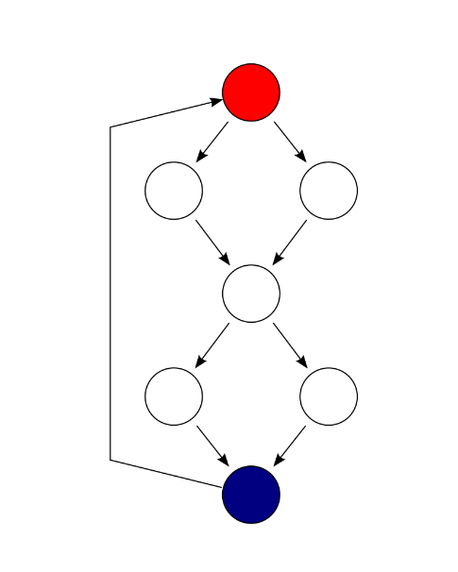  F  E  D  C  B  A  S
There are 4 cycles (paths) but only 3 of them are linearly independent. McCabe developed an algorithmic procedure (called the “baseline method”) to determine a set of basis paths. The method begins with the selection of a “baseline” path, which should correspond to some “normal case” program execution. This can be somewhat arbitrary; McCabe advises choosing a path with as many decision nodes as possible. Next the baseline path is retraced, and in turn each decision is “flipped”, that is when a node of outdegree ≥2 is reached, a different edge must be taken. Apply it:
P1=(S,A,C,D,F); P2=(S,B,C,D,F), and P3=(S,B,C,E,F).”

Task 4. (33 points) Consider the call graph shown in Figure 6.7
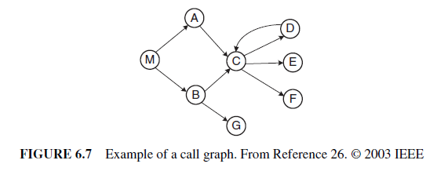
and an execution trace: M B G r r A C F r E r D r r r x.
- (16 points) Draw a call stack state after every its change (call or return)
Stack grows down. It is empty before the 1st call and the last function completes:
 | M | M | M | M | M | M | M | M | M | M | M | M | M | M | M
 |  | B | B | B |  | A | A | A | A | A | A | A | A | A
 |  |  | G |  |  |  | C | C | C | C | C | C | C
 |  |  |  |  |  |  |  | F |  | E |  | D

- (17 points) Define potentially impacted functions in the graph if G changes
Impacted functions are those in the stack when G works (it returns into B and then into M). Hence, impacted are G, B, and M. Impacted M can also effect the functions it calls next directly (A) or indirectly (C, F, E, and D).

Explain your answer
Hints:
“Let us consider an execution trace as shown in Figure 6.8.
The trace corresponds to a program whose call graph is shown in Figure 6.7. In the figure, r and x represent function returns and program exits, respectively. Let procedure E be modified. The impact of the modification with respect to the given trace is computed by forward searching in the trace to find: (i) procedures that are indirectly or directly invoked by E; and (ii) procedures that are invoked after E terminates. One can identify the procedures into which E returns by performing backward search in the given trace. For example, in the given trace, E does not invoke other entities, but it returns into M, A, and C. Due to a modification in E, the set of potentially impacted procedures is {M, A, C, E}.”

Task 5. (34 points) For the code below
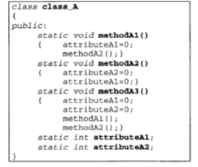 | 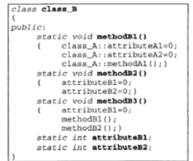

the distance matrix is
Calculate distances between 1) (17 points) aA1 and mB3 (0.88); 2) (17 points) mA2 and mB1 (0.6). Show details of your calculations and explain them.
Hints:
“Cohesion Metrics Simon et al., 2001, Metrics Based Refactoring. have introduced the concept of a distance based metric to express design cohesion, where cohesion refers to the degree to which module components belong together. The distance-based metric is explained in what follows. Let B be a set of considered properties for a special similarity viewpoint. Also, let x and y denote two entities (e.g., methods and attributes) of a “module” (e.g., a class) for which we are interested in finding its cohesion. Then, the distance between x and y with respect to the considered property set B, denoted by distB(x, y) is computed as follows:
distB(x, y) = 1 −|p(x) ∩ p(y)|/|p(x) ∪ p(y)| (7.1)
where p(x) = {pi ∈ B| x possesses property pi}.
For a method f, the set of its properties, denoted by Bf , is given as follows:
Bf = {f ∪ all methods directly used byf ∪ all attributes directly used by f }. (7.2)
Similarly, for an attribute g, the set of its properties, denoted by Bg, is given as follows:
Bg = {g ∪ all methods using g}. (7.3)
For the calculation of distance between two entities, the needed B is given by the union of the two corresponding sets of attributes. For example, if we are interested in calculating the distance between two methods f1 and f2, we have B = Bf1 ∪ Bf2.
Similarly, if we are interested in the distance between a method f and an attribute g, then we have B = Bf ∪ Bg.
$$B_{aA1}=\left\{mA1,mA2,aA1\right\}, B_{mA2}=\left\{mA2,aA1,aA2\right\},$$
$$dist\left(mA1,mA2\right)=1-\frac{\left|B_{mA1}∩B_{mA2}\right|}{\left|B_{mA1}∪B_{mA2}\right|}=1-\frac{\left|\left\{aA1,mA2\right\}\right|}{\left|\left\{mA1,mA2,aA1,aA2\right\}\right|}=1-\frac{2}{4}=0.5$$
”
Solution:
$$B_{aA1}=\left\{aA1,mA1,mA2, mA3,mB1\right\}, B_{mB3}=\left\{mB3,aB1,mB1,mB2\right\},$$
$$dist\left(mA1,mB3\right)=1-\frac{\left|B_{aA1}∩B_{mB3}\right|}{\left|B_{mA1}∪B_{mB3}\right|}=1-\frac{\left|\left\{mB1\right\}\right|}{\left|\left\{aA1,mA1,mA2, mA3,mB3,aB1,mB1,mB2 \right\}\right|}=1-\frac{1}{8}=0.875$$
$$B_{mA2}=\left\{mA2, aA2,aA1\right\}, B_{mB1}=\left\{mB1,aA1,aA2,mA1\right\},$$
$$dist\left(mA2,mB1\right)=1-\frac{\left|B_{mA2}∩B_{mB1}\right|}{\left|B_{mA2}∪B_{mB1}\right|}=1-\frac{\left|\left\{ aA2,aA1\right\}\right|}{\left|\left\{mA2, aA2,aA1,mB1,mA1 \right\}\right|}=1-\frac{2}{5}=\frac{3}{5}=0.6$$

