CMSE-520 Problem session 05.06.2026
04.06.2026. CMSE520 Final Exam 19.06.2026, Friday, 16.30, will be comprehensive including MT Exam subjects (33 points out of 100): 1) Lecture 1. Software Evolution & Maintenance Concepts; 2) Lecture 2. Taxonomy of Software Maintenance and Evolution; and 3) Lecture 3. Reengineering ; and after MT Exam subjects (67 points out of 100): 4) Lecture 4. Impact Analysis, and 5) Lecture 5 Refactoring (p. 1-49 are included; Section 5.3, c, System sandwich approach, p. 49, and the rest is not included). Five A4-sized cheat-sheets with your own handwritings and standalone calculators can be used for your help. Telephones, tablets, etc. are not allowed.
Contents
1. Refactoring 2
1.1. Restructuring technique 2
1.1.1. Elimination-of-goto Approach from code 2
1.1.1.1. Forward elimination 2
1.1.1.2. Backward elimination 2
1.1.1.3. Rewrite 1.1.1.2 using just exit (not exit label) 3
1.1.2. Localization and Information Hiding Approach 3
1.1.2. Program Slicing Approach 7
1.1.3. Approaches not involving code changes 7
1.2. Factors Influencing Software Structure 7
1.3. Examples of refactorings 7
1.3.1. Substitute Algorithm 7
1.3.2. Replace Parameter with Method 7
1.3.3. Push-down Method 7
1.3.4. Parameterize Methods 7
1.4. Refactorings using metrics 7
1.4.1. Cohesion-based refactoring 7
1.4.2. Coupling-based refactoring 7
1.5. Rule-based refactoring 7
1.6. Assertions 7
1.7. Refactorings of the class diagram of a LAN simulator 7
1.8. Code smells 7
1.8.1. Duplicate Code 7
1.8.2. Long Parameter List 7
1.8.3. Long Methods: 7
1.8.4. Message Chain 7
1.8.5. Comments 7
2. Impact analysis 8

Refactoring

Restructuring technique

Elimination-of-goto Approach from code
@article{Ramshaw1988EliminatingGT,
title={Eliminating go to's while preserving program structure},
author={Lyle Ramshaw},
journal={J. ACM},
year={1988},
volume={35},
pages={893-920},
url={https://api.semanticscholar.org/CorpusID:31001665}]

Forward elimination
actionl;  action2;  if test3 then go to G endthen fi;  action4;  if test5 then go to G endthen fi;  action6;  G: action7; | actionl;  action2;  repeat  if test3 then exit L endthen fi;  action4;  if test5 then exit L endthen fi;  action6;  exit;  endloop : L  action7;

FIG. 2. An example of the Forward Elimination Rule.
flowchart TD  A1([action₁])  A2([action₂])  T3{test₃?}  A4([action₄])  T5{test₅?}  A6([action₆])  G([G: action₇])  A1 --> A2 --> T3  T3 -- true --> G  T3 -- false --> A4  A4 --> T5  T5 -- true --> G  T5 -- false --> A6  A6 --> G | @startuml  start  :action1;  :action2;  :loop=true;  while (loop)  if (test3?) then  :loop=false;  :continue;  endif  :action4;  if (test5?) then  :loop=false;  :continue;  endif  :action6;  :loop=false;  endwhile  :action7;  stop  @enduml
Dashboard | Mermaid Chart | PlantUML Editor Online - Free & Fast UML Diagram Tool | PlantText

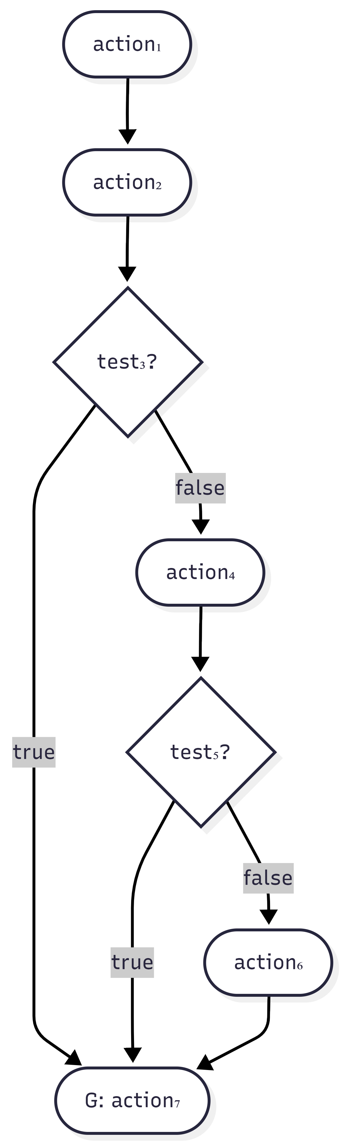 | 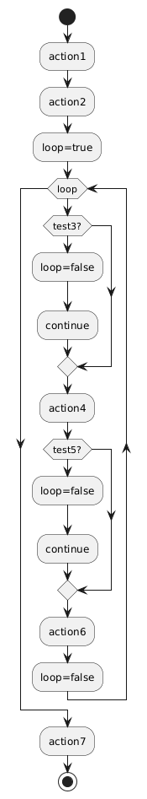
$$a7:t3⋁t5∨\overline{t3}∧\overline{t5}=1$$  $$a6:\overline{t3}∧\overline{t5}$$  $$a4:\overline{t3}$$  $$a2,a1:1$$ | $$a7:t3⋁t5∨\overline{t3}∧\overline{t5}=1$$  $$a6:\overline{t3}∧\overline{t5}$$  $$a4:\overline{t3}$$  $$a2,a1:1$$

1.1.1.2. Backward elimination
actionl  G: action2;  if test3 then go to G endthen fi;  action4;  if test5 then go to G endthen fi;  action6 ;  action7; | actionl;  repeat  action2;  Repeat  if test3 then exit L endthen fi;  action4;  if test5 then exit L endthen fi;  exit m;  endloop : L  endloop : m;  action6;  action7;
$$a6,a7: \overline{t3}∨\overline{t5}$$  $$a4:\overline{t3}$$  $$a2:1,t3∨t5$$  $$a1:1$$ | $$a6,a7: \overline{t3}∨\overline{t5}$$  $$a4:\overline{t3}$$  $$a2:1,t3∨t5$$  $$a1:1$$

FIG. 3. An example of the Backward Elimination Rule.

1.1.1.3. Rewrite 1.1.1.2 using just exit (not exit label)

1.1.2. Localization and Information Hiding Approach
From W. C. Chu and S. Patel, "Software restructuring by enforcing localization and information hiding," Proceedings Conference on Software Maintenance 1992, Orlando, FL, USA, 1992, pp. 165-172, doi: 10.1109/ICSM.1992.242546.
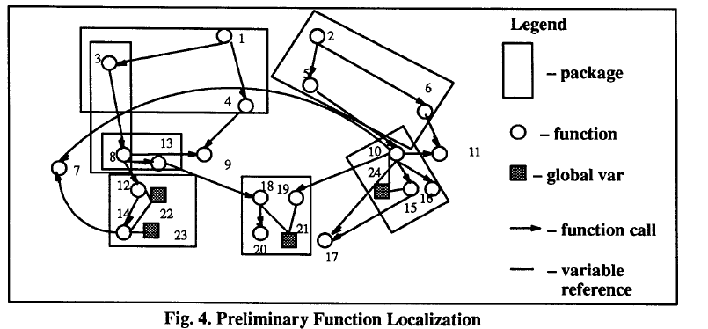

Copilot explanations:
An Abstract Data Type (ADT) is a theoretical construct in computer science that describes a data type purely by its behaviour and the operations it supports, rather than how it is implemented internally. ADTs provide a high-level abstraction, allowing programmers to focus on what operations can be performed on the data rather than how these operations are executed. This separation of interface from implementation enhances modularity, maintainability, and flexibility in software design
Examples of ADTs
- Stack: Follows Last In, First Out (LIFO) principle. Operations include push(), pop(), and peek() .
- Queue: Follows First In, First Out (FIFO) principle. Operations include enqueue() and peek().
- List: A sequential collection of elements with operations like insert(), remove(), and get().
- Graph or Tree: More complex structures that encapsulate nodes and edges or hierarchical relationships, with operations defined for traversal, insertion, or deletion .

Program Slicing Approach

Approaches not involving code changes

Factors Influencing Software Structure

Examples of refactorings

Substitute Algorithm

Replace Parameter with Method

Push-down Method

Parameterize Methods

Refactorings using metrics

Cohesion-based refactoring

Coupling-based refactoring

Rule-based refactoring

Assertions

Refactorings of the class diagram of a LAN simulator

Code smells

Duplicate Code

Long Parameter List

Long Methods:

Message Chain

Comments
From Refactoring: Improving the Design of Existing Code
by Martin Fowler, Kent Beck (Contributor), John Brant (Contributor), William
Opdyke, don Roberts
https://www.oreilly.com/library/view/refactoring-improving-the/9780134757681/
Don't worry, we aren't saying that people shouldn't write comments. In our olfactory analogy, comments aren't a bad smell; indeed they are a sweet smell. The reason we mention comments here is that comments often are used as a deodorant. It's surprising how often you look at thickly commented code and notice that the comments are there because the code is bad.
Comments lead us to bad code that has all the rotten whiffs we've discussed in the rest of this chapter. Our first action is to remove the bad smells by refactoring. When we're finished, we often find that the comments are superfluous.
If you need a comment to explain what a block of code does, try Extract Method. If the method is already extracted but you still need a comment to explain what it does, use Rename Method.
If you need to state some rules about the required state of the system, use Introduce Assertion.
Tip

When you feel the need to write a comment, first try to refactor the code so that any comment becomes superfluous.
A good time to use a comment is when you don't know what to do. In addition to describing what is going on, comments can indicate areas in which you aren't sure. A comment is a good place to say why you did something. This kind of information helps future modifiers, especially forgetful ones.

Impact analysis
  - Starting impact set, candidate impact set, discovered impact set, actual impact set, false positive impact set, recall, precision, adequacy, inclusiveness, effectiveness, ripple sensitivity, amplification, sharpness, change rate, adherence, S-ratio
  - Identifying SIS
  - Traceability graph
  - SLO (software life-cycle objects) dependency graph, connectivity matrix, reachability matrix, distance matrix
  - Program dependency graph, reaching definitions, static and dynamic program slices
  - Intra-module and inter-module change propagation. Matrices Vm, Zm, Xm, ripple effect calculation
  - Recall and precision calculation for change propagation heuristic
  - Heuristics for change propagation

