CMSE-520 Problem session 08.06.2026
04.06.2026. CMSE520 Final Exam 19.06.2026, Friday, 16.30, will be comprehensive including MT Exam subjects (33 points out of 100): 1) Lecture 1. Software Evolution & Maintenance Concepts; 2) Lecture 2. Taxonomy of Software Maintenance and Evolution; and 3) Lecture 3. Reengineering ; and after MT Exam subjects (67 points out of 100): 4) Lecture 4. Impact Analysis, and 5) Lecture 5 Refactoring (p. 1-49 are included; Section 5.3, c, System sandwich approach, p. 49, and the rest is not included). Five A4-sized cheat-sheets with your own handwritings and standalone calculators can be used for your help. Telephones, tablets, etc. are not allowed.

Reengineering

Program metrics

TABLE 4.3 Commonly Used Software Metrics
Metric Description
Lines of code (LOC) The number of lines of executable code
Global variable (GV) The number of global variables

Cyclomatic complexity (CC)
The number of linearly independent paths in a program unit is given by the cyclomatic complexity metric.
From https://en.wikipedia.org/wiki/Cyclomatic_complexity:
It is proposed to use a graph in which each exit point is connected back to the entry point. In this case, the graph is strongly connected. Here, the cyclomatic complexity of the program is equal to the cyclomatic number of its graph (also known as the first Betti number), which is defined as^{[2]}  $CC=E-N+P$  where E = the number of edges of the graph, N = the number of nodes of the graph, P = the number of connected components.  This may be seen as calculating the number of linearly independent cycles that exist in the graph: those cycles that do not contain other cycles within themselves. Because each exit point loops back to the entry point, there is at least one such cycle for each exit point. | 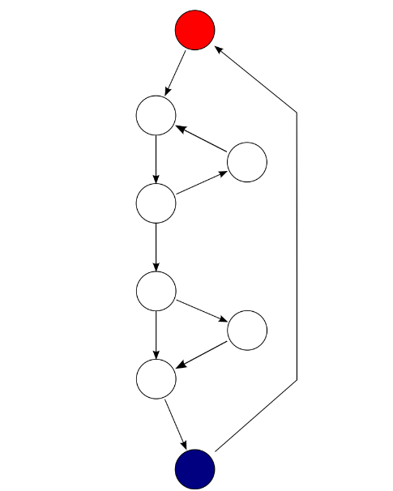  Each exit point is connected back to the entry point. This graph has 10 edges, eight nodes and one connected component, which also results in a cyclomatic complexity of 3 (10 − 8 + 1 = 3).
if (c1())  f1();  else  f2();  if (c2())  f3();  else  f4();  The cyclomatic complexity of the program is 3 (as the strongly connected graph for the program contains 9 edges, 7 nodes, and 1 connected component) (9 − 7 + 1). | 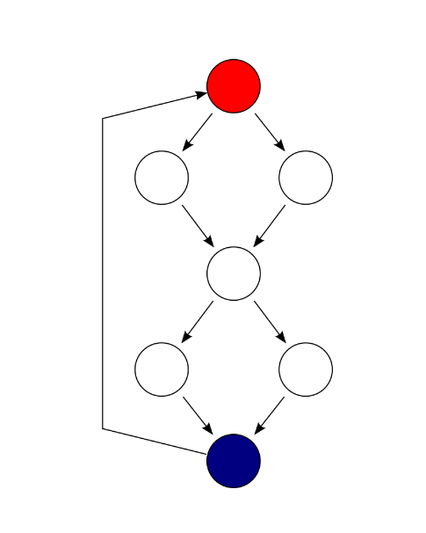  F  E  D  C  B  A  S
There are 4 cycles (paths) but only 3 of them are linearly independent. McCabe developed an algorithmic procedure (called the “baseline method”) to determine a set of basis paths. The method begins with the selection of a “baseline” path, which should correspond to some “normal case” program execution. This can be somewhat arbitrary; McCabe advises choosing a path with as many decision nodes as possible. Next the baseline path is retraced, and in turn each decision is “flipped”, that is when a node of outdegree ≥2 is reached, a different edge must be taken. Apply it:
P1=(S,A,C,D,F); P2=(S,B,C,D,F), and P3=(S,B,C,E,F).

Read coupling The number of global variables read by a program unit
Write coupling The number of global variables updated by a program unit
Address coupling The number of global variables whose addresses are extracted by a program unit but do not involve read/write coupling
Fan-in The number of other functions calling a given function in a module
Fan-out The number of other functions being called from a given function in a module

Module coupling
https://en.wikipedia.org/wiki/Coupling_%28computer_programming%29#:~:text=In%20software%20engineering%2C%20coupling%20is%20the%20degree%20of,between%20modules.%20Coupling%20is%20not%20binary%20but%20multi-dimensional.
For data and control flow coupling:
- d_{i}: number of input data parameters
- c_{i}: number of input control parameters
- d_{o}: number of output data parameters
- c_{o}: number of output control parameters
For global coupling:
- g_{d}: number of global variables used as data
- g_{c}: number of global variables used as control
For environmental coupling:
- w: number of modules called (fan-out)
- r>=1: number of modules calling the module under consideration (fan-in)
$Coupling\left(C\right)=1-\frac{1}{d_{i}+2c_{i}+d_{0}+2c_{0}+g_{d}+2g_{c}+w+r}$ (1)
$Coupling\left(C\right)$ makes the value larger the more coupled the module is. This number ranges from approximately 0.67 (low coupling) to 1.0 (highly coupled)
For example, if a module has only a single input and output data parameter
$$C=1-\frac{1}{1+0+1+0+0+0+1+0}=1-\frac{1}{3}=0.67$$
If a module has 5 input and output data parameters, an equal number of control parameters, and accesses 10 items of global data, with a fan-in of 3 and a fan-out of 4,
$$C=1-\frac{1}{5+2×5+5+2×5+10+0+3+4}=0.98$$

From H. Dhama, Quantitative Models of Cohesion and Coupling in Software, J. SYSTEMS SOFTWARE 1995; 29:65-74
MODULEl-Implementation #l-a single procedure implements a “selection sort.”
MODULE1
package sort1 is
type array-type is array (l..lOOO) of integer;
-- Specifications of the procedure
procedure sort1 (n: in integer; to-be-sorted: in out array-type; a--or-d: in character);
end sortl;
-- The code in the body is evaluated
package body sort1 is
procedure sort1 (n: in integer; to-be-sorted: in out array-type; a-or-d: in character) is
location, temp: integer;
begin
for start in l..n loop
location:= start;
--loop to get min or max each time
for i in (start + 1)..n loop
if a-or-d = ‘d’ then
if to-be-sorted(i) > to-be-sorted(location) then
location:= i;
end if;
else
if to-be-sorted(i) < to-be-sorted(location) then
location:= i;
end if;
end loop;
--The exchange
temp:= to-be-sorted(start);
to-be-sorted(start):= to-be-sorted(location);
to-be-sorted(location):= temp;
end loop;
end sortl;
end sortl;
MODULE2-Implementation #2-four procedures implement a “selection sort.”
MODULE2
package sort2 is
type array-type is array (l..lOOO) of integer;
--Specifications of the procedures
procedure sort2 (n: in integer; to-be-sorted: in out array-type; a-or-d: in character);
procedure find-max (n: in integer; to-be-sorted: in out array-type; location: in out integer);
procedure find-min (n, start: in integer; to-be-sorted: in out array-type; location: in out integer);
procedure exchange (start: in integer; to-be-sorted: in out array-type; location: in out integer);
end sort2;
package body sort2 is
--Only body code evaluated
--Procedure find-max body (‘Proc. B’ in Tables Al and A2)
procedure find-max (n, start: in integer; to-be-sorted: in array-type; location: in out integer); is
begin
location:= start;
for i in start + l..n loop
if to-be-sorted(i) > to-be-sorted (location) then
location:= i;
end if;
end loop;
end find-max;
--Procedure find-min body (‘Proc. c’ in Tables Al and A2)
procedure find-min (n, start: in integer; to-be-sorted: in array-type; location: in out integer) is
begin
location:= start;
for i in start + l..n loop
if to-be-sorted(i) < to-be-sorted (location) then
location:= i;
end if;
end loop;
end find-min;
--Procedure exchange body (‘Proc. D’ in Tables Al and A2)
procedure exchange (start: in integer; to-be-sorted: in out array-type; location: in integer) is
temp: integer;
begin
temp:= to-be-sorted(start);
to-be-sorted(start):= to-be-sorted(location);
to-be-sorted(location):= temp;
end exchange;
--Procedure sort2 body CProc. A’ in Tables Al and A2)
procedure sort2 (n: in integer; to-be-sorted: in out array-type; a-or-d: in character) is
location: integer;
begin
for start in l..n loop
if a-or-d =‘d’ then
find-max(n, start, to-be-sorted, location);
else
find-min(n, start, to-be-sorted, location);
end if;
exchange (start, to-be-sorted, location);
end loop;
end sort2;
end sort2;

Calculate Coupling of the procedures sort1, sort2, find_max, find_min, and exchange
procedure | $$d_{i}$$ | $$c_{i}$$ | $$d_{o}$$ | $$c_{o}$$ | $$g_{d}$$ | $$g_{c}$$ | $$w$$ | $$r≥1$$ | Coupling, formula (1)
Sort1 | 1(to-be-sorted) | 2(n,a-or-d, to-be-sorted) | 1(to-be-sorted) | 1(to-be-sorted | 0 | 0 | 0 | 1 | $$1-\frac{1}{1+2∙3+1+2+1}=1-\frac{1}{11}=\frac{10}{11}$$
Find-max | 1(to-be-sorted) | 4(n,  Start, to-be-sorted,  location) | 2(to-be-sorted) | 2(to-be-sorted, location) | 0 | 0 | 0 | 1 | $$1-\frac{1}{2+2∙4+2+4+1}=1-\frac{1}{17}=\frac{16}{17}$$

Functional Cohesion.
Let
F = functional cohesion of a module,
il = in data parameters,
i2 = in control parameters,
ul = out data parameters,
u2 = out control parameters,
11 = number of local variables used as data,
12 = number of local variables used as control,
gl = number of global variables used as data,
g2 = number of global variables used as control,
w = number of modules called.
Now let
p = il + q₁i2 + ul + q₂u2 + I1 + q₃12+ gl + q₄g2 + q₅w, (2)
where q_{l}, q₂, q₃, q₄, and q₅ are constants, and, as a first heuristic estimate, are assumed
to be 2 in our calculations.
Then,
F=1/p
When a module is called, there is an implicit transfer of control to the module, that is, an implied system control parameter is being passed to the module. Therefore, when all the constituents of p are 0, then the minimum value of p is assumed to be 1. With this assumption, functional cohesion is an interval scale with values > 0 but < 1. Therefore,
F = Kl/maximum (p, 1)
where Kl is the proportionality constant. Assuming Kl = 1,
F = l/maximum(p, 1) (3)
Calculate Functional Cohesion (3) of the procedures sort1, sort2, find_max, find_min, and exchange
procedure | $$i_{1}$$ | $$i_{2}$$ | $$u_{1}$$ | $$u_{2}$$ | $$l_{1}$$ | $$l_{2}$$ | $$g_{1}$$ | $$g_{2}$$ | $$w$$ | Functional cohesion, formula (3)
Sort1 | 1(to-be-sorted) | 3(n,a-or-d, to-be-sorted) | 1(to-be-sorted) | 1(to-be-sorted) | 1(temp) | 3(start,  I, location) | 0 | 0 | 0 | $$1/(1+2∙3+1+2+1+$$  $$6)=\frac{1}{17}$$
Find-max | 1(to-be-sorted) | 4(n,  Start, location, to-be-sorted) | 0 | 1(  Location) | 0 | 1(i) | 0 | 0 | 0 | $$1/(1+2∙4+2+2)=\frac{1}{13}$$

Halstead complexity (HC)
It is defined as effort: E = D ∗ V, where: Difficulty: D =(n1/2)×(N2/n2); Volume: V =N× log2 n Program length: N = N1 + N2; Program vocabulary: n = n1 + n2 n1 = the number of distinct operators n2 = the number of distinct operands N1 = the total number of operators N2 = the total number of operands
https://en.wikipedia.org/wiki/Halstead_complexity_measures
For a given problem, let:
$η_{1}$ = the number of distinct operators
$η_{2}$= the number of distinct operands
$N_{1}N_{1}$ = the total number of operators
$N_{2}NN$ = the total number of operands
From these numbers, several measures can be calculated:
- Program vocabulary: $η=η_{1}+η_{2}$
- Program length: $NNN=N_{1}+N_{2}$
- Calculated estimated program length: $NN\hat{N}=η_{1}\log_{2}{η_{1}}+η_{2}\log_{2}{η_{2}}$
- Volume: $V=Nlog_{2} η$
- Difficulty: $D=\frac{ η_{1}}{2}×\frac{N_{2}}{ η_{2}}$
- Effort: $E=D×V$
The difficulty measure is related to the difficulty of the program to write or understand, e.g. when doing code review.
The effort measure translates into actual coding time using the following relation,
- Time required to program: $T=\frac{E}{18}$ seconds
Halstead's delivered bugs (B) is an estimate for the number of errors in the implementation.
- Number of delivered bugs $B=\frac{E^{\frac{2}{3}}}{3000}$: or, more recently, $B=\frac{V}{3000}$ is accepted.

Example
Consider the following C program:
main()
{
int a, b, c, avg;
scanf("%d %d %d", &a, &b, &c);
avg = (a+b+c)/3;
printf("avg = %d", avg);
}
The distinct operators () are: main, (), {}, int, scanf, &, =, +, /, printf, ,, ;
The distinct operands () are: a, b, c, avg, "%d %d %d", 3, "avg = %d"
- $η_{1}=12,η_{2}=7,η=19$
- $N_{1}=27,N_{2}=15,N=42$
- Calculated Estimated Program Length: $\overset{^}{N}=12×log_{2}12+7×log_{2}7=62.67$
- Volume: $V=42×log_{2}19=178.4$
- Difficulty: $D=DD=\frac{12}{2}×\frac{15}{7}=12.85$
- Effort: $EEEeee==E=12.85×178.4=2292.44$
- Time required to program: $T=\frac{2292.44}{18}=127.357$seconds
- Number of delivered bugs: $B$$B=\frac{{2292.44}^{\frac{2}{3}}}{3000}=0.05$

Function points
It is a unit of measurement to express the amount of business functionality an information system provides to a user. Function points are a measure of the size of computer applications and the projects that build them
https://www.geeksforgeeks.org/software-engineering-calculation-of-function-point-fp/
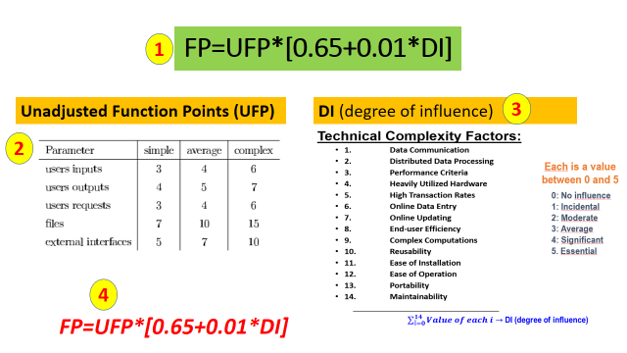
Example:
Given the following values, compute function point when all complexity adjustment factor (CAF) and weighting factors are average.
User Input = 50
User Output = 40
User Inquiries = 35
User Files = 6
External Interface = 4

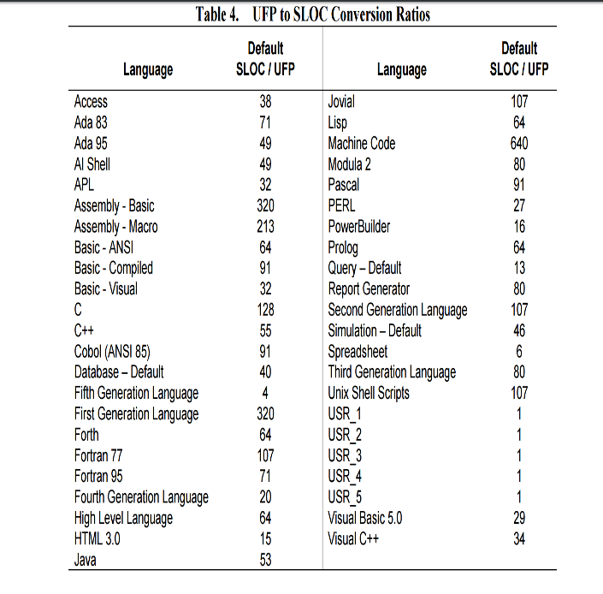
Calculate KLOC if the project used VisualC++

OO metrics
In the 1990s, large-scale adoption of object-oriented (OO) programming techniques gave rise to some OO design metrics known as Chidamber and Kemerer (CK) metric suite. Six performance metrics are found in the CK metric suite as follows:
- Weighted methods per class (WMC)—This is the number of methods implemented within a given class.
- Response for a class (RFC)—This is the number of methods that can potentially be executed in response to a message being received by an object of a given class. It is the number of methods implemented within a class plus the number of methods accessible to an object class due to inheritance.
- Lack of cohesion in methods (LCOM)—For each attribute in a given class, calculate the percentage of the methods in the class using that attributes. Next, compute the average of all those percentages, and subtract the average from 100%.
- LCOM from S.R. Chidamber, C.F. Kemerer, A metrics suite for object-oriented design, IEEE Trans on Software Engineering, 1994, vol. 30, no. 6, p. 476-493.
- Coupling between object class (CBO)—This is the number of distinct non-inheritance-related classes on which a given class is coupled. A class is said to be coupled to another class if it uses methods or attributes of the other class.
- Depth of inheritance tree (DIT)—This is the length of the longest path from a given class to the root in the inheritance hierarchy.
- Number of children (NOC)—This is the number of classes that directly inherit from a given class.

Program slicing

https://en.wikipedia.org/wiki/Program_slicing
int i;
int sum = 0;
int product = 1;
int w = 7;
for(i = 1; i < N; ++i) {
sum = sum + i + w;
product = product * i;
}
write(sum);
write(product);
The static executable slice for criteria (write(sum), sum) is the new program shown below.
int i;
int sum = 0;
int w = 7;
for(i = 1; i < N; ++i) {
sum = sum + i + w;

}
write(sum);

The reaching definition analysis https://en.wikipedia.org/wiki/Data-flow_analysis
It calculates for each program point the set of definitions that may potentially reach this program point.
- if b == 4 then
- a = 5;
- else
- a = 3;
- endif

- if a < 4 then
...
The reaching definition of variable a at line 6 is the set of assignments a = 5 at line 2 and a = 3 at line 4.

Dead code elimination
https://en.wikipedia.org/wiki/Dead-code_elimination
int foo(void) {
int a = 24;
int b = 25; /* Assignment to dead variable */
int c;
c = a * 4;
return c;
b = 24; /* Unreachable code */
return 0;
}
Simple analysis of the uses of values would show that the value of b after the first assignment is not used inside foo. Furthermore, b is declared as a local variable inside foo, so its value cannot be used outside foo. Thus, the variable b is dead and an optimizer can reclaim its storage space and eliminate its initialization.
Furthermore, because the first return statement is executed unconditionally and there is no label after it which a "goto" could reach, no feasible execution path reaches the second assignment to b. Thus, the assignment is unreachable and can be removed. If the procedure had a more complex control flow, such as a label after the return statement and a goto elsewhere in the procedure, then a feasible execution path might exist to the assignment to b.

Backward analysis https://en.wikipedia.org/wiki/Data-flow_analysis

Live variables Live-variable analysis - Wikipedia
Consider the following program:
- b = 3
- c = 5
- a = f(b * c)
The set of live variables between lines 2 and 3 is {b, c} because both are used in the multiplication on line 3. But the set of live variables after line 1 is only {b}, since variable c is updated later, on line 2. The value of variable a is not used in this code.

Backward analysis
The analysis is done in a backwards order, and the dataflow confluence operator is set union. In other words, if applying liveness analysis to a function with a particular number of logical branches within it, the analysis is performed starting from the end of the function working towards the beginning (hence "backwards"), and a variable is considered live if any of the branches moving forward within the function might potentially (hence "may") need the variable's current value. This is in contrast to a "backwards must" analysis which would instead enforce this condition on all branches moving forward.
The dataflow equations used for a given basic block s and exiting block f in live variable analysis are the following:
$Gen(s)GEE$: The set of variables that are used in s before any assignment in the same basic block.
$Kill(s)$: The set of variables that are assigned a value in s (in many books that discuss compiler design, KILL (s) is also defined as the set of variables assigned a value in s before any use, but this does not change the solution of the dataflow equation):
$${\text{LIVE}}_{in}[s]=\text{GEN}[s]∪({\text{LIVE}}_{out}[s]-\text{KILL}[s])$$
$${\text{LIVE}}_{out}[final]=∅$$
$${\text{LIVE}}_{out}[s]=\bigcup_{p∈succ[s]}{{\text{LIVE}}_{in}}[p]$$
$$\text{GEN}[d:y←f(x_{1},⋯,x_{n})]=\{x_{1},...,x_{n}\}$$
$$\text{KILL}[d:y←f(x_{1},⋯,x_{n})]=\{y\}$$
The in-state of a block is the set of variables that are live at the start of it. It initially contains all variables live (contained) in the block, before the transfer function is applied and the actual contained values are computed. The transfer function of a statement is applied by killing the variables that are written within this block (remove them from the set of live variables). The out-state of a block is the set of variables that are live at the end of the block and is computed by the union of the block's successors' in-states.
Initial code:
b1: a = 3;
b = 5;
d = 4;
x = 100;
if a > b then
b2: c = a + b;
d = 2;
b3: endif
c = 4;
return b * d + c;
Live-in and live-out sets:
// in: {}; predecessor blocks: none
b1: a = 3;
b = 5;
d = 4;
x = 100; //x is never being used later thus not in the out set {a,b,d}
if a > b then
// out: {a,b,d} //union of all (in) successors of b1 => b2: {a,b}, and
// b3:{b,d}

// in: {a,b}; predecessor blocks: b1
b2: c = a + b;
d = 2;
// out: {b,d}

// in: {b,d}; predecessor blocks: b1 and b2
b3: endif
c = 4;
return b * d + c;
// out:{}
The in-state of b3 only contains b and d, since c has been written. The out-state of b1 is the union of the in-states of b2 and b3. The definition of c in b2 can be removed, since c is not live immediately after the statement.
Solving the data flow equations starts with initializing all in-states and out-states to the empty set. The work list is initialized by inserting the exit point (b3) in the work list (typical for backward flow). Its computed in-state differs from the previous one, so its predecessors b1 and b2 are inserted and the process continues. The progress is summarized in the table below.
processing | out-state | old in-state | new in-state | work list
b3 | {} | {} | {b,d} | (b1,b2)
b1 | {b,d} | {} | {} | (b2)
b2 | {b,d} | {} | {a,b} | (b1)
b1 | {a,b,d} | {} | {} | ()
Note that b1 was entered in the list before b2, which forced processing b1 twice (b1 was re-entered as predecessor of b2). Inserting b2 before b1 would have allowed earlier completion.

Regular expressions
https://developer.mozilla.org/en-US/docs/Web/JavaScript/Guide/Regular_expressions/Cheatsheet
1.6.1. ^[ \t]+|[ \t]+$ matches excess whitespace at the beginning or end of a line.
Characters | Meaning
^ | Input boundary beginning assertion: Matches the beginning of input. If the multiline (m) flag is enabled, also matches immediately after a line break character. For example, /^A/ does not match the "A" in "an A", but does match the first "A" in "An A".  Note: This character has a different meaning when it appears at the start of a character class.
$ | Input boundary end assertion: Matches the end of input. If the multiline (m) flag is enabled, also matches immediately before a line break character. For example, /t$/ does not match the "t" in "eater", but does match it in "eat".

Characters | Meaning
[xyz]  [a-c] | Character class: Matches any one of the enclosed characters. You can specify a range of characters by using a hyphen, but if the hyphen appears as the first or last character enclosed in the square brackets, it is taken as a literal hyphen to be included in the character class as a normal character.  For example, [abcd] is the same as [a-d]. They match the "b" in "brisket", and the "c" in "chop".  For example, [abcd-] and [-abcd] match the "b" in "brisket", the "c" in "chop", and the "-" (hyphen) in "non-profit".  For example, [\w-] is the same as [A-Za-z0-9_-]. They both match the "b" in "brisket", the "c" in "chop", and the "n" in "non-profit".
[^xyz]  [^a-c] | Negated character class: Matches anything that is not enclosed in the square brackets. You can specify a range of characters by using a hyphen, but if the hyphen appears as the first character after the ^ or the last character enclosed in the square brackets, it is taken as a literal hyphen to be included in the character class as a normal character. For example, [^abc] is the same as [^a-c]. They initially match "o" in "bacon" and "h" in "chop".  Note: The ^ character may also indicate the beginning of input.
\t | Matches a horizontal tab

x+ Matches the preceding item "x" 1 or more times. Equivalent to {1,}. For example, /a+/ matches the "a" in "candy" and all the "a"'s in "caaaaaaandy".
x|y | Disjunction: Matches either "x" or "y". Each component, separated by a pipe (|), is called an alternative. For example, /green|red/ matches "green" in "green apple" and "red" in "red apple".  Note: A disjunction is another way to specify "a set of choices", but it's not a character class. Disjunctions are not atoms — you need to use a group to make it part of a bigger pattern. [abc] is functionally equivalent to (?:a|b|c).

An advanced regular expression that matches any numeral is
    - [+-]?(\d+(\.\d*)?|\.\d+)([eE][+-]?\d+)?
\d Digit character class escape: Matches any digit (Arabic numeral). Equivalent to [0-9]. For example, /\d/ or /[0-9]/ matches "2" in "B2 is the suite number".

Backus-Naur form
As an example, consider this possible BNF for a U.S. postal address:
<postal-address> ::= <name-part> <street-address> <zip-part>

<name-part> ::= <personal-part> <last-name> <opt-suffix-part> <EOL> | <personal-part> <name-part>

<personal-part> ::= <first-name> | <initial> "."

<street-address> ::= <house-num> <street-name> <opt-apt-num> <EOL>

<zip-part> ::= <town-name> "," <state-code> <ZIP-code> <EOL>

<opt-suffix-part> ::= "Sr." | "Jr." | <roman-numeral> | ""
<opt-apt-num> ::= "Apt" <apt-num> | ""
https://en.wikipedia.org/wiki/Backus%E2%80%93Naur_form
This translates into English as:
- A postal address consists of a name-part, followed by a street-address part, followed by a zip-code part.
- A name-part consists of either: a personal-part followed by a last name followed by an optional suffix (Jr. Sr., or dynastic number) and end-of-line, or a personal part followed by a name part (this rule illustrates the use of recursion in BNFs, covering the case of people who use multiple first and middle names and initials).^{[3]}
- A personal-part consists of either a first name or an initial followed by a dot.
- A street address consists of a house number, followed by a street name, followed by an optional apartment specifier, followed by an end-of-line.
- A zip-part consists of a town-name, followed by a comma, followed by a state code, followed by a ZIP-code followed by an end-of-line.
- An opt-suffix-part consists of a suffix, such as "Sr.", "Jr." or a roman-numeral, or an empty string (i.e. nothing).
- An opt-apt-num consists of a prefix "Apt" followed by an apartment number, or an empty string (i.e. nothing).
Note that many things (such as the format of a first-name, apartment number, ZIP-code, and Roman numeral) are left unspecified here. If necessary, they may be described using additional BNF rules.

Theoretical questions
    - What are the seven factors necessitating code reverse engineering?
    - What are the six key steps in reverse engineering?
    - What are the five phases of the phase reengineering model?
    - What are the six layers of the source code reengineering reference model concerning reverse engineering?
    - What are the three layers of the source code reengineering reference model concerning forward engineering?
    - What are the five reengineering approaches?
    - What are the three reengineering strategies?
    - What are the four types of changes used in reengineering?

